

**Module Title : COMPUTER SYSTEMS**

**Assignment Title : PRACTICAL PORTFOLIO**

**Examination Cycle : SUMMER 2023**

**Candidate Name : KYAW ZAYAR TUN**

**Candidate No : P00200833**

**Centre Name : KMD COMPUTER CENTRE (YANGON)**

**Submission Date : 25 April 2023**

**Important Notes:**

* Please refer to the Assignment Presentation Requirements for advice on how to set out your assignment. These can be found on the NCC Education *Campus*. Scroll down the left hand side of the screen until you reach Personal Support. Click on this, and then on Policies and Advice. You will find the Assignment Presentation Requirements under the Advice section.
* You must familiarise yourself with the NCC Education Academic Dishonesty and Plagiarism Policy and ensure that you acknowledge all the sources which you use in your work. The policy is available on *Campus*. Follow the instructions above, but click on Policies rather than Advice.
* You must complete the **‘Statement and Confirmation of Own Work’**. The form is available on the Policies section of *Campus*. Scroll down the left hand side until you reach Personal Support. Click on this and then click on Policies and Advice.
* Please make a note of the recommended word count. You could lose marks if you write 10%more or less than this.
* You must submit a paper copy and digital copy (on disk or similarly acceptable medium).Media containing viruses, or media which cannot be run directly, will result in a fail grade being awarded for this module.
* All electronic media will be checked for plagiarism.

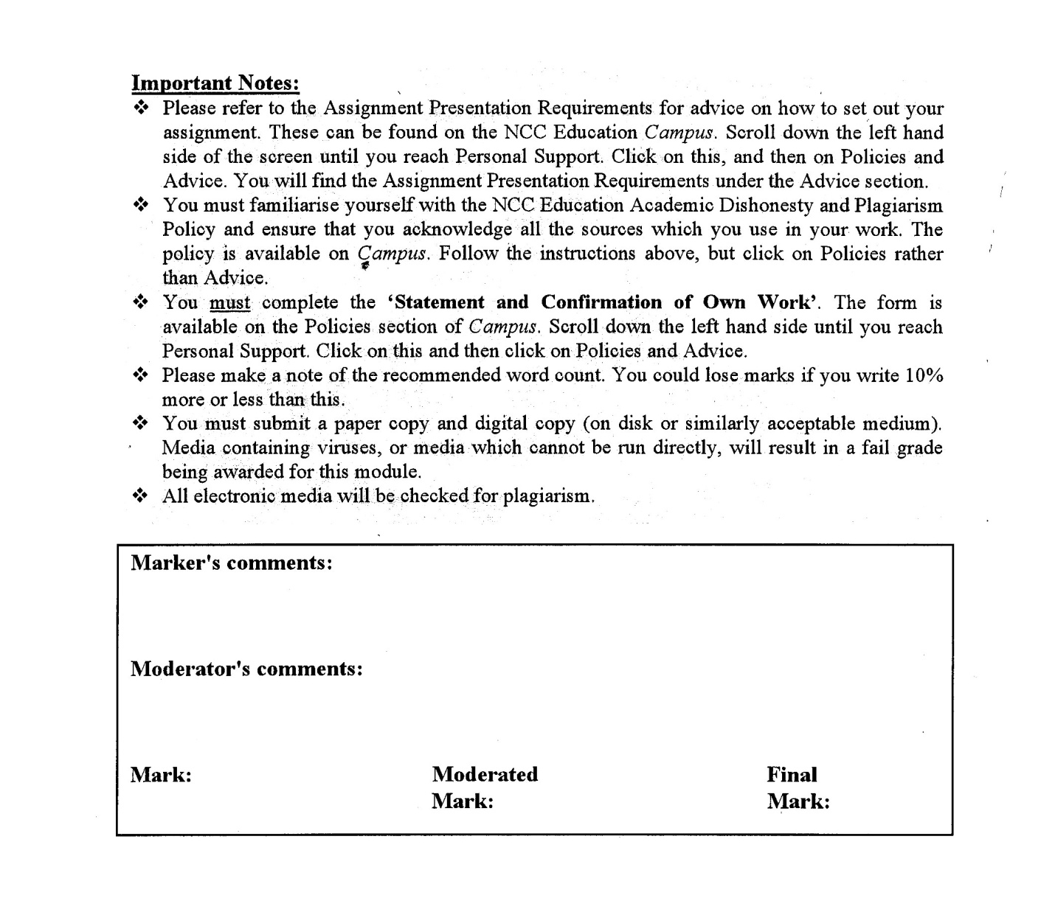



**Statement and Confirmation of Own Work**

**Programme/Qualification name: L4DC**

***All NCC Education assessed assignments submitted by students must have this statement as the cover page or it will not be accepted for marking. Please ensure that this statement is either firmly attached to the cover of the assignment or electronically inserted into the front of the assignment.***

**Student declaration**

**I have read and understood NCC Education’s Policy on Academic Dishonesty and Plagiarism.**

**I can confirm the following details.**

**Student ID/Registration number : P00200833**

**Name : KYAW ZAYAR TUN**

**Centre Name : KMD COMPUTER CENTRE (YANGON)**

**Module Name : COMPUTER SYSTEMS**

**Module Leader : HEIN SITHU NYUNT**

**Number of words : ( 3000 ) words**

**I confirm that this is my own work and that I have not plagiarised any part of it. I have also noted the assessment criteria and pass mark for assignments.**

**Due Date : 30 April 2023**

**Student Signature : KYAW**

**Submission Date : 25 April 2023**

**Table of Contents**

Table of Contents

Task (1) 6

Updating IT Infrastructure 6

Part a) Outline Requirements Specification 7

a. Introduction 7

b. Outline of the industry and organization’s business 7

c. Systems needed to support the business 9

d. Outline of current problems 10

e. Outline list of system functions 10

f. Outline list of non-functional requirements 11

g. (i) Explanation of the importance of CPU type (single/multi-core), RAM and Disk space in the performance of the system 12

g. (ii) Discussion of how disk space may be organized in your selected company. Justify your choices 12

Part b) System Design Specification 13

1. systems specifications for the SME’s needs 13

2. Identify TWO (2) different products for each area that match these specifications 13

3. Exact product details 16

4. The SME requires the pricing in GBP (£) so prices 16

Microsoft 365 Business Premium 16

Part c) Critical Evaluation and System Selection 24

Select ONE (1) solution for each area and justify that selection 24

Task (2) 26

Windows Installation 26

a) Installation of Windows 27

1. Identification of key stages in the installation. 27

2. Identification and description of required device drivers and their source locations. 58

3. Identification and description of unresolved issues – especially missing device drivers. 71

b) Installation of antivirus software 72

1. Identification of product used. 72

2. Identification and description of key stages in installation. 73

3. Identification and description of problems and unresolved issues. 79

4. Outline of the update process for the antivirus software. 80

c) Installation of office software 83

1. Identification of product used. 83

2. Identification and description of key stages in installation. 84

3. Identification and description of problems and unresolved issues. 90

d) Installation of free utility 91

1. Identification of utility, outline of what it does and reason why you chose this. 91

91

2. Identification and description of key stages in installation. 92

3. Identification and description of problems and unresolved issues. 97

Task (3) 98

Faulty PCs and Software Maintenance 98

a) Fault finding and computer maintenance 99

Faulty PC’s (1) 99

1) The steps that you followed to identify the fault. 99

2) The cause of the fault. 99

3) The steps taken to resolve the fault. 99

4) The success or failure of the repair. 99

Faulty PC’s (2) 100

1) The steps that you followed to identify the fault. 100

2) The cause of the fault. 100

3) The steps taken to resolve the fault. 100

4) The success or failure of the repair. 100

Faulty PC’s (3) 101

1) The steps that you followed to identify the fault. 101

2) The cause of the fault. 101

3) The steps taken to resolve the fault. 101

4) The success or failure of the repair. 101

Maintenance of Computer System 102

1) Identification of OS update / software package to update. 102

2) Identification of hardware driver to update. 104

3) Performance of system maintenance and the outcome explaining why it was done and the improvements brought to the system. 107

b) Routine / Preventative maintenance 108

1. Identify FIVE (5) potential reasons why a user might experience this problem and for each of the issues identified explain how you would recommend investigating and addressing the issue. 108

2. Identify FIVE (5) regular maintenance tasks that users should undertake and for each of the issues identified explain why each of them is important 109

Conclusion 111

References for Task(1) 112

Candidate Checklist 135

# Task (1)

# Updating IT Infrastructure

# Part a) Outline Requirements Specification

## Introduction

This assignment has three essential Tasks, updating the IT infrastructure, installing Windows, and dealing with faulty PCs and software maintenance. Task 1 is to write a report about updating IT infrastructure, and Task 2 and Task 3 are portfolio types and explain the content of what I did with a screenshot. Task 1, is divided into three parts. They are Outlining requirements specification, System design specification, and Critical evaluation and system selection. Task 2 also has four tasks, Installing Windows, antivirus software, office applications, and free utilities. Task 3 focuses on troubleshooting and maintaining caused by faulty Computers, as well as routine/preventative maintenance to protect the strength and durability of the system.

## Outline of the industry and organization’s business

This report gives an overview of fashion retail company, a fashion retail business targeting eco-conscious, stylish, contemporary customers. Fashion retail company has developed high-quality, ethically sourced products that attract customers from its target demographic with a focus on sustainability. The company's strong brand and continuous presence in the fashion sector are the effects of its efforts to share important trend information and use numerous marketing methods across both its physical stores and online platforms. Company's fashion selections include dresses, shirts, jeans, and accessories to suit a variety of tastes and needs. The company's engagement is obvious in its use of environmentally friendly goods and ethical sourcing strategies. The success of this company may be exposed to its creative marketing strategies and customer-centric strategy. This company is a fashion retail company aiming to provide trendy, sustainable, and high-quality women's clothes.

Technology has become a vitally important component of corporate operations in the modern world, and the fashion retail sector is no different. A small to medium-sized fashion retail firm would require a strong and safe and reliable IT infrastructure to manage inventory, sales data, customer information, and other functions of an organization. (Managementstudyguide, 2023) In accordance with market trends and the objectives of such a business, numerous critical components are required to maintain the safe and efficient operation of its IT infrastructure. (TechTarget, 2023)

**Servers**

Small- to medium-sized fashion retailers' IT infrastructures rely heavily on servers. Information about a company is kept, managed, and controlled on a central server or servers. (ServerWatch, 2023) Sales data, client orders, and inventory data are all important aspects of the company's operations. The organization's apps and services are hosted and managed by the server. (Techbuyer, 2023)

**Desktops**

A fashion retailer's IT infrastructure would include PCs and laptops in addition to servers. The staff would use desktops or laptops to complete daily tasks like order processing, accounting, and inventory management. (Digitalthinkerhelp, 2023) Employees can't connect with others, access the server, or use software or apps that are important to their jobs without these devices. (lumapps, 2023)

**Mobile Devices**

The IT foundation of style retail organizations is progressively subject to mobile phones. Employees require access to smartphones and tablets to manage sales remotely and access essential information outside the office due to the exponential growth of mobile technology. (IBM, 2022) For salespeople to have access to product, customer, and sales information in the field or in the store, this would be crucial. (VAINU, 2023)

**Network**

In fashion retail organizations, a fundamental requirement for IT infrastructure is hardware for telecom and networks. A network infrastructure with high speeds including routers, switches, etc. is needed to transport data. Telecom equipment is likewise expected for telephone and web access. (CISA, 2023) Unified communications tech can be utilized by a venture to join telephone and internet providers, cutting capital expenditure. (CarrierBid, 2023)

**Telecoms hardware and system software/applications**

Software and applications like inventory management, customer relationship management (CRM), and point-of-sale (POS) systems are essential to a fashion retail company's IT infrastructure. (mondayblog, 2023) A POS system would be used to monitor sales, inventory levels, and customer interactions. Inventory management systems would ensure that the company has the accurate inventory to fulfill customer demand by automating the ordering process and monitoring inventory levels. (acctivate, 2023) To handle customer data and offer insights into consumer behavior, preferences, and trends, CRM software would be employed. The business would be able to develop and implement effective marketing strategies as a result. (comparitech, 2023)

A small to medium-sized fashion retail business needs an extensive and integrated IT infrastructure, including servers, PCs, mobile devices, network and telecommunications hardware, system software, and applications to meet customer needs, to compete in the fast-paced and constantly evolving fashion market. In the increasing technology industry, a sound investment in IT infrastructure will provide you with a competitive edge while also enhancing operations and customer service. (HouseOfIt, 2021)

## Systems needed to support the business

**Sales order processing system –** This system aids in the management of orders from customers, including order tracking, inventory management, and delivery. (Roughan, 2021)

**Inventory management system –** Inventory levels, stock movement, and stock replenishment are all aided by this system. It is necessary for the effective management of the supply chain. (Jenkins, 2023)

**Point of sale (POS) system –** The system is used to handle payments made by customers in person or online. It is a necessary tool for keeping track of information about customers, inventory, and sales. (avidxchange, 2017)

**CAD/CAM system –** Patterns, prototypes, and samples have been generated and developed using this method. It is a must-have for clothes designers and producers. (Geeksforgeeks, 2022)

**Customer relationship management (CRM) system –** Customer contact information, purchasing history, and preferences may all be controlled with the help of this system. It is required for building and maintaining customer connections. (SIMON, 2021)

**Payroll system –** Payroll is a system used in a company to manage employee salary, benefits, taxes, and other HR-related responsibilities. Payroll is of vital importance in a retail company to make sure that employees are on an equally basis rewarded for their time and perks.(FreshBooks, 2022)

**Email system –** Email is one of the essential tools for communication among customers, suppliers, and employees. It is also used for customer outreach and marketing campaigns. (LeadG2, 2020)

**Website** – A website is necessary for a fashion retail company due to the fact that it allows customers to explore products, place orders, and learn more about the brand. It should be intended to be user-friendly and simple to use. (UKDiss.com, 2023)

**Social media –** Fashion retail businesses are increasingly relying on social media platforms like Instagram, Facebook, and Twitter to connect with customers and promote their brands. (Brahma, 2023)

**Data Analytics –** Customer behavior, sales patterns, and inventory data may all be investigated by employing data analytics technologies. This data may be implemented to make more informed business choices and increase operational efficiency. (Raitaluoto, 2023)

## Outline of current problems

There are some problems in both physical stores and online platforms. The current problem that facing physical stores is their employee management system is poor and in online platforms, company website’s security is not secure. A poorly functioning employee management system can cause significant challenges for retail companies, including reduced productivity and increased turnover rates. A company's website that is not secure might result in data breaches, theft of consumer information, and loss of customer trust.

## Outline list of system functions

**Must-have**

* POS system for transaction handling
* Control of inventories for keeping track of stock levels
* Customer relationship management (CRM), used for overseeing customer data and interactions
* Scheduling, time tracking, and payroll management system
* Online sales e-commerce platform

**Should-have**

* Sales, inventory, and customer data analytics and reporting
* Order management system for handling online and offline orders
* Controlling the design, manufacture, and sale of products through product lifecycle management
* Integration with third-party systems such as accounting software or marketing tools
* Employee and customer mobile applications

**Could-have**

* Augmented Reality (AR) and Virtual Reality (VR) for improving the experience for customers
* Chatbots through AI for customer service and sales support
* Integration of social media for marketing and customer interaction
* RFID technology for inventory management and theft prevention
* Tools for personalization offering specialized products and recommendations

**Won't-have**

* Robots or virtual helpers for in-store customer service
* Advanced artificial intelligence for predicting sales
* Supply chain management using blockchain technology
* Voice-activated aides for shopping
* For both online and in-person transactions, biometric authentication

## Outline list of non-functional requirements

**Must-have**

* Performance – systems that are swift and reliable that can manage lots of users and transactions
* Accessibility – systems that are accessible by all users, even those with restricted internet accessibility or disability
* Security – strong security steps to protect customer data, payment details, and proprietary information
* Implementation – obeying required and regulatory standards, such as tax laws and data protection rules

**Should-have**

* Reliability – systems that are continually responsive, accessible, and have no downtime or mistake
* Usability – detailed documentation and user-friendly interfaces for both customers and employees
* Scalability – technologies that are sufficiently adaptive to adapt to modifying company circumstances and seasonal variations
* Interoperability – tools, and technology that may be integrated with third-party systems, such as social media or payment gateways

**Could-have**

* Maintainability – technologies that are simple to upgrade and manage with little impact on company operations
* Portability – systems that may be deployed on a variety of platforms and gadgets, including mobile phones or cloud servers
* Customizability – systems that may be modified according to certain company requirements and needs
* Endurance - systems that can immediately recover from emergencies or system failures, with the least amount of data loss or downtime

**Won't-have**

* Advanced features – Unique or sophisticated features that have no impact on the operation of the system as a whole are not considered critical non-functional needs.
* Innovation - Innovation is important, but it is not a need for non-functional parts of a system, regardless of how important it is.
* Aesthetic design – Aesthetics are important, but they aren't necessary for non-functional parts of a system.

(Ceymox Technologies, 2021) (elogic commerce, 2022) (M, 2022)

## (i) Explanation of the importance of CPU type (single/multi-core), RAM and Disk space in the performance of the system

**CPU** – The CPU is critical in PC performance. It has one or more cores. PUs with multiple cores process multiple commands simultaneously, whereas single-core CPUs process only one command at a time. For demanding jobs like video editing, gaming, and running numerous programs, multi-core CPUs are superior. (LCSO, 2023)

**RAM** – RAM is the computer's temporary storage for running programs and data. More RAM allows for more applications without slowing down, as more data can be stored in memory. Computers that lack sufficient RAM use a slower hard drive as a replacement, highlighting the significance of having sufficient RAM for smooth operation. Adequate RAM is crucial for effective system operation. (techtorium, 2022)

**Disk space** – The permanent storage device for a computer's programs and data is the hard drive. Disk space affects system performance, application, and file viewing is slowed down by a lack of disk space. Since insufficient disk space can result in errors and instability, adequate disk space is necessary for optimal framework performance and reliability. (Cedric, 2023)

## (ii) Discussion of how disk space may be organized in your selected company. Justify your choices

Disk space can be organized in a variety of ways in a retail company based on the specific needs of the company. The division of the disk space into multiple partitions or drives, each of which serves a distinct purpose, is one common strategy. Here are four examples of how plate space might be coordinated in a retail company.

**Partition of the system** – This partition stores the operating system data and system files required for the computer to run. This partition should be able to handle the operating system as well as any recently published upgrades or fixes. (Microsoft, 2023)

**Partition for applications** – Applications used by retail companies, such as inventory management, relationship with customers management, and point-of-sale software, are stored in this different partition. This partition should have enough room to keep all necessary apps, along with any expected updates or new versions. (SafetyCulture, 2023)

**Partition for data** – The information generated by the retail company, such as transaction exchanges, customer information, and product information, is kept in this partition. This parcel should have enough space to hold all current data as well as any long-term growth in information output. To prevent data loss, it is also essential to ensure that data backups are stored on a separate drive. (Marketing91, 2023)

**Partition for temporary files** – This partition is utilized to store brief records produced by applications, including internet browser reserves, impermanent establishment documents, and other transitory documents. It prevents fragmentation and keeps the system working efficiently by keeping temporary files separate from the operating system and data sectors. (Hans, 2022)

**Justification**

Organizing disk space into distinct partitions can improve data security, and system performance, and prevent data loss. A company can prevent the corruption of crucial system files and applications by separating the operating system, applications, and data. Performance is improved and fragmentation prevention is improved by isolating temporary files. A retail business can keep smooth operations and satisfy customer demands by optimizing its disk space.

# Part b) System Design Specification

## systems specifications for the SME’s needs

A computer system that can handle key business functions like payroll, inventory management, sales order processing, and website management is needed by the fashion retail company. The hardware and software of the system should be dependable, and it should be able to efficiently handle large amounts of data and transactions. Desktop computers, servers, printers, and networking hardware and enough processing speed, RAM, and storage space should all be included in the hardware specifications. Operating systems, productivity tools, inventory management, website development, security, and other software should all be included in the software requirements. The system should also be set up with recovery and backup features to protect company stability.

## Identify TWO (2) different products for each area that match these specifications

**Application Software**

**Microsoft Office** –Microsoft Office is a set-up of utilizations that incorporates Word, Succeed, PowerPoint, and another programming for efficiency and cooperation. In corporate and educational settings, Microsoft Office is a versatile suite of software used for document formatting, data analysis, and presentation design. It requires minimal hardware to run on Windows and macOS. (Bose, 2021)

**SoftMaker Office** – SoftMaker Office is a powerful and user-friendly productivity suite that offers a variety of tools for word processing, spreadsheets, and presentations. Its streamlined interface and compatibility with Microsoft Office make it an excellent alternative. (Ortega, 2023)

**Accounting software**

**QuickBooks** – For small to medium-sized businesses, QuickBooks is a popular accounting software that makes managing finances easier. With only a few clicks on a user-friendly interface, users can quickly issue receipts, keep track of spending, handle payroll, produce financial reports, and work in real-time with their accountant. (Shweta, 2023)

**Xero** – Xero Accounting is a cloud-based accounting solution for small and medium-sized businesses that offers features like tracking expenses, invoicing, bank reconciliation, and financial reporting. It provides access to financial data in real time and enables seamless integration with other business software. (Rosencrance, 2023) (StudyCompass, 2017)

**Point-of-sale (POS) software**

**Square POS** – Popular point-of-sale software called Square POS has a user-friendly design, a number of features, and a reasonable cost. It integrates with a variety of hardware and software, making it ideal for small businesses. (Davies, 2023)

**Shopify POS** – Shopify POS is a flexible point-of-sale solution that enables business owners to control both in-person and online sales from one interface. It has significant features like stock management, request following, and customer the board and is simple and intuitive to use, and is equipped with these. (beehexa, 2022)

**Inventory management software**

**Zoho Inventory** – Zoho Inventory is an inventory management software that streamlines businesses' operations by automating workflows, providing real-time stock level tracking, and producing insightful reports to help with decision-making. (SoftwareWorld, 2023)

**Cin7** – Cin7 is a cloud-based inventory management software with features including live monitoring, warehouse management, and online sales that is intended to streamline organizations' whole end-to-end operations, from manufacturing to point of sale. (Software4Business, 2009)

**Customer relationship management (CRM) software**

**Zoho CRM** – Zoho CRM is a cloud-based customer relationship management software that helps businesses streamline their operations and increase customer engagement by allowing them to manage their sales, marketing, customer support, and inventory from a single platform. (Communication Square, 2023)

**Salesforce CRM** – A platform for managing client relationships in the cloud is called Salesforce CRM which makes it possible for businesses to manage sales, customer service, marketing, analytics, and other aspects of business in a single location in order to boost productivity and spur growth. (FinancesOnline, 2023)

**Website Builder**

**WordPress** – WordPress is a widely popular content management system (CMS) used for creating websites and blogs. It provides a wide range of themes, plugins, and features that make website customization and administration simple. (Osman, 2023) (webdigital, 2021)

**Weebly** – Weebly is a user-friendly website builder that has a drag-and-drop interface and customizable templates that make it easy for individuals and businesses to create websites with a professional appearance without having to know how to code. (Graw, 2023)

**Backup Software**

**Acronis Cyber Protect Cloud** – Acronis Cyber Protect Cloud is a comprehensive cybersecurity and data protection platform that offers many elements, including reinforcement and catastrophe recuperation, hostile to malware, and endpoint the board. (Löke, 2023)

**Paragon backup software** - Paragon backup software is a reliable and comprehensive solution for protecting your data, facilitating simple backups and restoring lost files with little effort and downtime. (Jean, 2023)

**Payroll Software**

**Gusto Payroll** – Gusto Plus is a payroll software that is hosted in the cloud. It makes it easier to run payroll, makes it easier to file taxes, and gives HR tools for managing employee benefits, time off, and compliance. (shiftbase, 2023) (Jibble, 2023)

**Paychex Payroll** – Paychex Payroll software is a payroll management tool designed for businesses of all sizes that is dependable and effective. It improves on complex finance errands and guarantees consistence with charge guidelines while offering adaptable elements and fantastic client service. (Johnson, 2023) (FinancesOnline, 2023)

**Sever**

**HP Server** – High-performance computing systems from HP are built with cutting-edge hardware and software for quick data processing, storage, and retrieval to support mission-critical business activities. HP servers are preferred by businesses that need a lot of processing power because they are known for being dependable, scalable, and long-lasting. (SEVERMALL, 2023)

**Lenovo Server** – Businesses of any size can take advantage of Lenovo servers' high-performance computing, advanced security, and scalability to meet today's demands. They have adaptable configuration options for a wide range of applications and excel at supporting workloads that are crucial to the mission. (Lenovo, 2023)

**Operating System**

**Windows Operating System** –Microsoft developed the popular operating system known as Windows, which is widely used on laptops and personal computers. It has a user-friendly layout and a host of features, including a taskbar, start menu, and setting customization options. Additionally, Windows supports a wide variety of software programs and hardware gadgets, making it a flexible option for numerous users. (АВТОР, 2021) (Kumar, 2023)

**Mac Operating System** – Mac OS, commonly referred to as macOS, is a Unix-based operating system created by Apple Inc. to operate only on their Macs range of computers. It is famous for its easy-to-use interface, stable execution, and security highlights, going with it a favored decision for creatives, experts, and relaxed clients the same. (Swift, 2023)

**Desktop**

**Acer Desktop** – The Acer desktop is a powerful and dependable computer that performs well for both personal and business use. It is a top option for any individual in need of a high-quality desktop computer according to its modern and stylish appearance, cutting-edge technical components, and user-friendly features. (R, 2022)

**Lenovo Desktop** – Lenovo desktop computers are dependable, strong, and flexible engines that deliver outstanding performance for both home and business usage. They have a reputation for their reliability and clear-cut features and are available in a variety of models and styles, providing options for every financial strategy and registered demand. (Blue, 2023)

## Exact product details

## 4. The SME requires the pricing in GBP (£) so prices

|  |  |  |  |
| --- | --- | --- | --- |
| **No** | **Products** | **Specifications** | **Cost**  **GBP (£)** |
| **1.** | Microsoft 365 Business Premium | * Offers Office programs, email, online meetings, file storage, and cutting-edge security measures. * Microsoft is the supplier * Configuration comes with the most recent version of Office for up to 300 users, 1TB of OneDrive storage per user, and the ability to use the apps on multiple devices. * Microsoft Teams, Exchange Online, SharePoint Online, and Intune device management are all included. | £17.71 per month |
| **2.** | SoftMaker Office Standard 2021 | * Developed by SoftMaker Software GmbH * includes TextMaker, PlanMaker, and Presentations for word processing, spreadsheets, and presentations. * Installable on 5 devices, compatible with Microsoft Office formats. | £ 40.18 |
| **3.** | QuickBooks Online | * Produced by Intuit Inc. * Runs in the cloud and can be used from any location with an internet connection. * It incorporates highlights, for example, invoicing, cost following, bank compromise, and monetary detailing. * Three different plans available - Simple Start, Essentials, and Plus - each with varying levels of features and support. | £122.67 per 12 months |
| **4.** | Xero | * Supplied by Xero * Offers a complete accounting solution with features like invoicing, bill the board, multi-cash support, project following, and inside and out an investigation. * Additionally included are purchase orders, file management, contact management, payment acceptance, and bank connections. | £ 14.09 per month |
| **5.** | Square POS Retail Plus | * Produced by Square, Inc. * includes Square Stand, iPad Pro 12.9" (4th Gen), Square Retail Plus, printer, cash drawer, and scanner. * Add-ons include display, printer & extra iPad for mobile POS. | £ 48.54 per month |
| **6.** | Shopify POS Basic | * Supplied by Shopify Inc. * includes Basic reports, Up to 1,000 inventory locations, 2 staff accounts * upholds Visa and contactless installments, and incorporates stock administration, representative administration, and essential revealing abilities. * Configured with a barcode scanner and/or a customer-facing display, allows custom payment types/discounts. Incl. * 24/7 support and Shopify App Store access for extra functionality. | £ 20.23 per month |
| **7.** | Zoho Inventory Professional | * Supplied by Zoho Corporation Pvt. Ltd * Includes composite items, five warehouses, five users, and more. It supports e-commerce integrations, customer and vendor portals, and basic multi-currency handling. * It has five automated workflows or modules, can connect to two Shopify stores and also has the ability to track serial and batch data. | £ 79.69 per month |
| **8.** | Cin7 Core | * Supplied by Cin7 Limited * Integrate with top e-commerce, accounting, and payment platforms. * Access for 5 users included, extra users for a fee. | £ 262.95 per month |
| **9.** | Zoho Enterprise CRM | * Developed by Zoho Corporation Pvt. Ltd * Manage up to 10M records with 24/7 support, customizable modules/fields, third-party app integrations, mobile access, analytics, marketing automation, and social media integration. * also include user-friendly interface, strong security, scalable. | £ 32.362  per month |
| **10.** | Salesforce Essentials CRM | * Supplied by Salesforce * includes contact/opportunity management, sales forecasting, and email integration. * Configurable for up to 10 users * Subscription-based pricing model * Access to Salesforce's AppExchange for third-party apps and integrations. * Options included lead and campaign management, collaboration tools, and mobile access. | £ 20.14 per month |
| **11.** | WordPress | * Developed by Automattic Inc * Free and open-source content management system (CMS) that is based on PHP and MySQL * High-frequency CPUs, automated datacenter failover, isolated site infrastructure, managed malware protection, DDOS mitigation, SFTP-SSH, WP-CLI, Git tools, and automated WordPress updates for centralized site management. | £ 20.12 per month |
| **12.** | Weebly Professional | * Square, Inc is supplier * include free SSL, 3rd party embeds, unlimited storage, custom domain, advanced stats, free domain, no square ads and password protection. | £ 9.65 per month |
| **13.** | Acronis Cyber Protect Cloud | * Supplied by Acronis * Features: anti-virus, anti-malware, backup, and disaster recovery * Options: centralized management, remote monitoring, reporting, endpoint protection, server protection, cloud workload protection, virtual environment support, container support, and mobile device support. | £ 47.45 per year |
| **14.** | Paragon Hard Disk Manager for Business | * Supplier is Paragon Software Group * include a perpetual license for 5 workstations and 1 server, allowing full, incremental, and differential backups, disk imaging, and cloning. * features should include flexible scheduling options, encryption and compression of backups | £ 79.92 |
| **15.** | Gusto Plus Payroll | * Developed by Punch Financials Pty Ltd * Full-service multi-state payroll with W-2s and 1099s, next-day direct deposit, advanced hiring and onboarding, PTO management, time and project tracking, workforce costing, team management, and full support included. | £ 48.26 per month |
| **16.** | Paychex Go Payroll | * Produced by Paychex, Inc. * Features include online payroll processing, automatic W-2s and 1099s, and integration with QuickBooks. * features include general ledger with analytics, time & attendance integration, payment options (direct deposit, prepaid card, checks). * also includes labor posters, HR updates, and business forms. | £ 47.45 per month |
| **17.** | HP ProLiant ML30 Gen10 Server | * Supplied by Hewlett Packard Enterprise * powered by an Intel Xeon E-2224 processor and can support up to 64GB of RAM. * comes with 4 drive bays, supports RAID for data protection. * includes features HPE iLO5 for remote management and monitoring, and HPE Smart Array S100i for hardware RAID support | £ 808.80 |
| **18.** | Lenovo ThinkSystem ST50 Tower Server | * Produced by Lenovo * Intel Xeon E-2200 processor, up to 6 cores at 95W, TruDDR4 2666MHz memory with 64GB capacity (4 UDIMMs). * 4x 3.5-inch HDD bays support hybrid HDD and SSD configurations * Small tower form factor * Easy setup, firmware and remote server management with the latest Intel Active Management Technology * Optional Lenovo XClarity Provisioning Manager (USB version) * Enhanced power efficiency – 80 PLUS Platinum | £ 428.21 |
| **19.** | Window 11 Pro | * Developed by Microsoft * 64-bit OS for pros, runs on Intel/AMD with min. 4GB RAM & 64GB storage. * includes BitLocker, Remote Desktop, Hyper-V, and Windows Sandbox. * supports Microsoft Store for Business and includes Group Policy management for IT admins * Microsoft Edge as default browser and supports multiple languages. | £ 161.81 |
| **20** | macOS Monterey (12) | * Supplied by Apple Inc * Mac with 6th Gen Intel/Apple M1, 8GB RAM, 256GB storage require * include new features such as Universal Control, AirPlay to Mac, Shortcuts, Focus, Live Text, and more | Free |
| **21.** | Acer Veriton X4650G Desktop | * Developed by Acer * include an Intel Core i5 7th Gen 7400 processor running at 3.00GHz, 8GB DDR4 RAM, a 1TB HDD, Windows 10 Pro operating system, and Intel HD Graphics 630. * including a power cable and keyboard/mouse. | £ 76.30 |
| **22** | [ThinkVision 22.5 inches Monitor - T23d-0](https://www.lenovo.com/us/en/p/accessories-and-software/monitors/office/61C3MAR6US) | * Developed by Lenovo * 22.5-inch monitor with a resolution of 1920 x 1080 pixels, an IPS panel with 178° viewing angles, a 60Hz refresh rate * Variety of connectivity options including HDMI, DisplayPort, and USB 3.0. | £ 136.04 |

(Microsoft, 2023) (IONOS, 2023) (SoftMaker, 2023) (BinaryNow, 2023) (quickbooks, 2022) (BooksTime, 2023) (Xero, 2023) (Rowe, 2023) (Shopify, 2023) (CLICKPOST, 2023) (Le, 2023) (ZOHO, 2023) (CIN7, 2023) (ZOHO CRM, 2023) (Jeff White, Cassie Bottorff, 2023) (Sevilla, 2023) (WordPress.com, 2023) (Web Marketing Tools, 2023) (weebly, 2023) (Acronis, 2023) (Gupta, 2023) (SoftwareAdvice, 2023) (Paragon Software, 2023) (gusto, 2023) (Kueber, 2023) (Intelligentservers, 2023) (Lenovo, 2023) (Microsoft, 2023) (CARRASQUEIRA, 2023) (Apple.com, 2023) (Potuck, 2021) (ebay, 2023) (newegg, 2023) (Lenovo, 2023) (e-catalog, 2023)

# Part c) Critical Evaluation and System Selection

## Select ONE (1) solution for each area and justify that selection

**Microsoft Office**

When compared to SoftMaker Office, Microsoft Office is the best option because it is widely used in retail businesses and provides superior functionality, compatibility, and support. (ComputerTechnicians, 2023)

**QuickBooks**

QuickBooks is a popular accounting software that is easy to use and has a lot of features that are good for small and medium-sized retail businesses. Retail businesses can rely on its inventory management, invoicing, and reporting capabilities. (Seppala, 2023)

**Shopify POS**

Shopify POS offers an instinctive UI, broad stock administration highlights, and consistent joining with Shopify's internet business stage, making it the best option for retail companies aiming to improve operational efficiency and increase their online visibility. (LOUIE, 2023) (Ecomclips, 2019)

**Zoho Inventory**

Due to its ease of use, more affordable pricing options than Cin7, customizable features, and seamless integration with other Zoho applications, Zoho Inventory is the better option for the fashion retail company. (RebeLink, 2023) (Kerai, 2023)

**Zoho CRM**

With a user-friendly UI, customizable functionality, and a lower price and robust integrations, Zoho CRM is an excellent option for the fashion retail company that wants to effectively manage customer relationships and streamline sales procedures. (LOCKWOOD, 2023) (Emley, 2023)

**WordPress**

When compared to Weebly, WordPress is a more adaptable and scalable platform, making it an excellent option for the fashion retail company with changing requirements. It is the preferred choice for online stores due to its extensive plugin library and robust e-commerce capabilities. (Fitzgerald, 2023) (Camellia, 2023)

**Acronis Cyber Protect Cloud Backup Software**

For this company, Acronis Cyber Protect Cloud backup software is the best option because it includes endpoint management, backup, anti-malware, and a full suite of data protection and cybersecurity features in a single solution. (Pickavance, 2022)

**Gusto payroll software**

Gusto is the best payroll software for a retail business based on ratings and pricing. Gusto offers everything a small business payroll manager needs, including transparent pricing, customizable features, and integrations. (Hart, 2023)

**Lenovo server**

The Lenovo server was chosen for this company in view of its dependability, execution, and cost-viability. Additionally, it has a track record of successfully supporting retail operations. (Lenovo Press, 2023) (Kay, 2023)

**Windows Operating System**

Every computer user has heard of Microsoft Windows due to its widespread use, compatibility with a wider range of software, and lower hardware cost, Windows is the better option to choose for a retail business. (Ashtari, 2023)

**Lenovo Desktop**

Due to its superior dependability, performance, and support for customers, the Lenovo Desktop is the best choice for a retail business. Thanks to its sleek design and customizable features, it is ideal for any retail setting. (Lenovo, 2023)

# Task (2)

# Windows Installation

# a) Installation of Windows

## 1. Identification of key stages in the installation.

First of all, you have to install Windows 10 iOS.

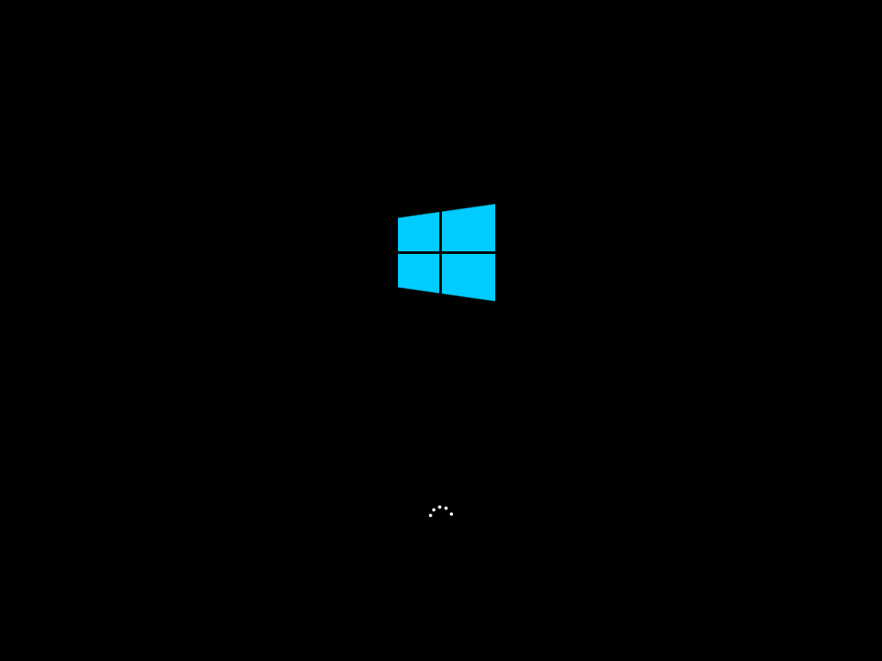

Fig.1 - It is processing to start loading the Windows.

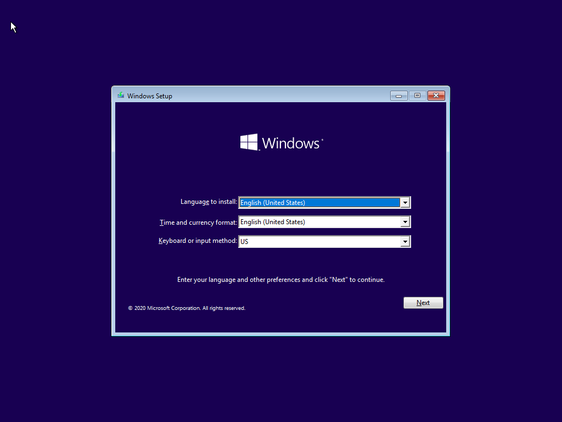

Fig.2 - The first step for installing Windows, we have to choose the language of the interface; Time and currency format, and keyboard layout. I set the language, time currency format, and keyboard method to English (United States). After choosing I click the next button to continue the process.

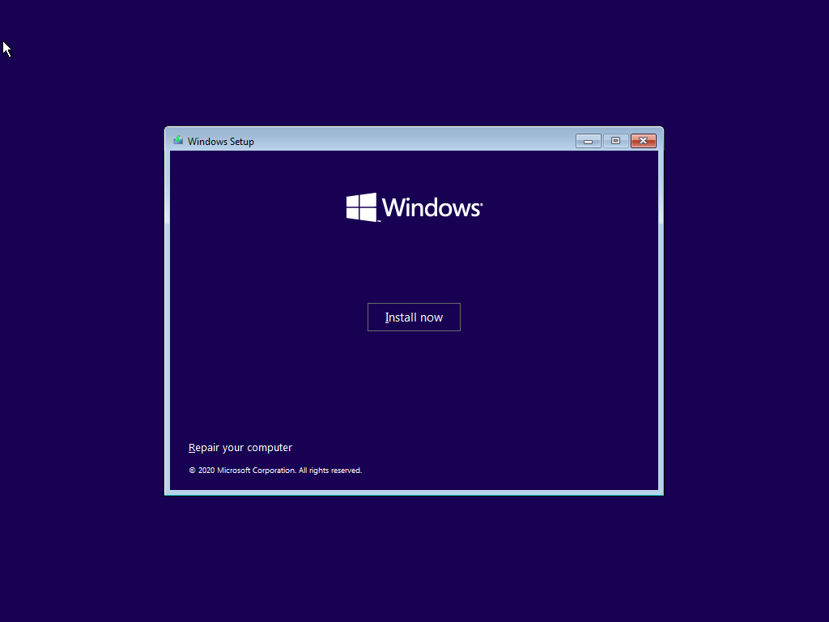

Fig.3 - When it said to install Windows, I clicked the “Install now” button to install Windows. Click “repair your computer” to solve some problems with your computer.

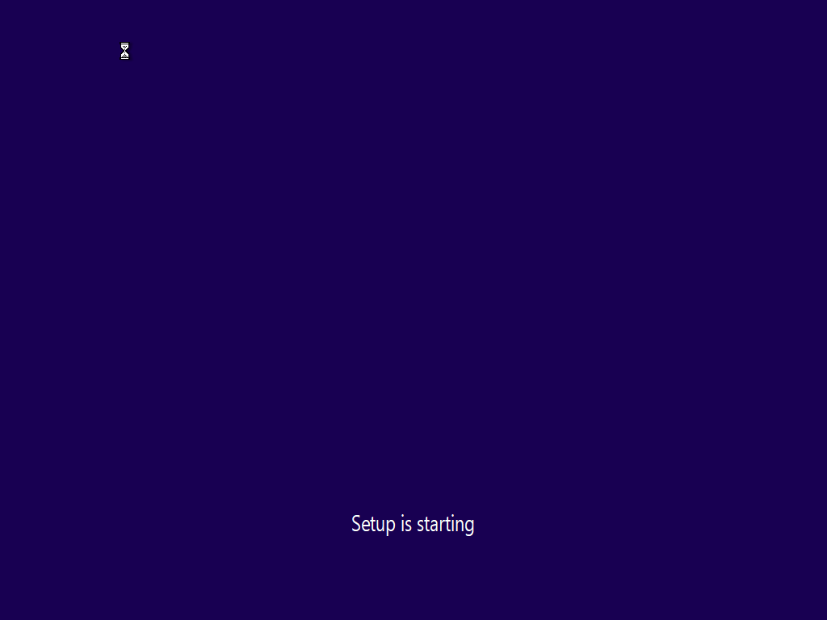

Fig.4 – After clicking the “Install now” button, the text “Setup is starting” will appear on the screen and I had to wait a while for the setup to finish.

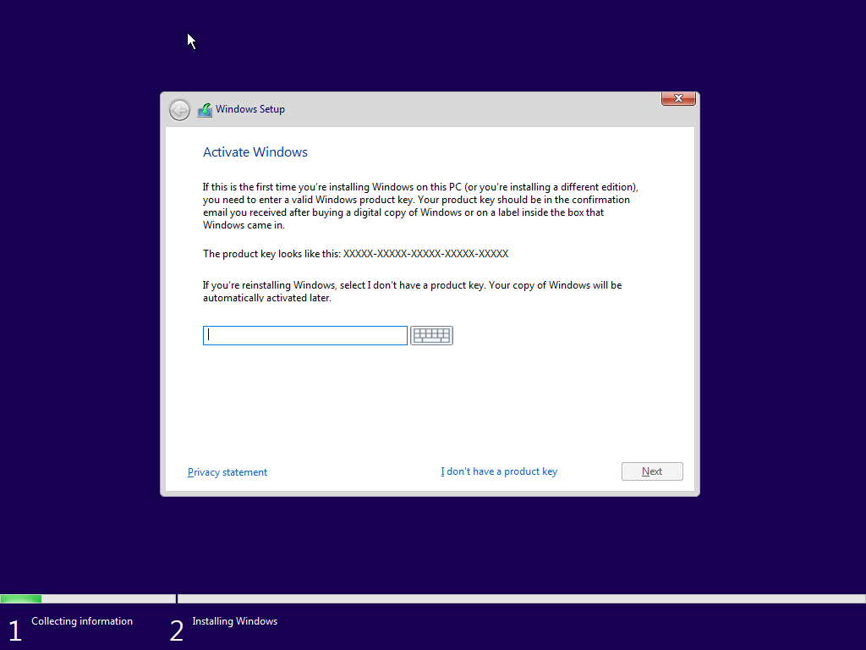

Fig.5 – The next step is to enter a Windows product key. If you don’t have a Windows product key, you can select “I don’t have a product key” shown below, and click the next button to continue. So, I entered the Windows product key and clicked next.

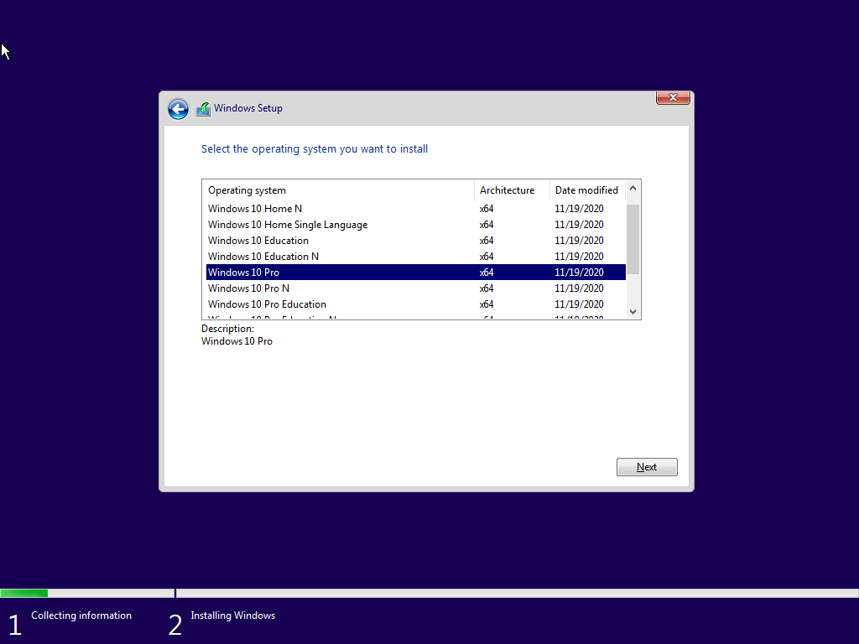

Fig.6 – If you have reached this stage, you have to select which edition you want to install and click the next button.

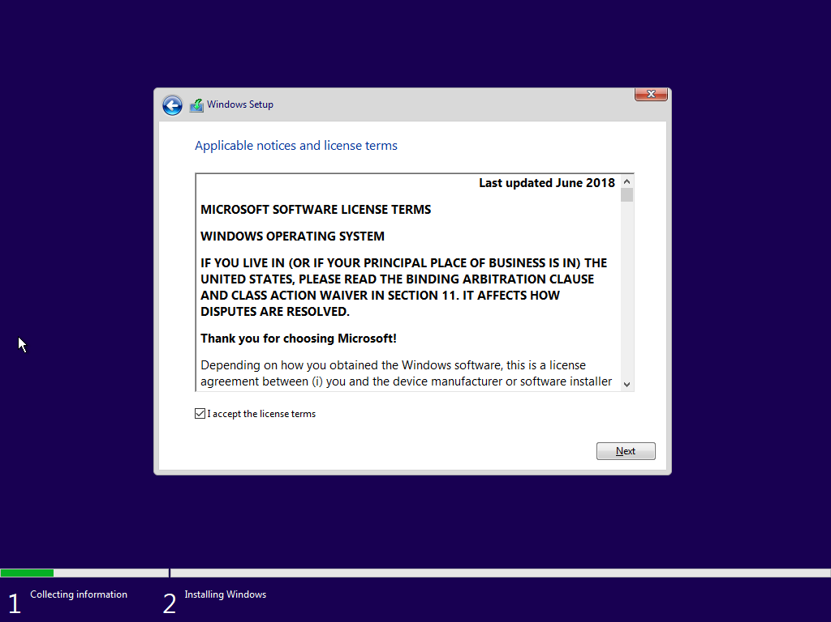

Fig.7 – You must agree to the license terms to proceed. If you have not agreed, you can’t click the next button to continue the process.

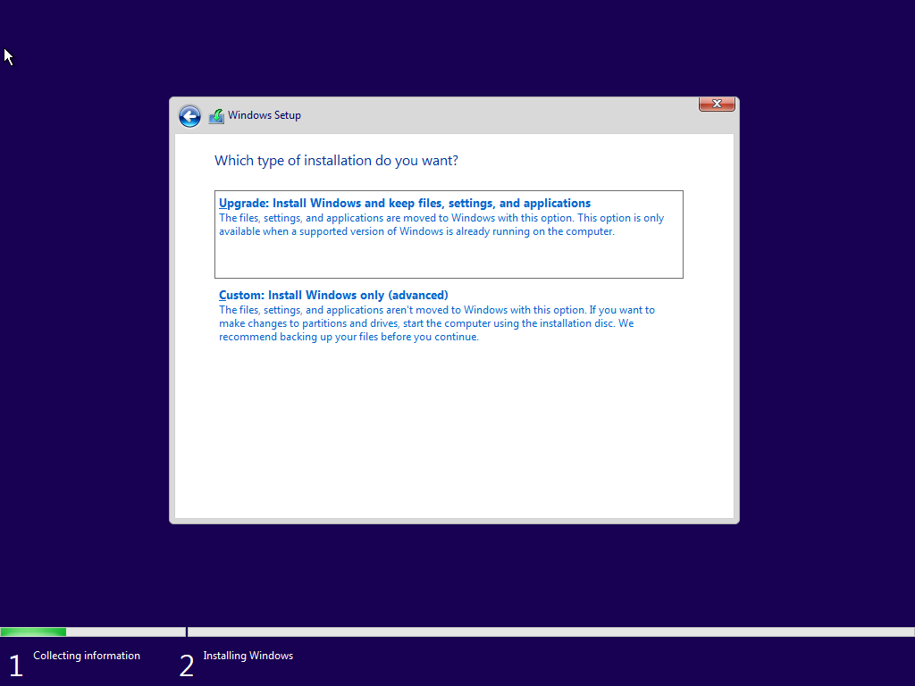

Fig.8 – This is where you have to choose the type of installation you want to install. I am only going to install Windows, so I chose Custom but if you want to upgrade the version of the existing Windows, you should choose Upgrade.

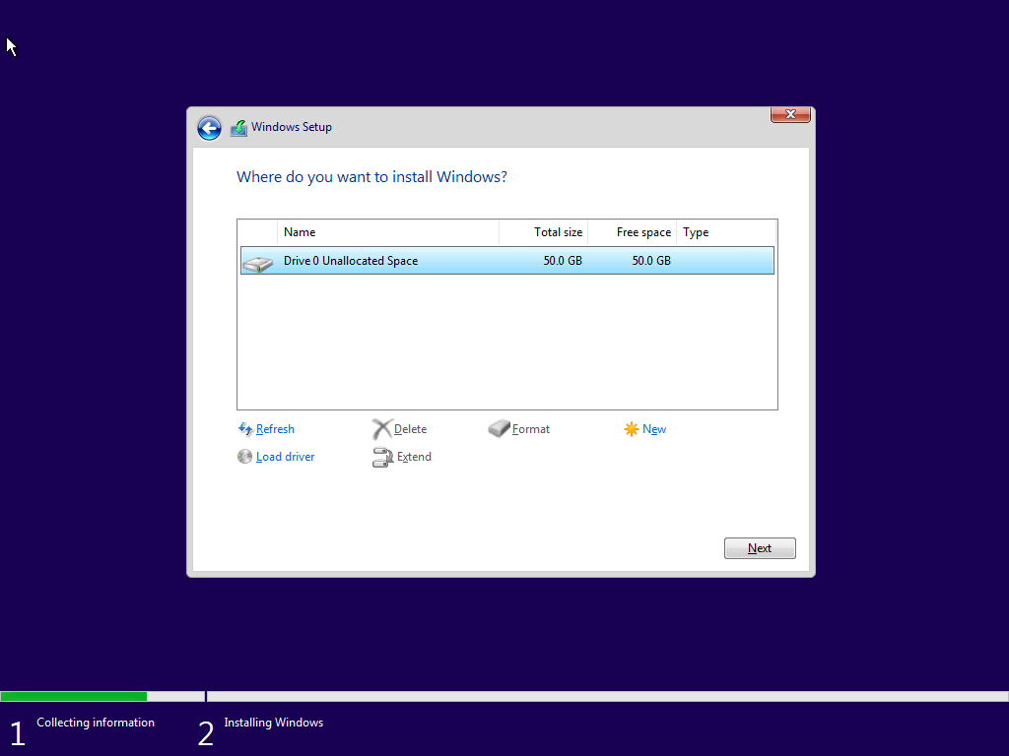

Fig.9 – Now it is time to tell the installer which disk to copy the Windows files to. In this step, you can partition the existing disk into smaller virtual disks. If you only have an unformatted disk, select it and click “Next”. The installer will create all necessary partitions

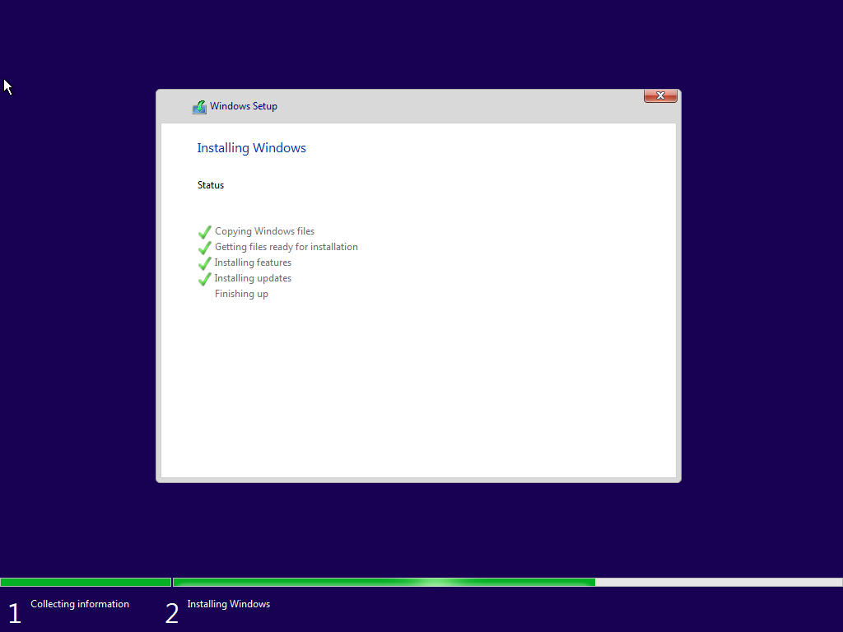

Fig.10 – Setup will now begin copying files from the installed disk to their destination. If all five stages are checked, the process is complete.

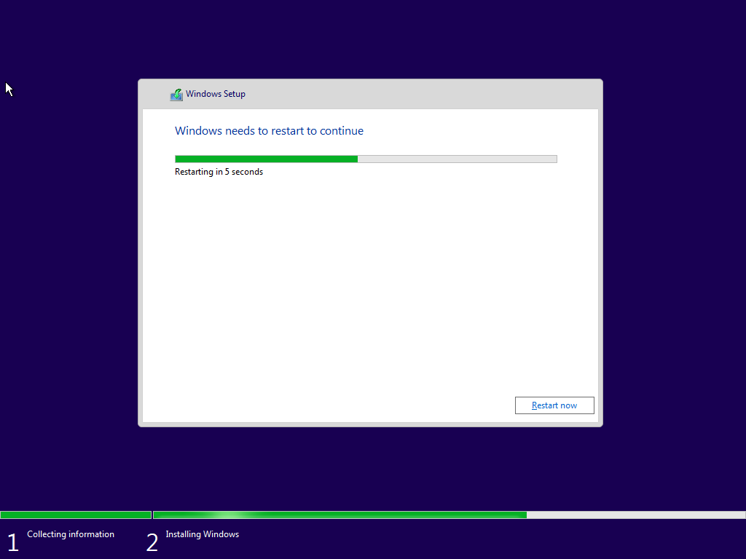

Fig.11 – After finishing all five stages, it will restart to go on. If you don’t want to wait for the restart, you can click the “Restart now” button.

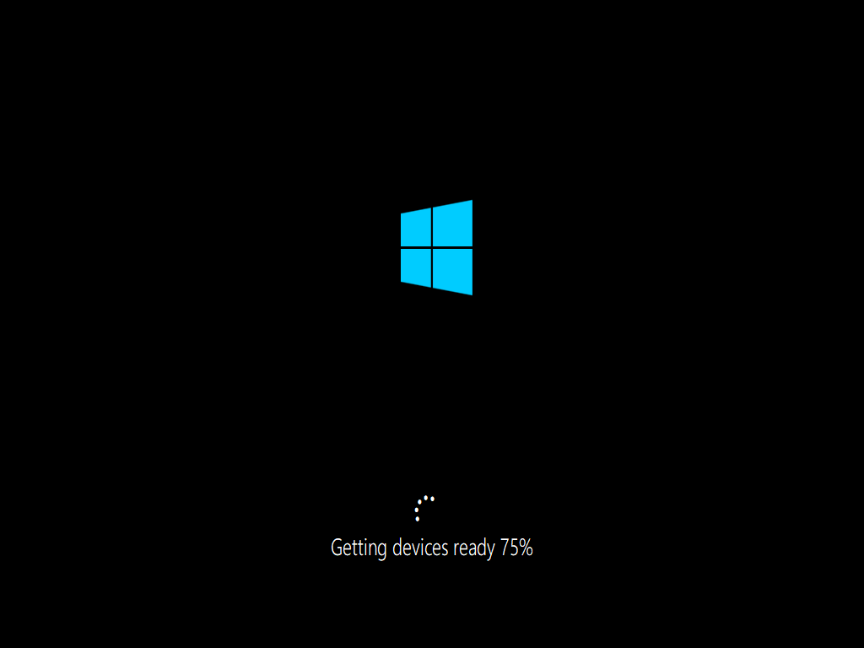

Fig.12 – This stage is restarting the computer and you have to wait until it is 100% to restart.



Fig.13 – Then “Just a moment” appears on the screen, and you have to wait for a while.

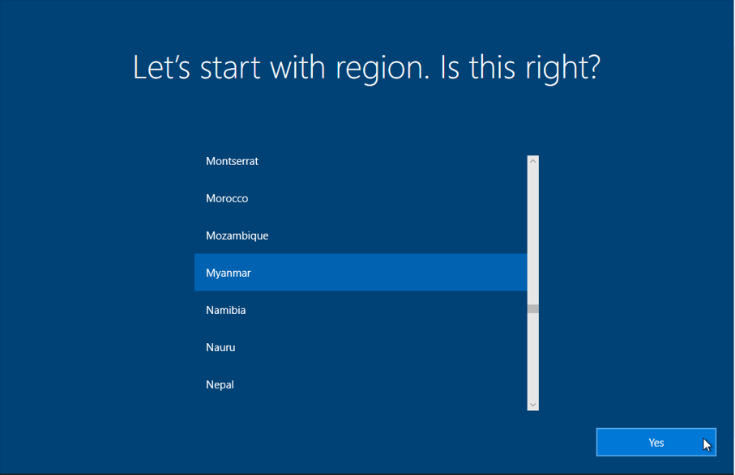

Fig.14 – “Let’s start with region. Is this right?” will appear on the screen. You have to select the region you like and click the next button.

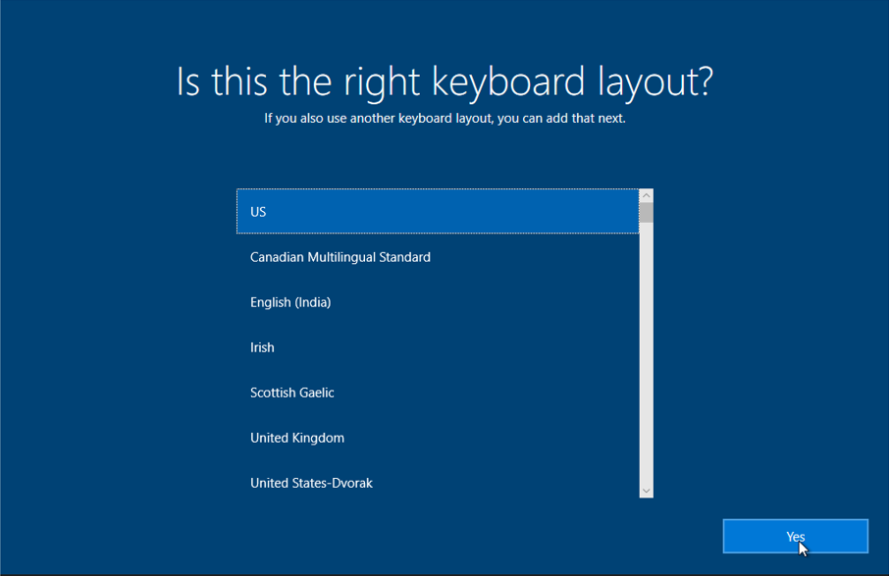

Fig.15 – Then you can find and select the keyboard layout you like. Now, the US is selected.

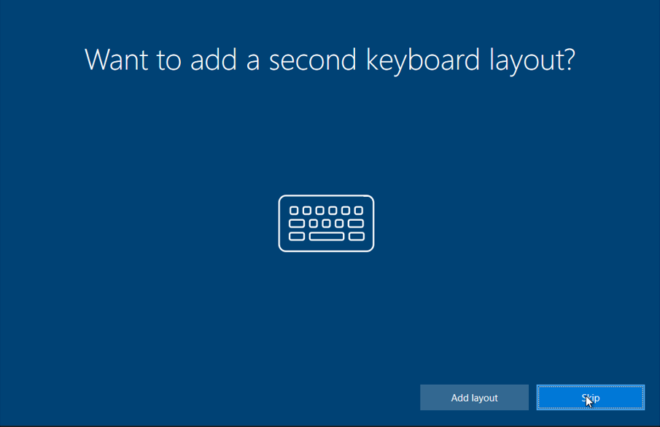

Fig.16 – If you want to add a keyboard layout, you can add it by clicking on add layout but if you don’t want to click the skip button to continue.

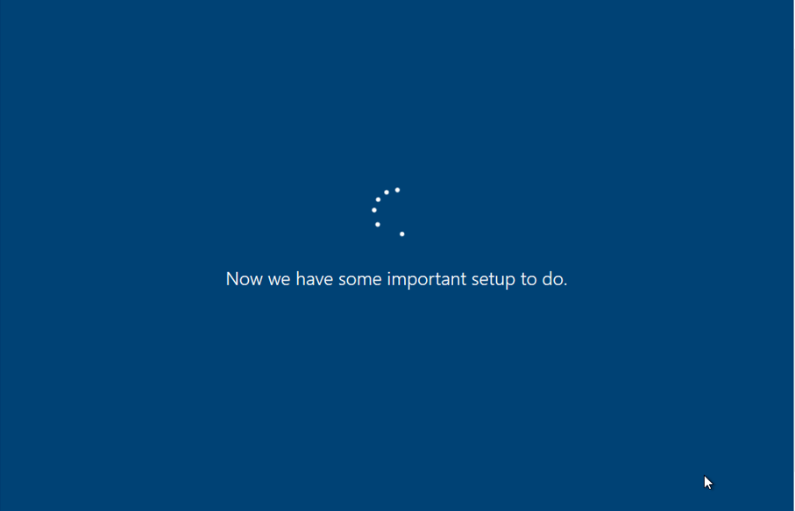

Fig.17 – After that, you have to wait for a while for the process.



Fig.18 – And the Windows will restart again.

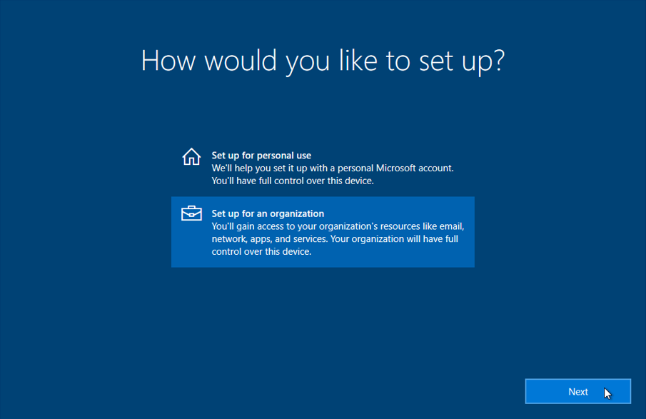

Fig.19 – At this stage, you have to choose the type you want to set up. For example, you have to choose whether to use it personally or for the organization.

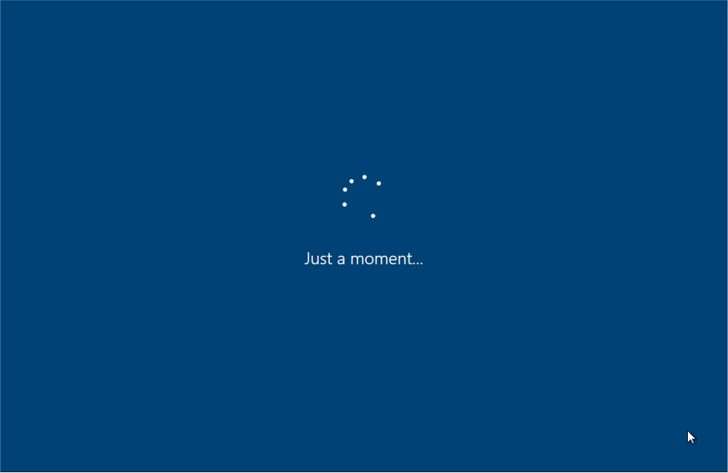

Fig.20 – Then it shows “Just a moment” and you have to wait a little longer again.

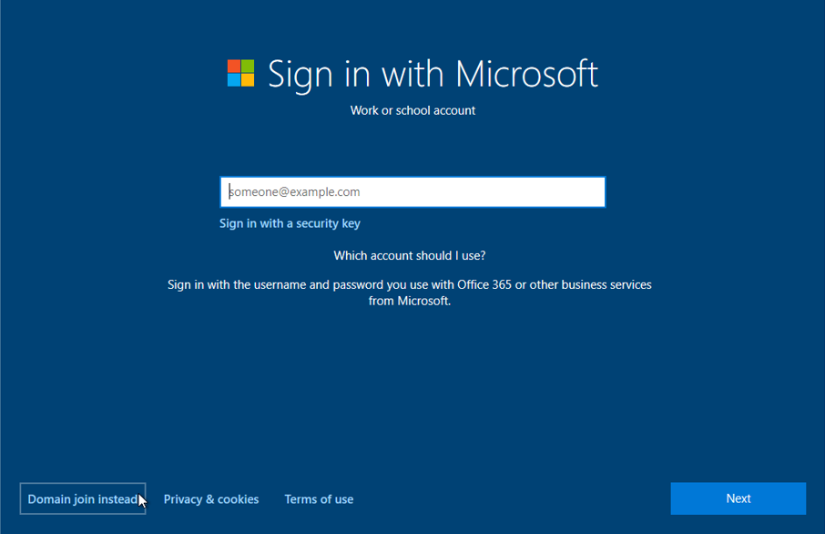

Fig.21 – You can enter your email to open a new account and then click the next button.

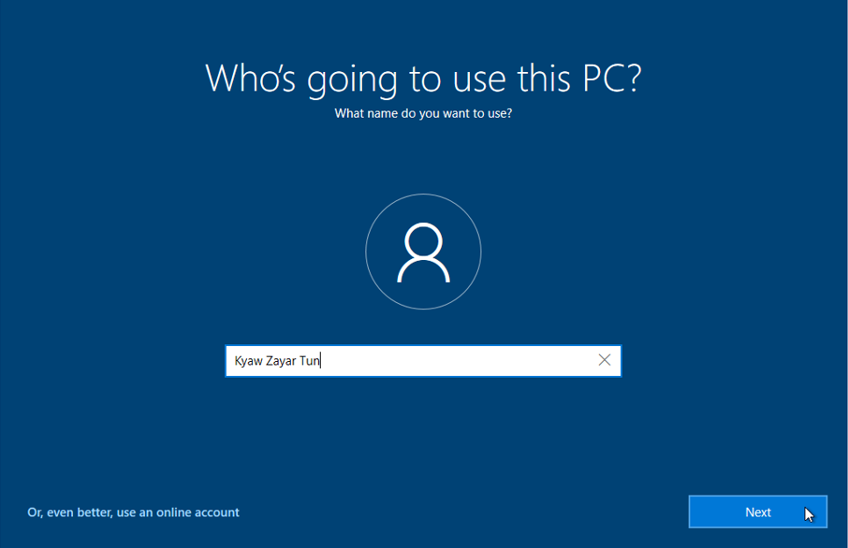

Fig.22 – “Who’s going to use this PC” will appear on the screen you need to enter your username as you like and then click “Next”.

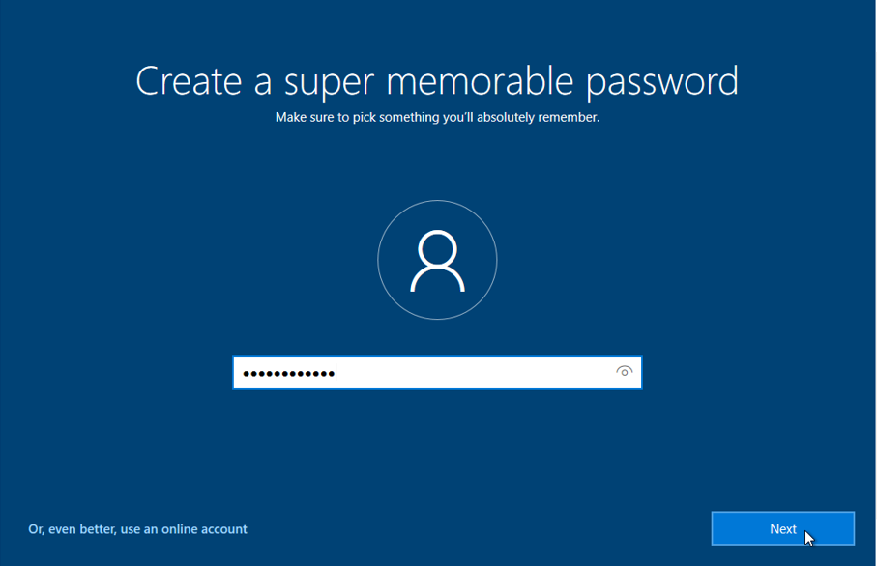

Fig.23 – After entering the username and password, enter the password for that username and click next.

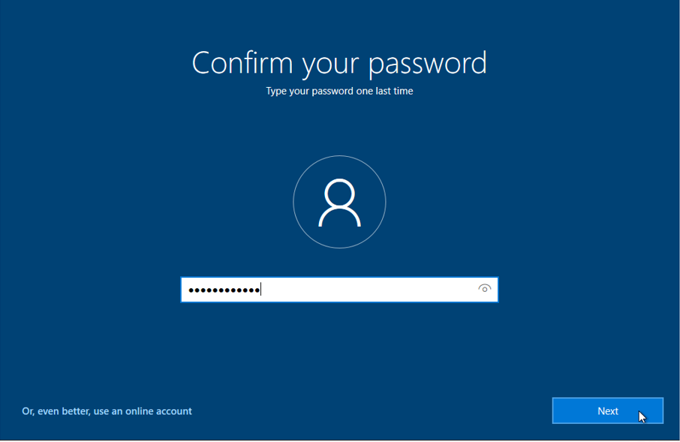

Fig.23 – At this stage, you will be asked to confirm the username’s password above. After confirming, press next.

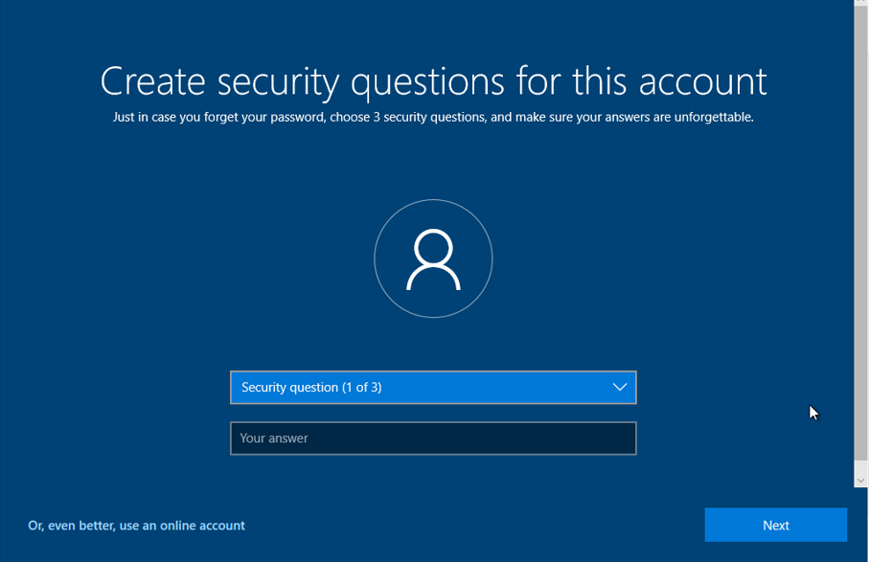

Fig.24 – After entering the username and password above, if you forget your account password, you must choose and answer (3) security questions that will help you to recover your account.

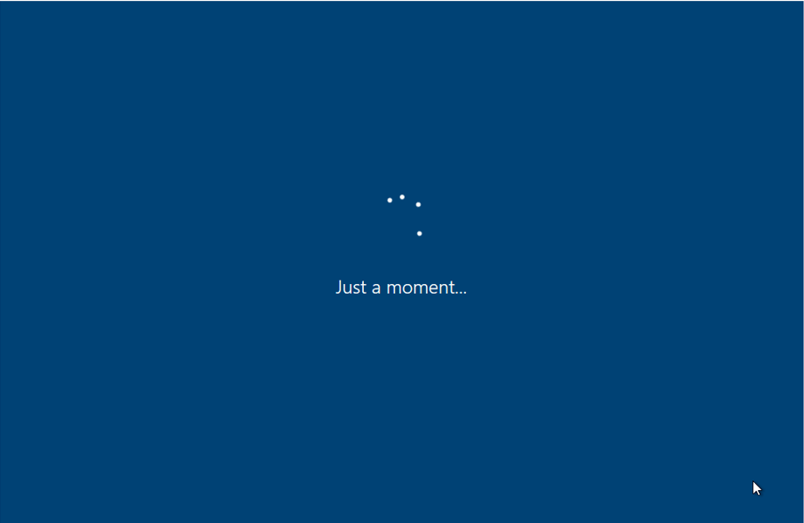

Fig.25 – You have to wait a while to finish “Just a moment”.

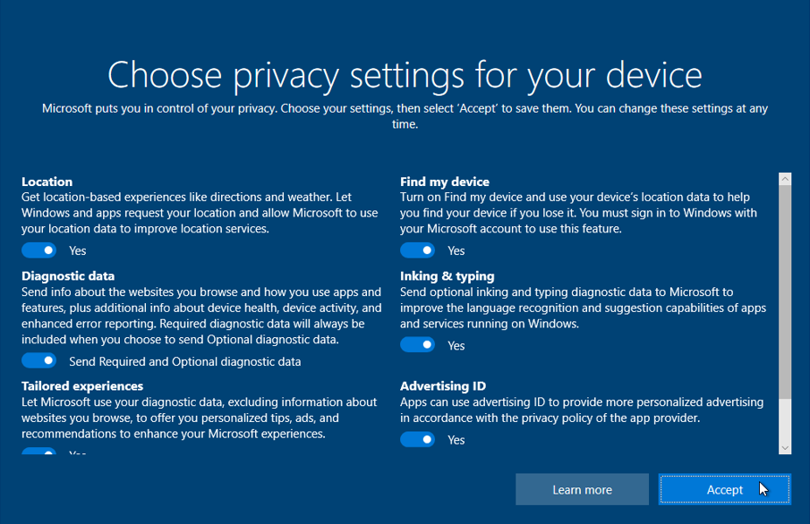

Fig.26 – After answering the security questions, Windows tells you to choose a privacy setting for your device. You can choose what you want to choose by clicking “Yes”. I clicked “Yes” for all settings and accept button to continue.

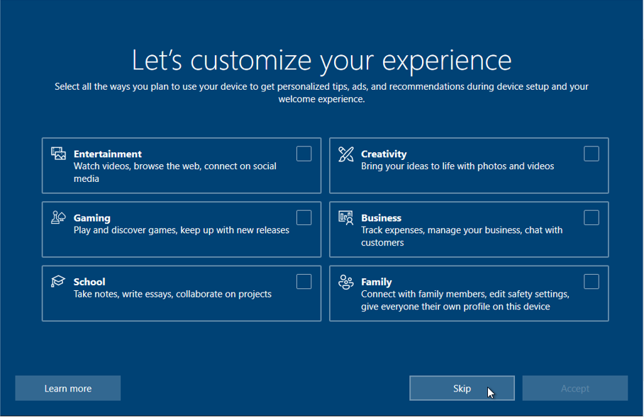

Fig.27 – At this stage, you can customize your experience by choosing and clicking the boxes you want to and clicking the “Accept” button. But I clicked the “Skip” button to continue the process.

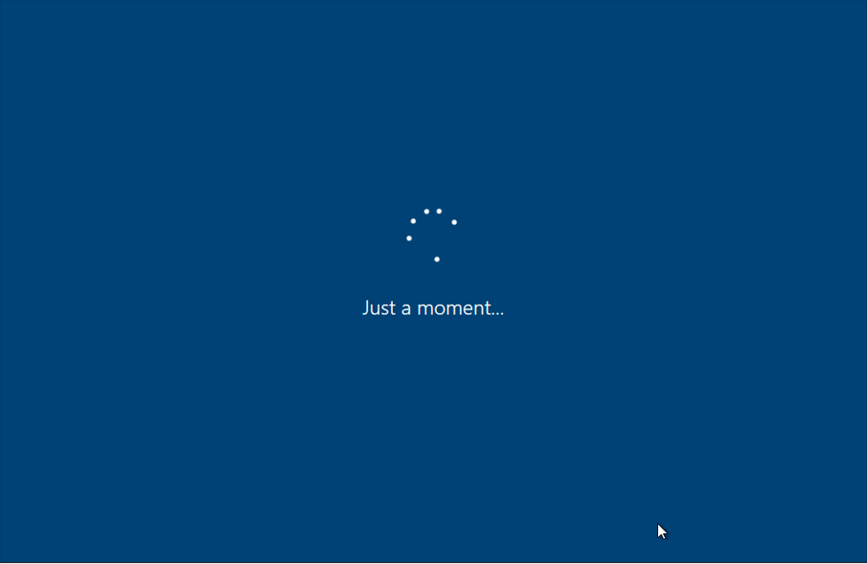

Fig.28 – You have to wait a few minutes to process.

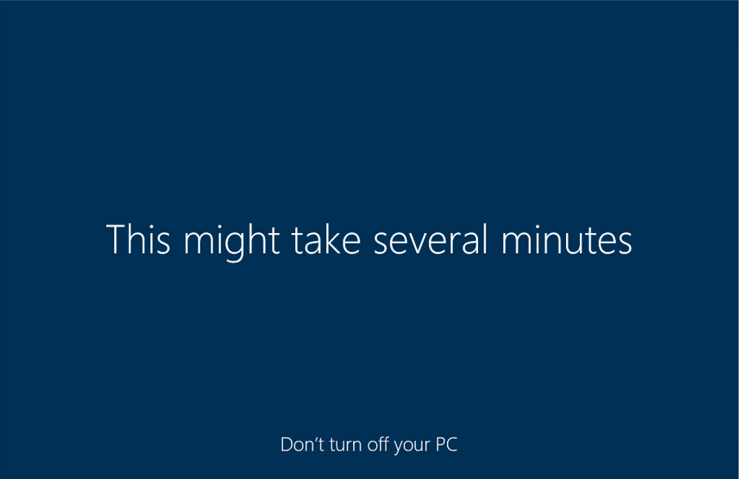

Fig.29 – You have to wait for a while for Windows to start up and the important thing is that do not turn off your PC at that time.

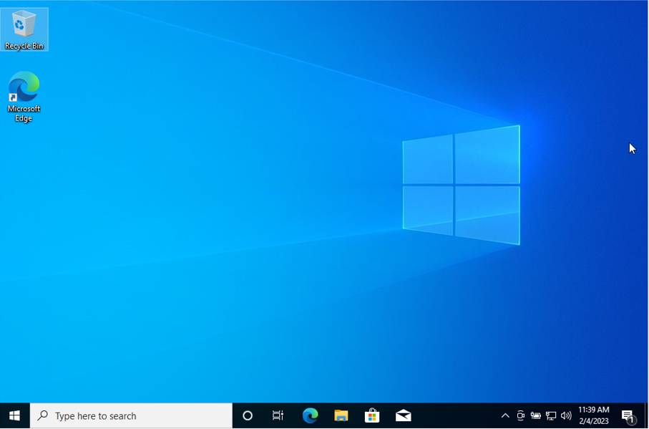

Fig.30 – Finally, after a few minutes of going through the different screens, you will see the Windows 10 desktop and it is all complete.

## 2. Identification and description of required device drivers and their source locations.

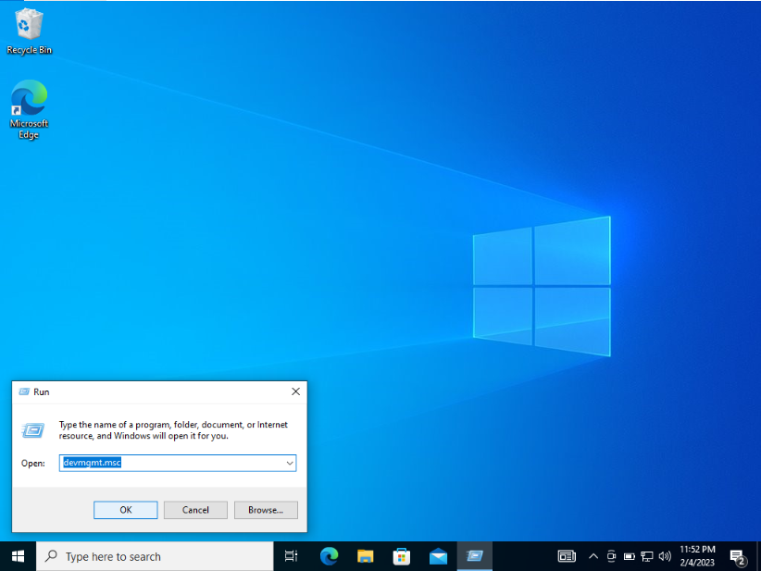

Fig.1 – To install the necessary device drivers. Firstly, I pressed the Windows key and R on the keyboard to bring up the “Run” box, a program that can open settings and documents. Then I typed “devmgmt.msc” in the “Run” box and click “OK” to open the device manager.

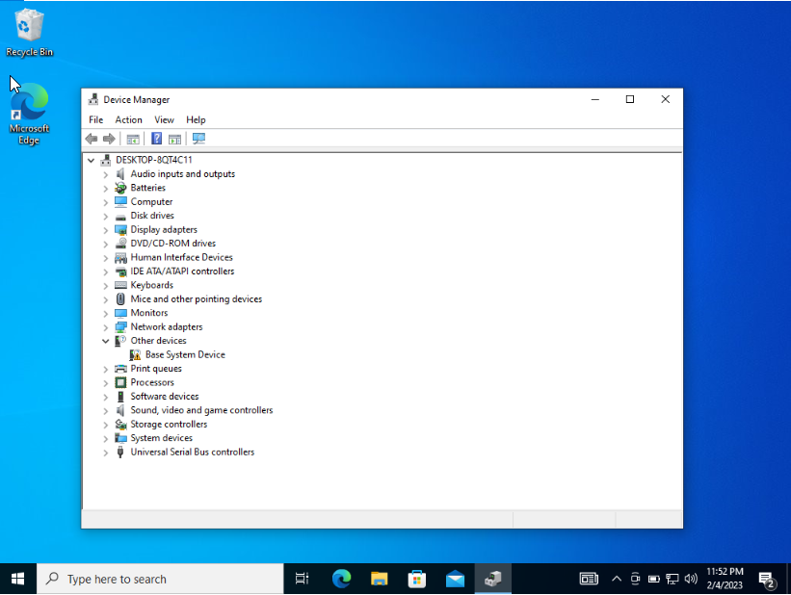

Fig.2 – In a device manager, you can see the “Basic System Device” error in my laptop as shown above.

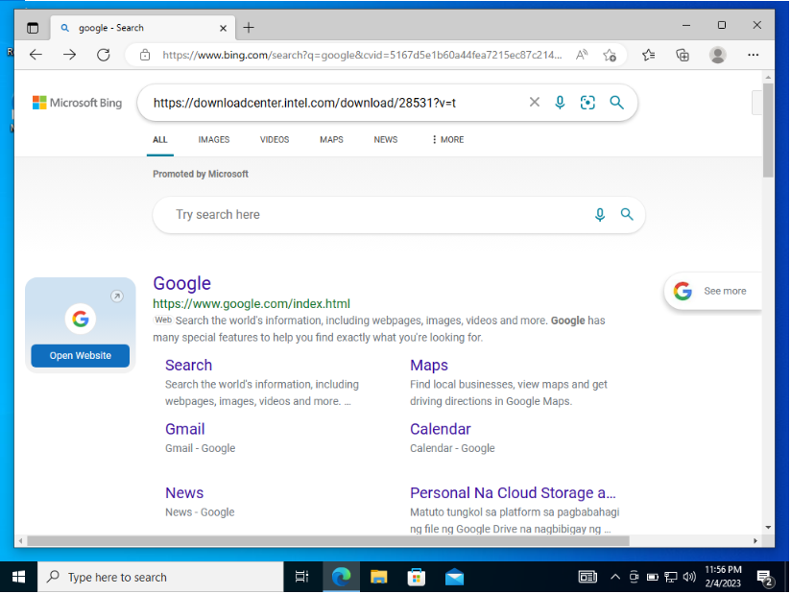

Fig.3 – So, to solve the “Base System Device” error, I first went to Google and copy paste a link to solve the error.

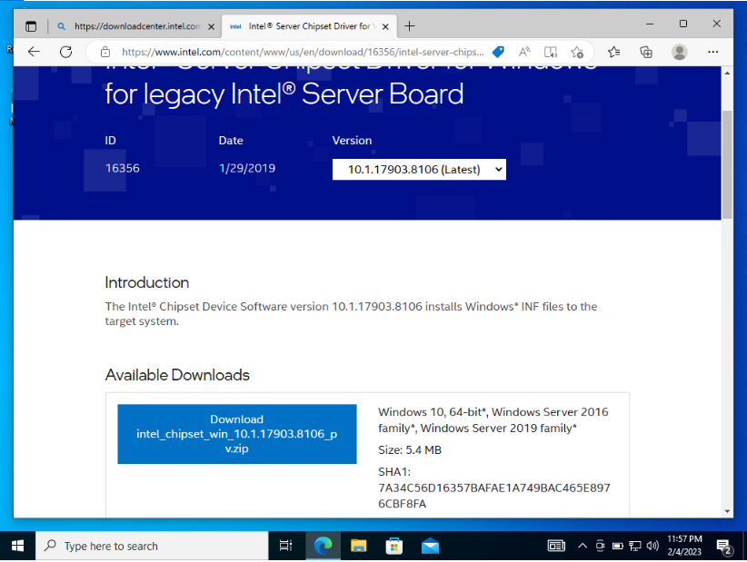

Fig.4 – After entering the website and I clicked on the Intel chipset download page and download that intel chipset.

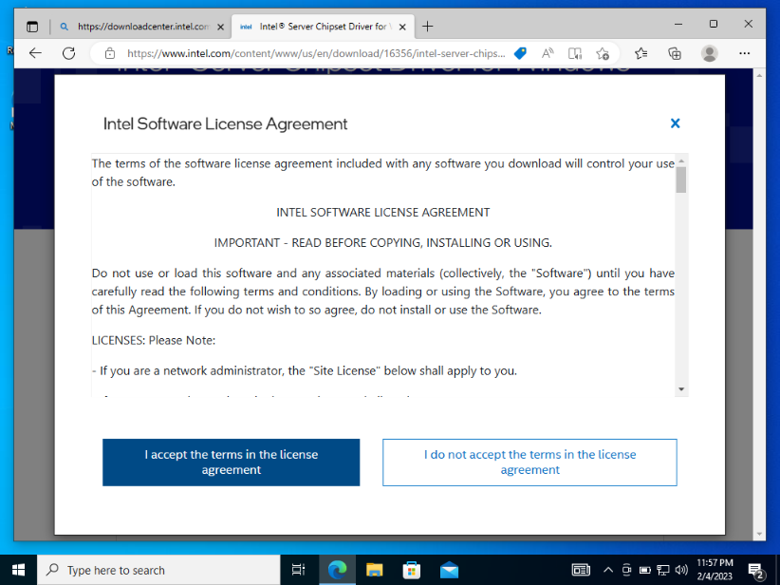

Fig.5 – Then, the “Intel Software License Agreement” will come down and you will be asked to agree to the terms of the software license so I accepted to continue.

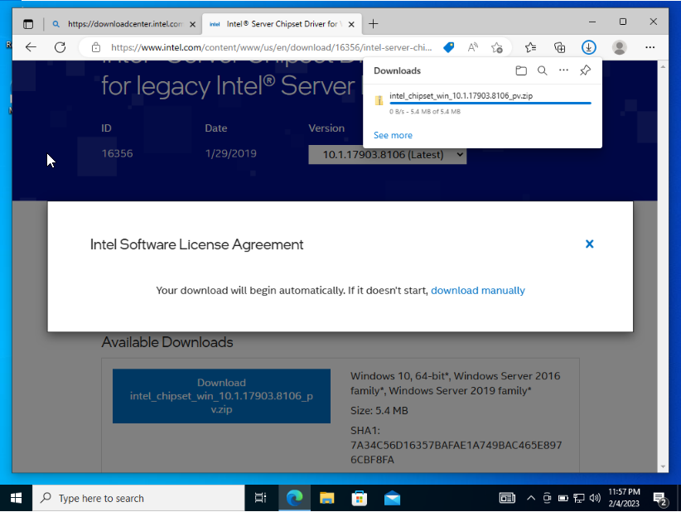

Fig.6 – After you agree “Intel Software License Agreement” it starts to download and you need to wait for a while to complete the download.

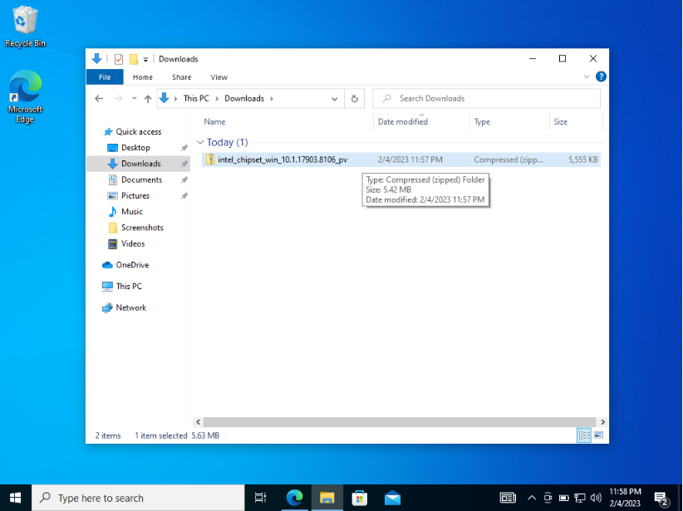

Fig.7 – After the download is finished, the intel chipset has arrived in the download file folder, and then you have to extract all of the zip files.

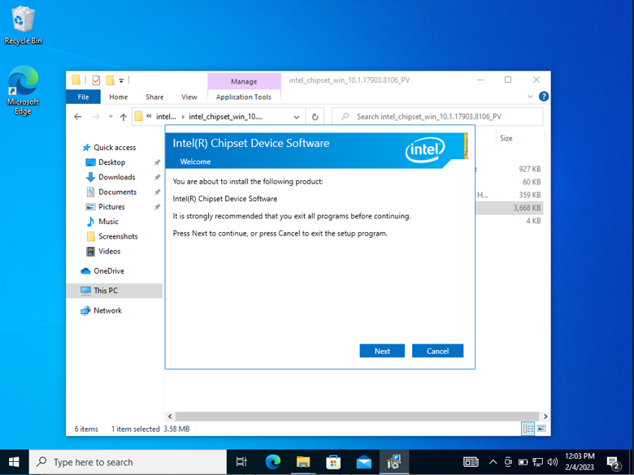

Fig.8 – Now, the installation file will appear on your screen, and click the “Next” button to continue.

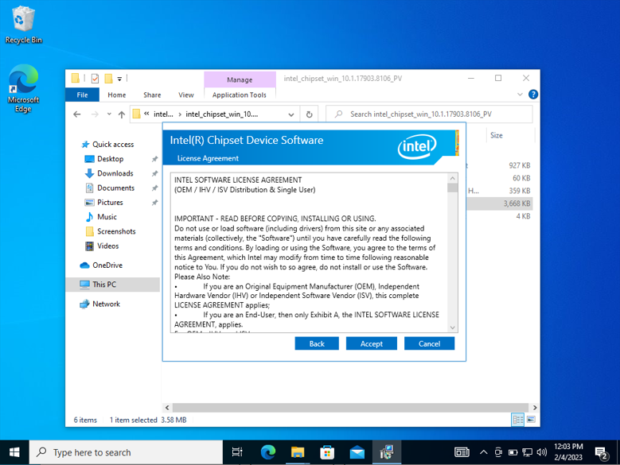

Fig.9 – I was asked to accept the license agreement again from intel in order to do the installation and I accept all “License Agreements” of Intel(R) Chipset Device Software

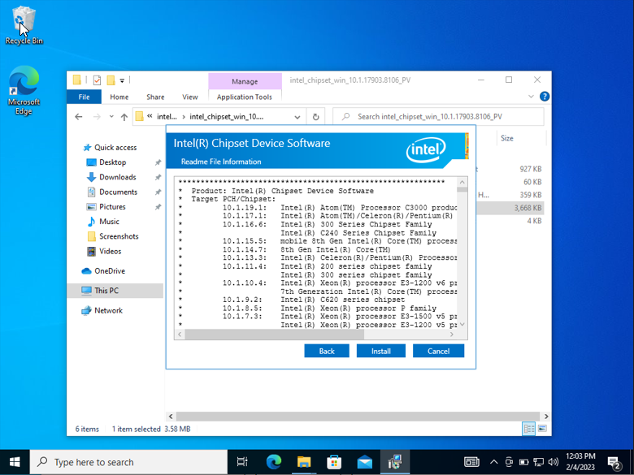

Fig.10 – After that, I clicked the “Install” button to install the installation.

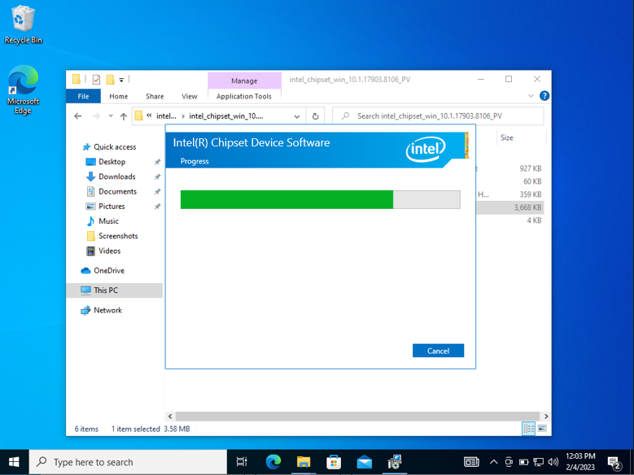

Fig.11 – And, you have to wait for the installation to complete.

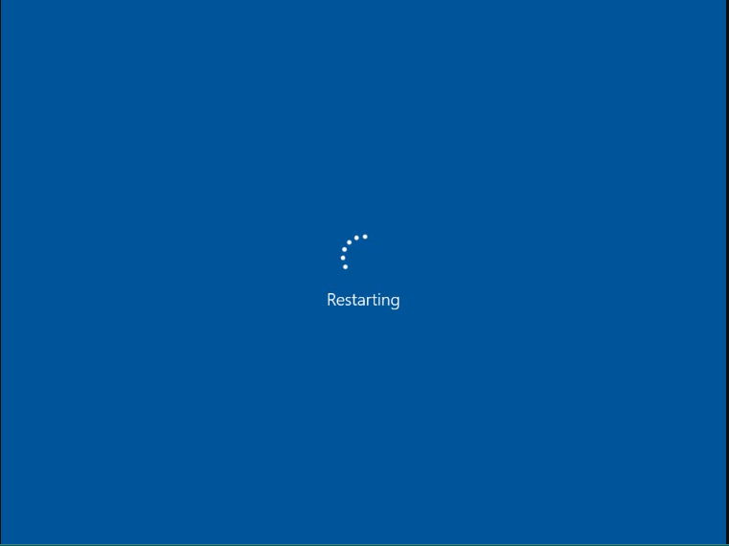

Fig.12 – After finishing the installation process you need to restart your PC.

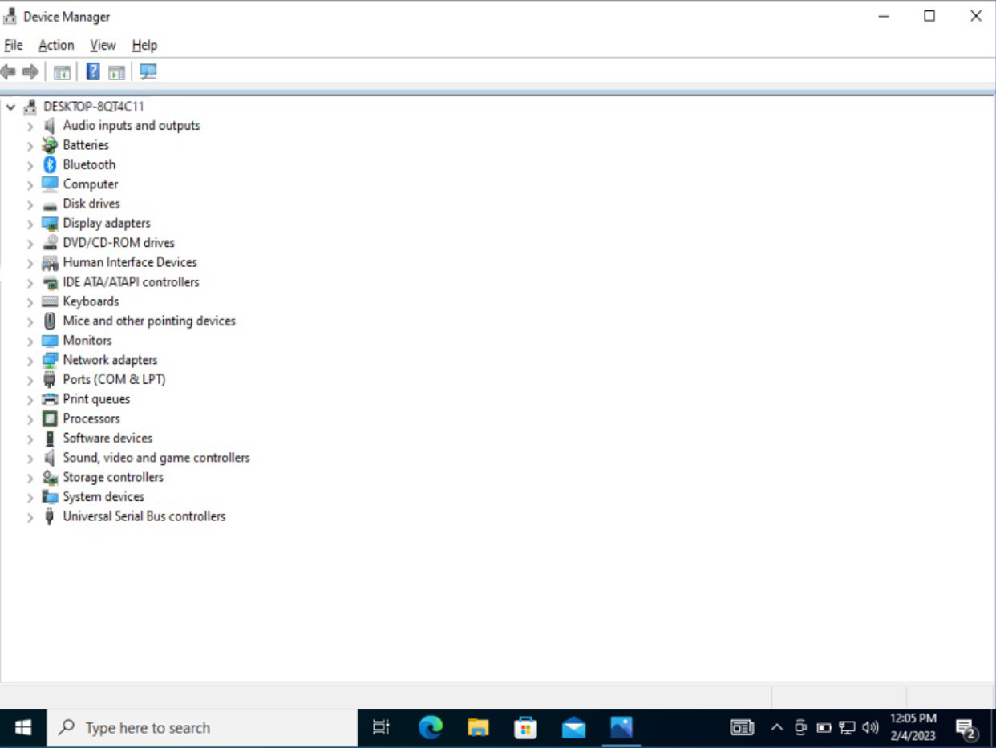

Fig.13 – After restarting your computer, the current “Basic System Device” error will be resolved.

## 3. Identification and description of unresolved issues – especially missing device drivers.

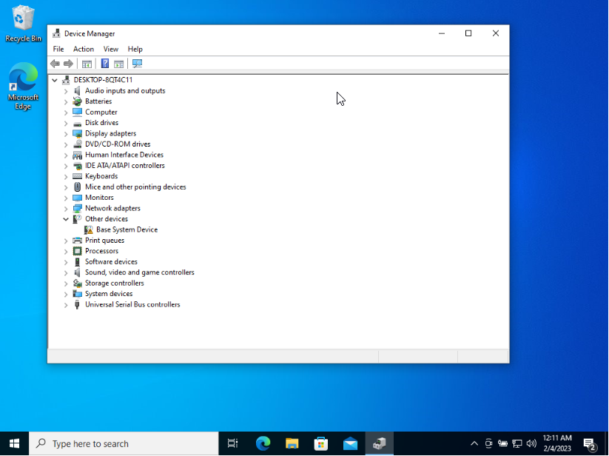

Fig.1 – I have one missing driver on my PC which is the “Base System Device” shown with the exclamation mark

# b) Installation of antivirus software

## 1. Identification of product used.



Fig.1 – To install Antivirus software, although there are many Antiviruses software, I choose Avast Antivirus software. This Antivirus software I used is “Avast” it was founded in April 1988, in Prague, Czechia.

## 2. Identification and description of key stages in installation.

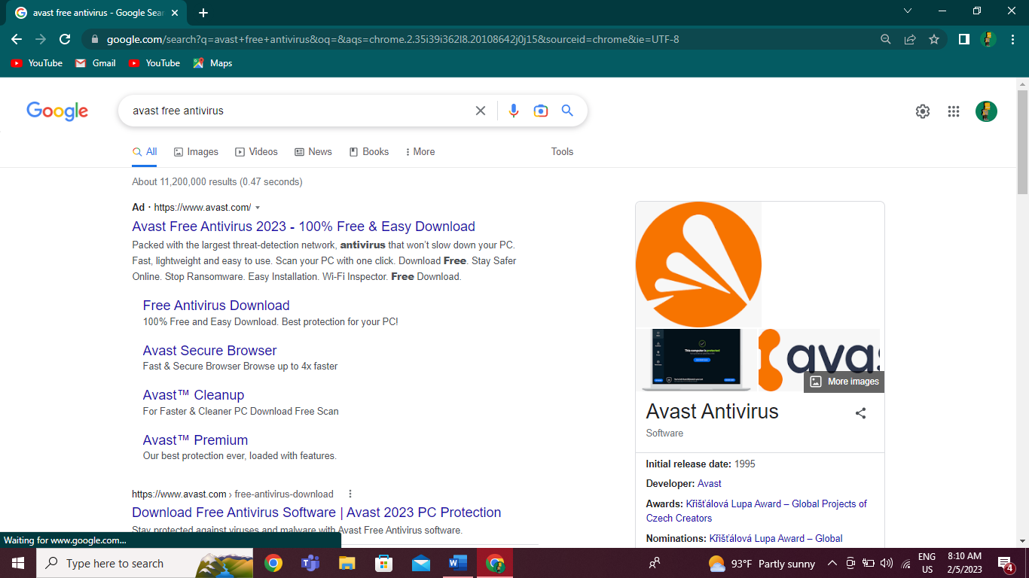

Fig.1 – First to install the Avast Antivirus Software, I entered google and typed “Avast free antivirus” and entered one of the websites below.

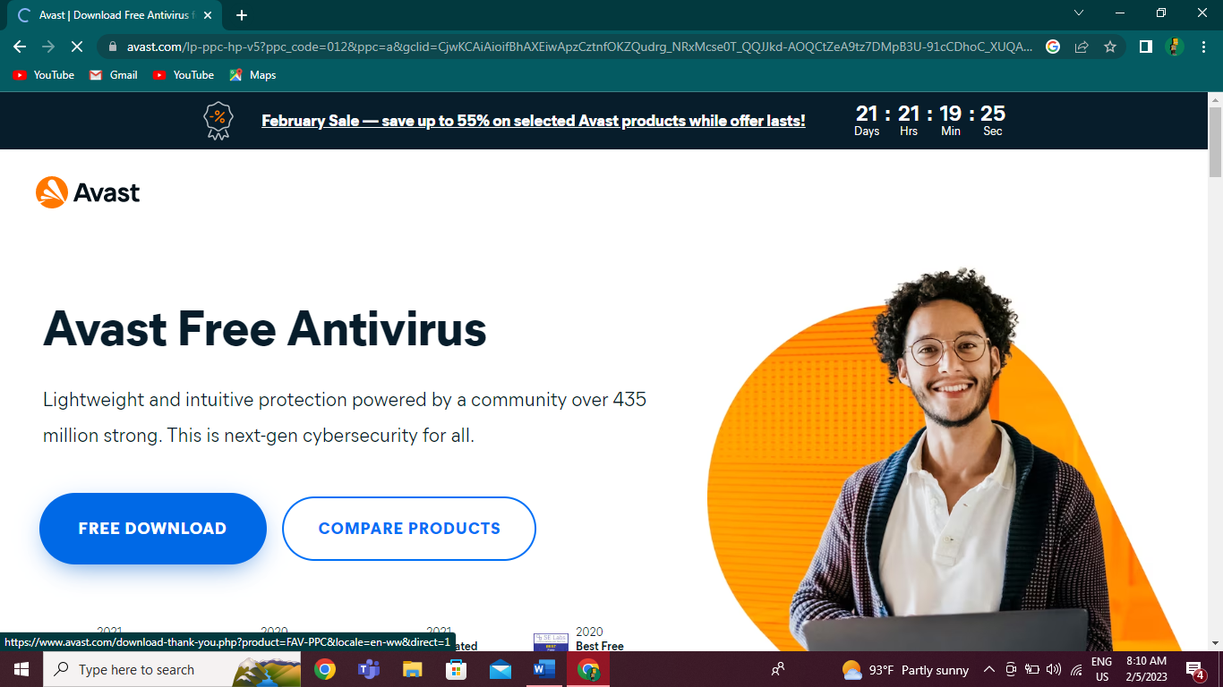

Fig.2 – After entering the “Avast Free Antivirus” website there is the “Free Download” button so I clicked it and started to download.

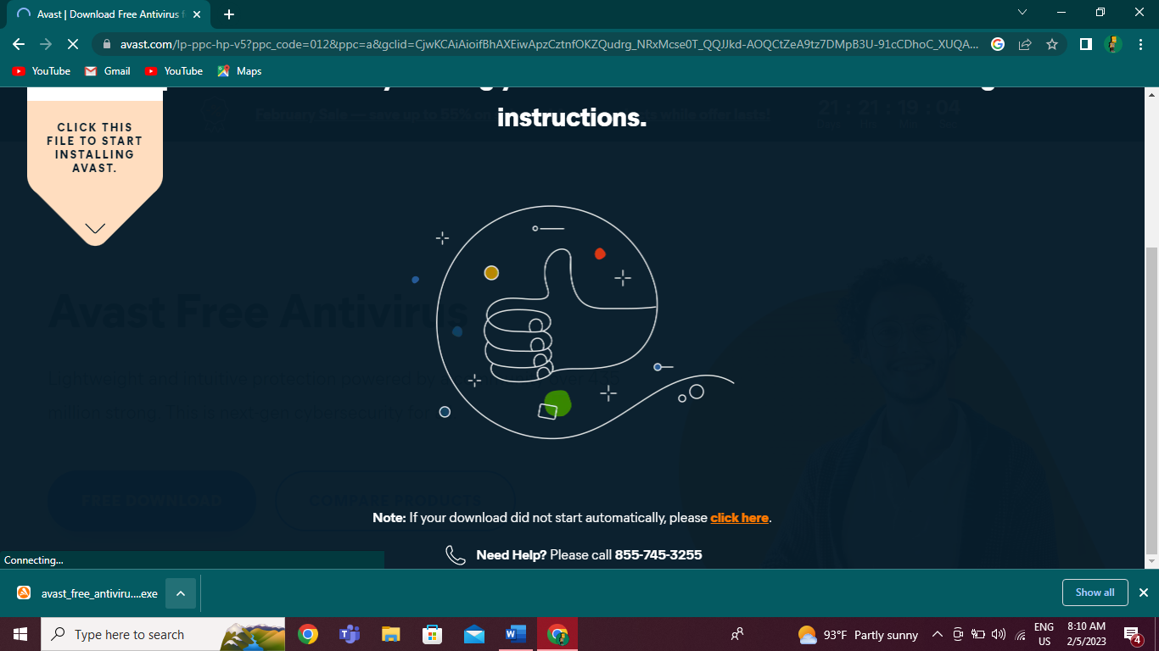

Fig.3 – After clicking the download button, it starts to download in just a minute.

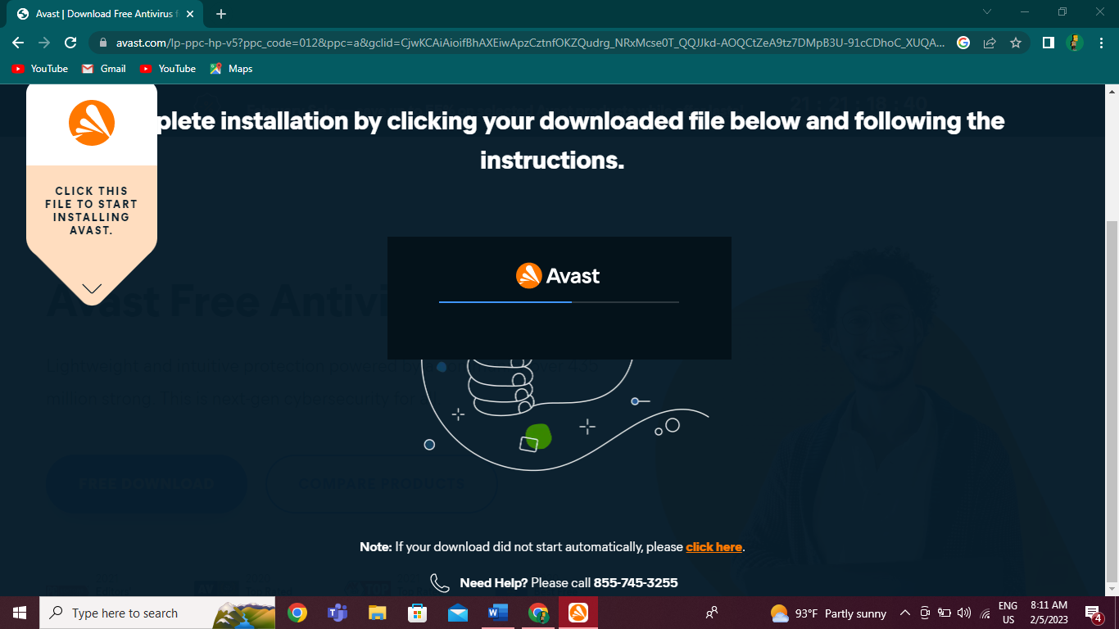

Fig.4 – The installation of Avast Antivirus Software is starting to processing.

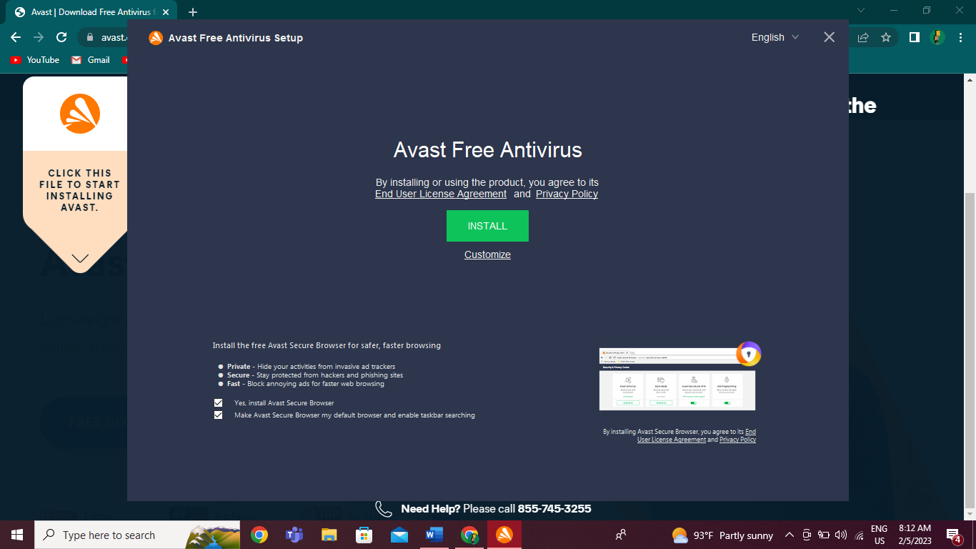

Fig.5 - Then click Install to continue with the default installation. Or click Customize if you need to make changes to the default settings.

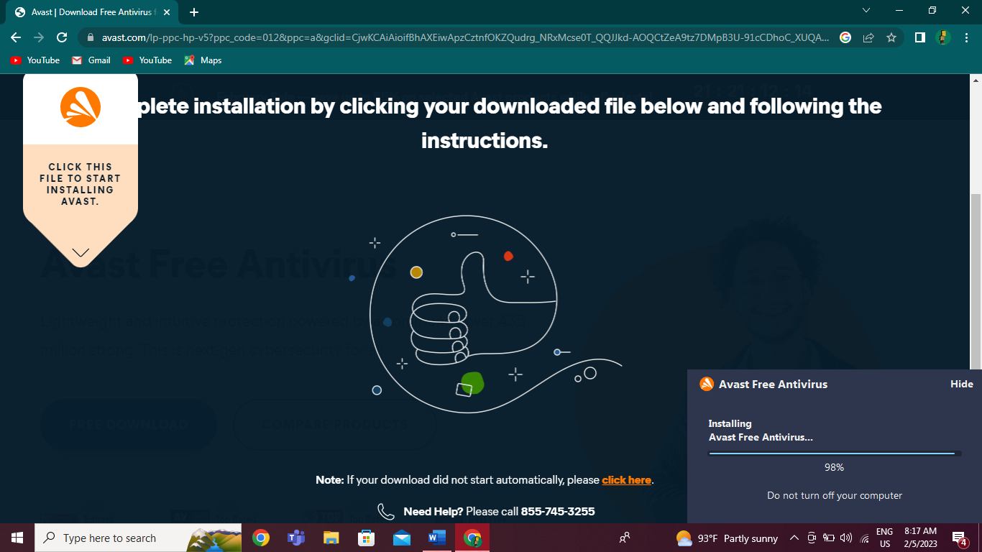

Fig.6 – After clicking the install button, you have to wait a moment for Avast Free Antivirus to complete the installation process until it reaches 100%.

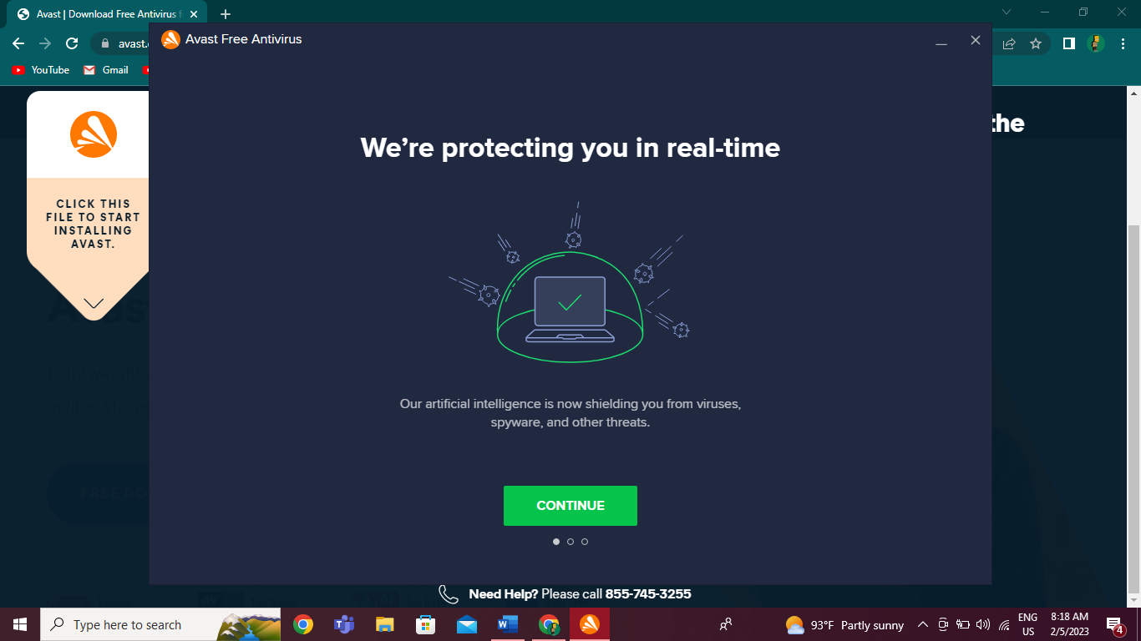

Fig.7 - When the installation is complete clicked the “Continue” button.

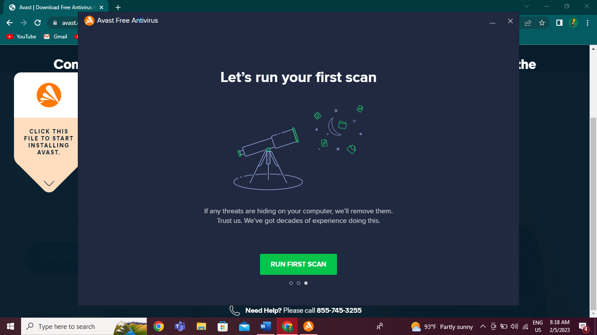

Fig.8 - Click Run the first scan to start a comprehensive Smart Scan, which detects viruses, malware, bad browser add-ons, and other issues on your PC.

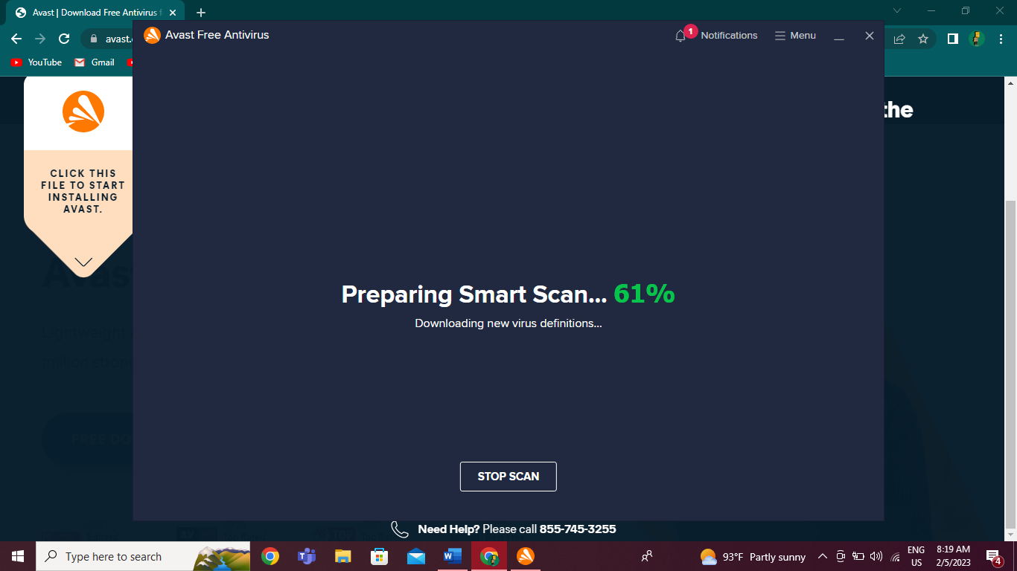

Fig.9 – And it starts to prepare Smart Scan and you should wait for a few minutes.

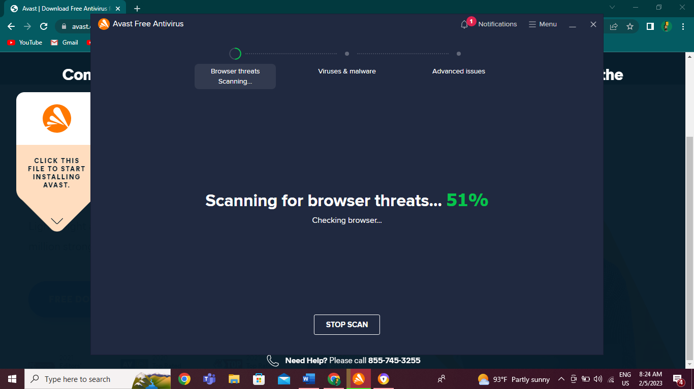

Fig.10 – It will start scanning for browser threats.

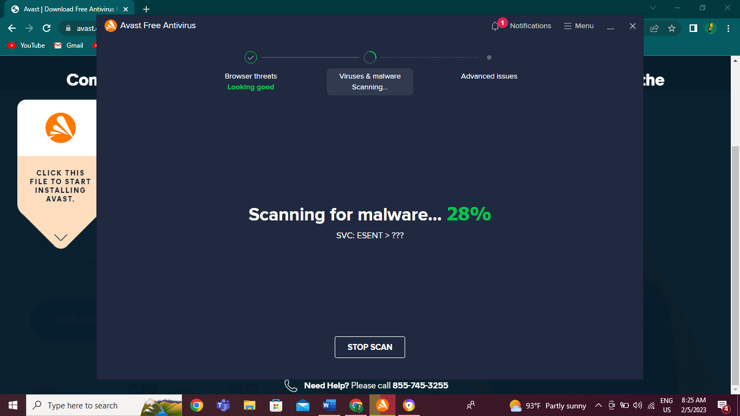

Fig.11 – After that, it will scan for malware.

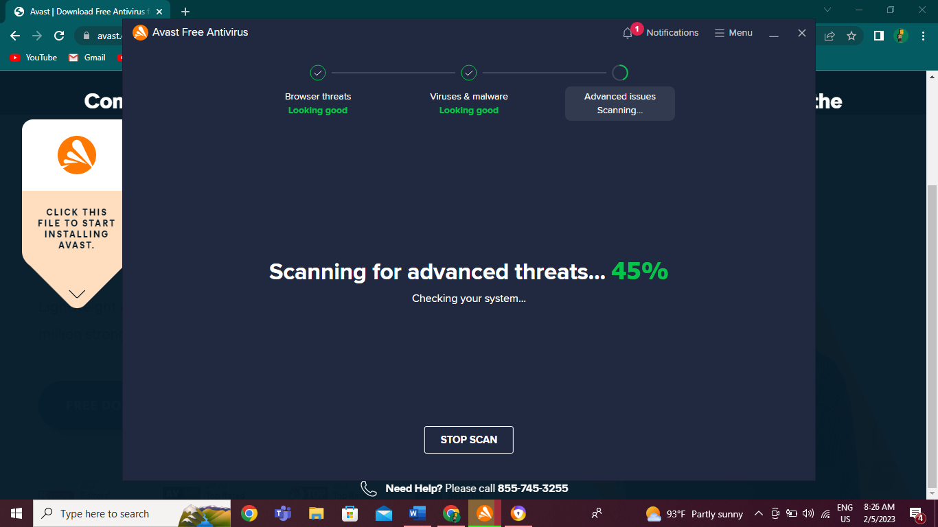

Fig.12 – As the last step, scanning for advanced threats is done when it reaches 100%.

## 3. Identification and description of problems and unresolved issues.

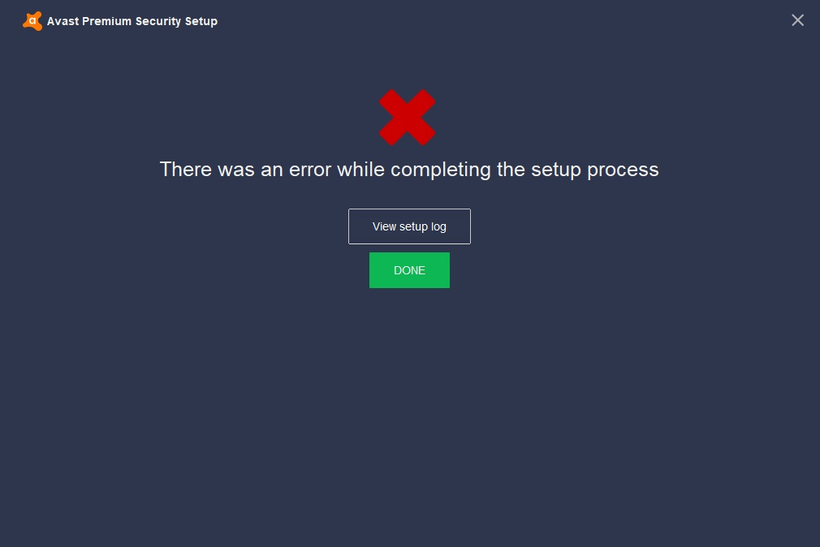

Fig.1 – There is one error that occurred while completing the installation process.

## 4. Outline of the update process for the antivirus software.

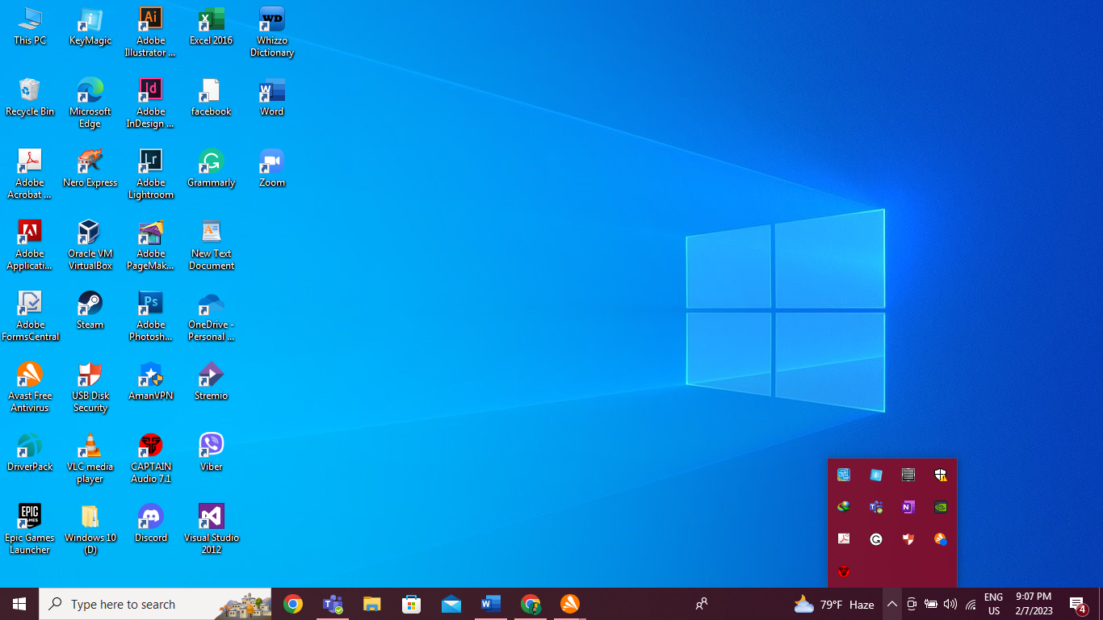

Fig.1 – To update “Avast Free Antivirus” software, first I clicked “show hidden icons” on the Taskbar.

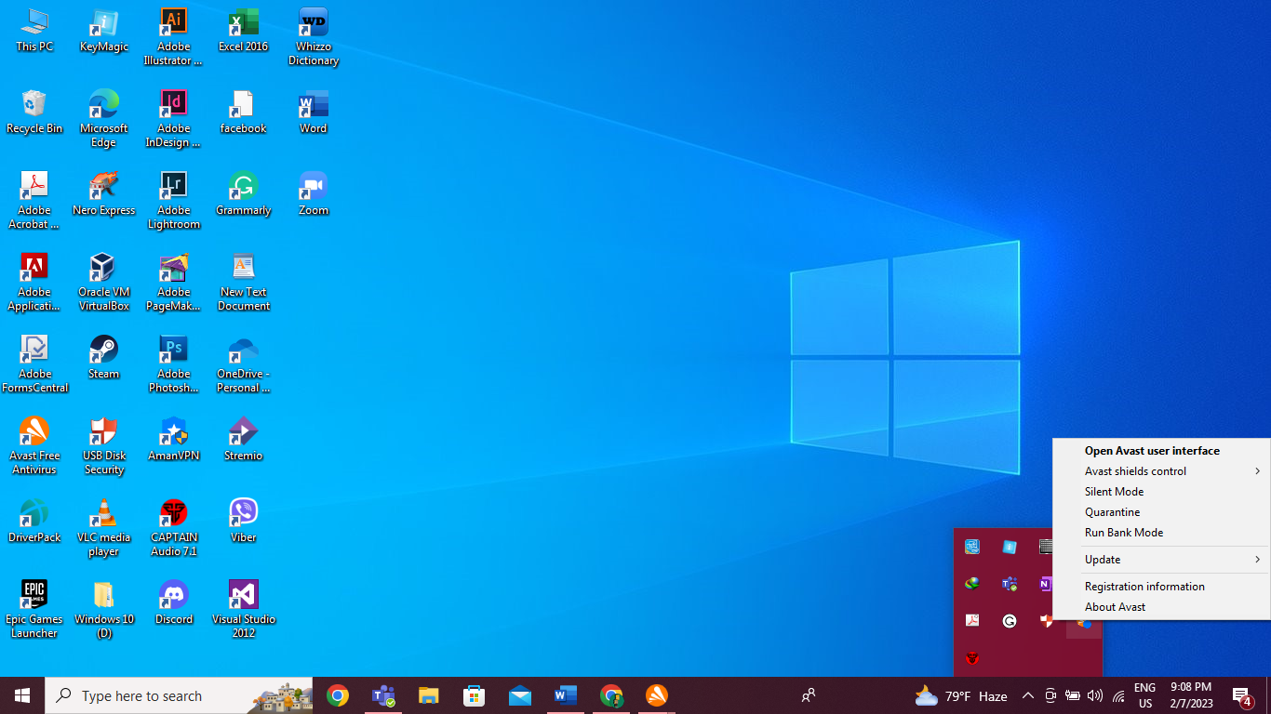

Fig.2 – And then, I Right Click on the “Avast Free Antivirus” icon.

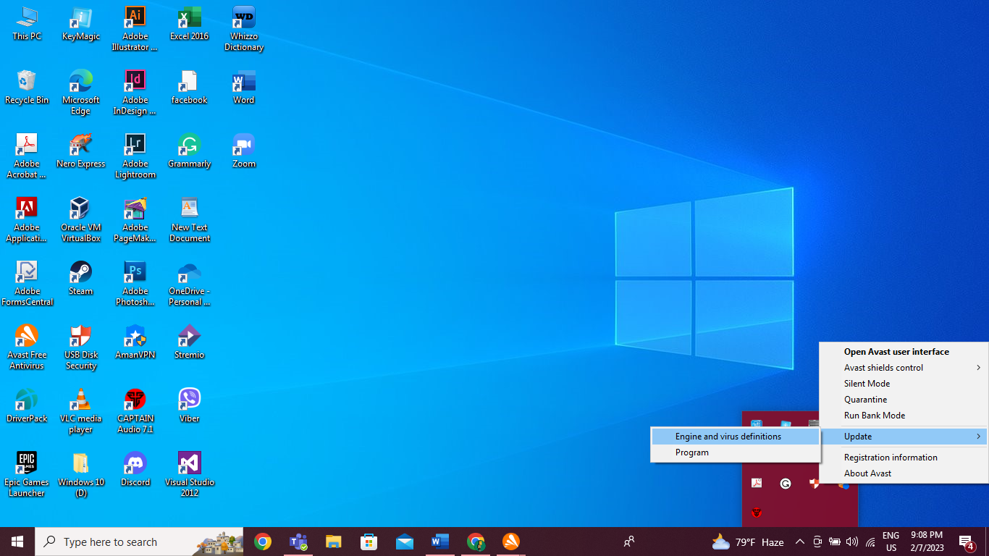

Fig.3 – After that, I clicked on “Update” and click again on “Engine and virus definitions”.

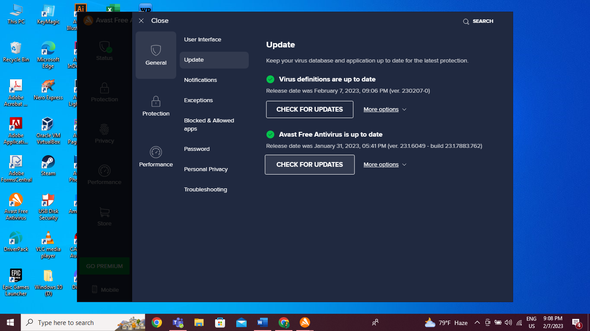

Fig.4 – The “Avast Free Antivirus” application will appear on your PC screen then click on the “CHECK FOR UPDATES” which is below the “Avast Free Antivirus is up to date”.

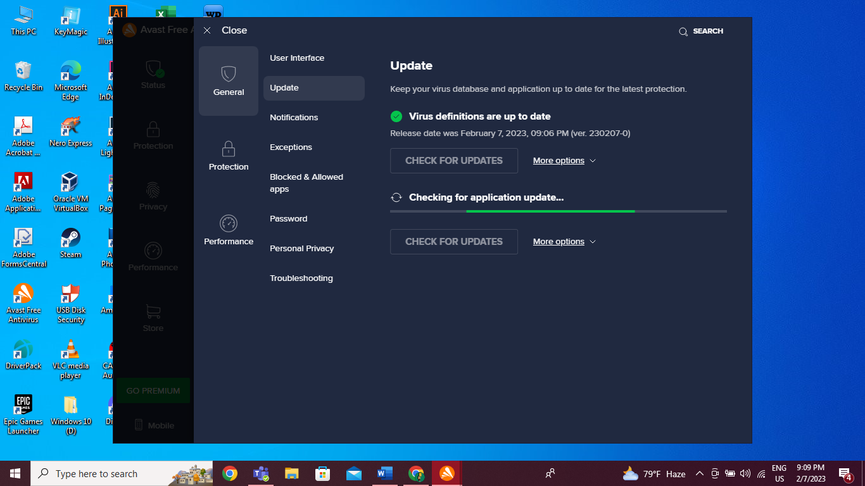

Fig.5 – After you clicked “CHECK FOR UPDATES” it starts to update the application and once the updating process is complete, everything is done.

# c) Installation of office software

## 1. Identification of product used.



Fig.1 – An Office is a software that everyone should have on every computer. Now I will use LibreOffice for office installation. LibreOffice was released on January 25, 2011, by an organization called “The Document Foundation” located in Berlin, Germany.

## 2. Identification and description of key stages in installation.

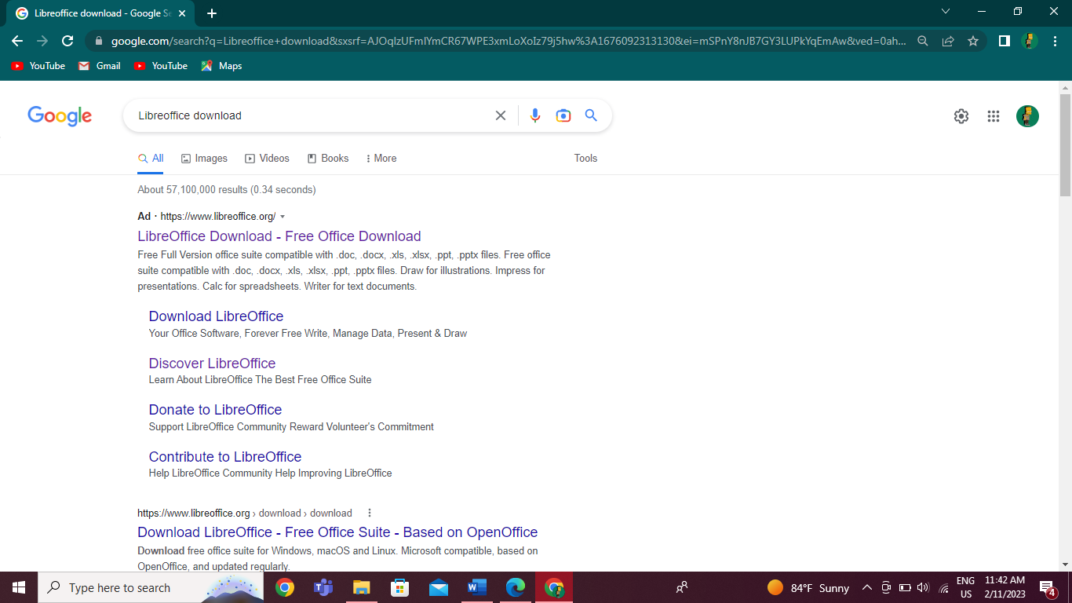

Fig.1 – To download the Office, I typed “LibreOffice Download” in Google’s search box and clicked on the first website.

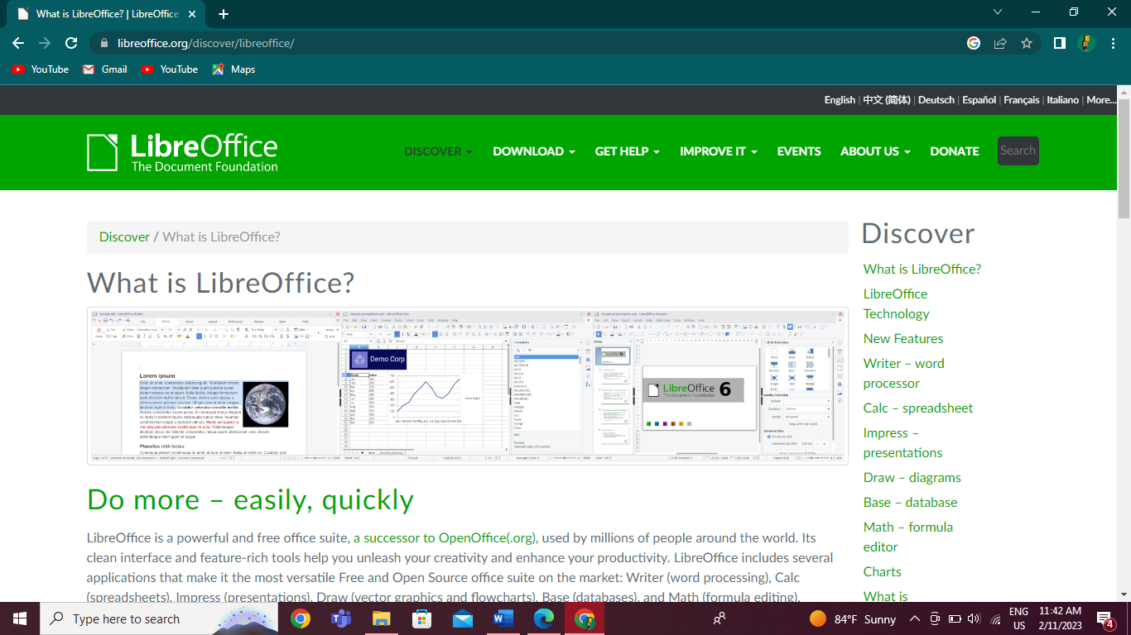

Fig.2 - When I got to the website, I clicked the “Download” button and downloaded it.

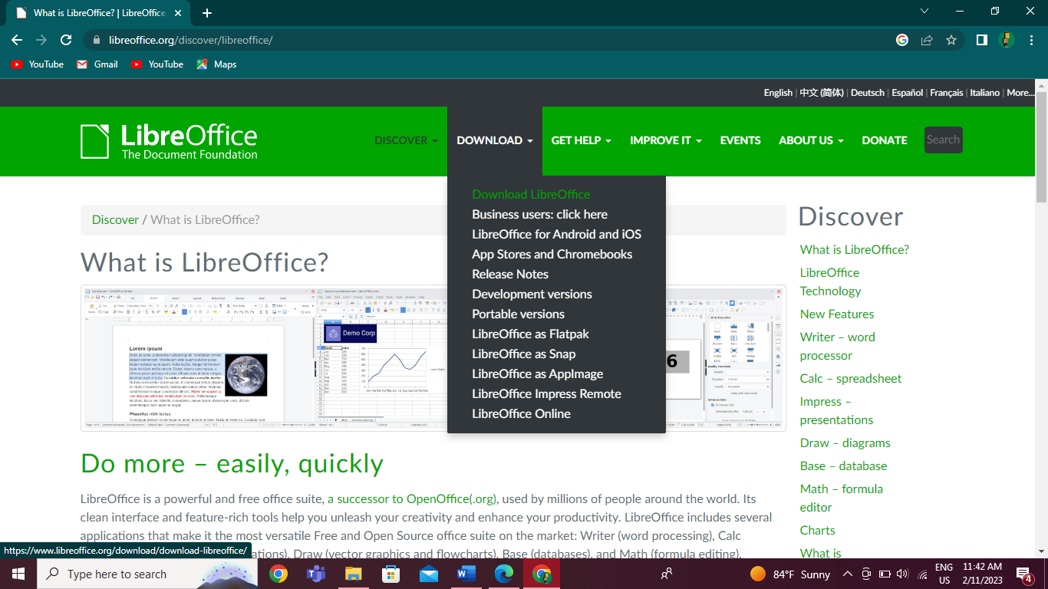

Fig.3 – And then, select and click the “Down LibreOffice”.

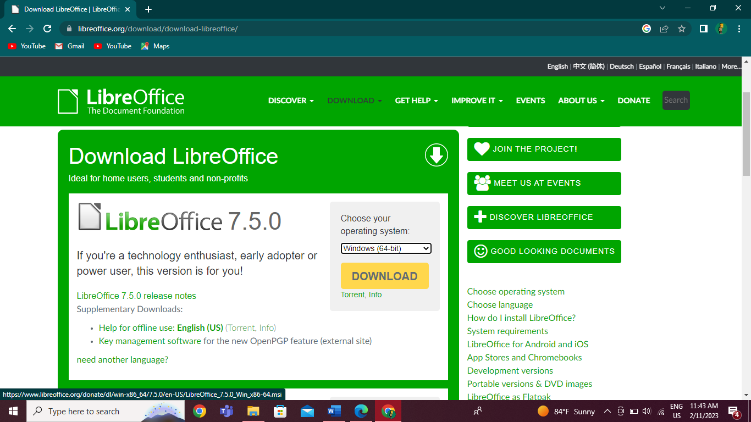

Fig.4 – To download “LibreOffice” you can choose your operating system so I chose Windows (64-bit) and clicked the “DOWNLOAD” button.

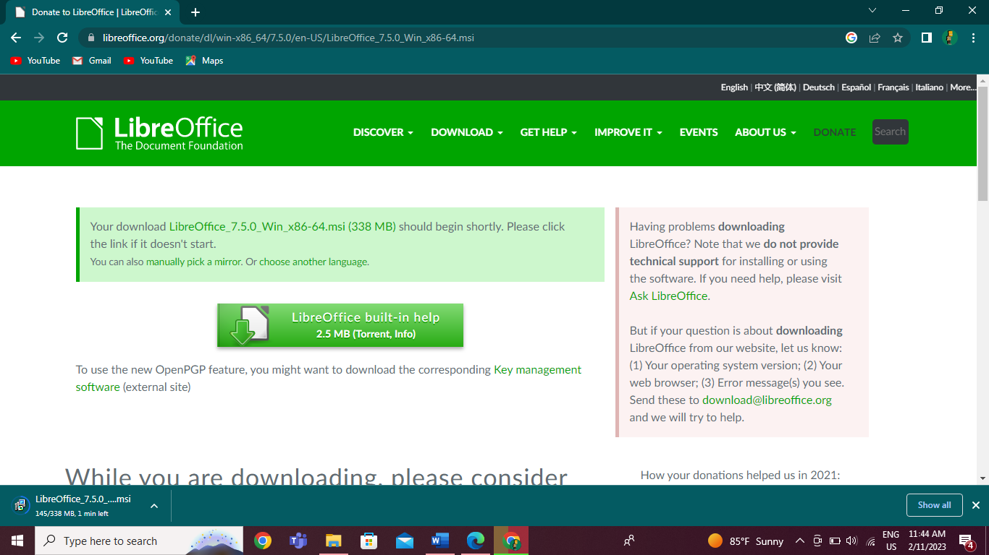

Fig.5 – And it starts to download and you have to wait for a minute to complete all.

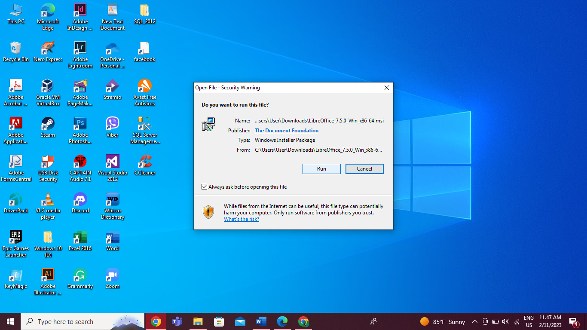

Fig.6 – When the download is complete, I clicked the “Run” button to move on the process.

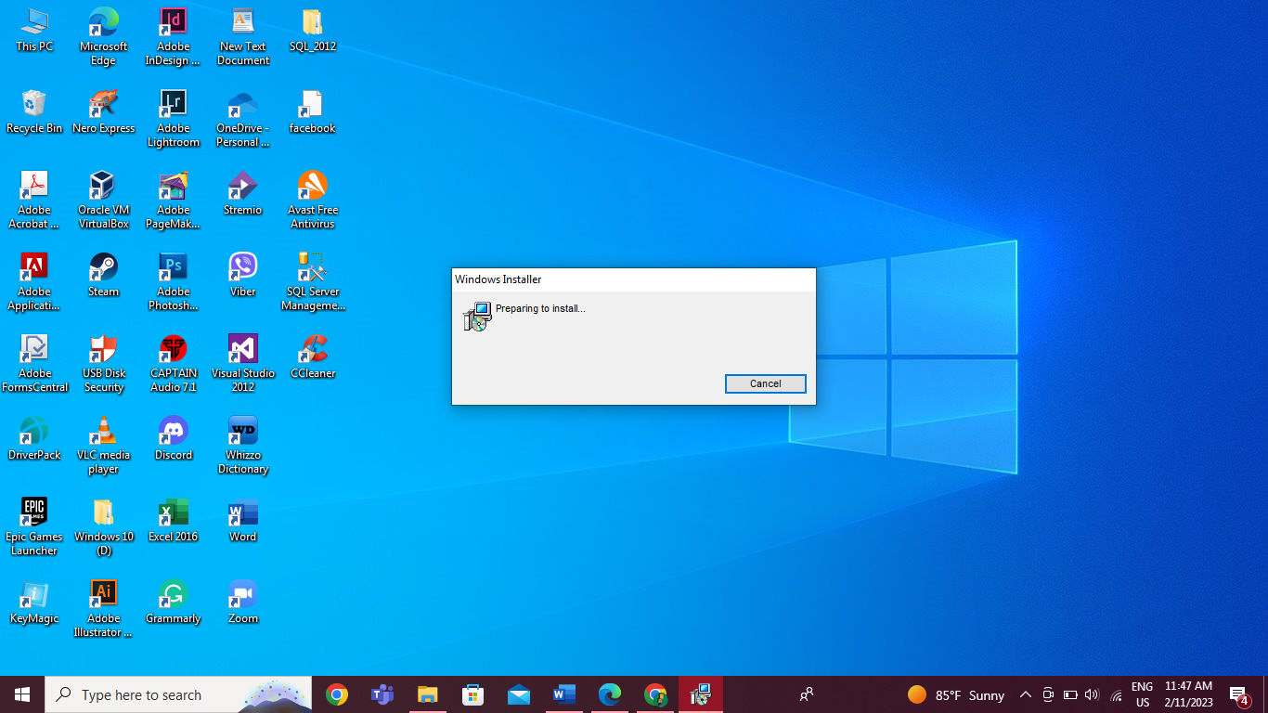

Fig.7 – “Windows Installer” box will appear on your screen and it is preparing to install.

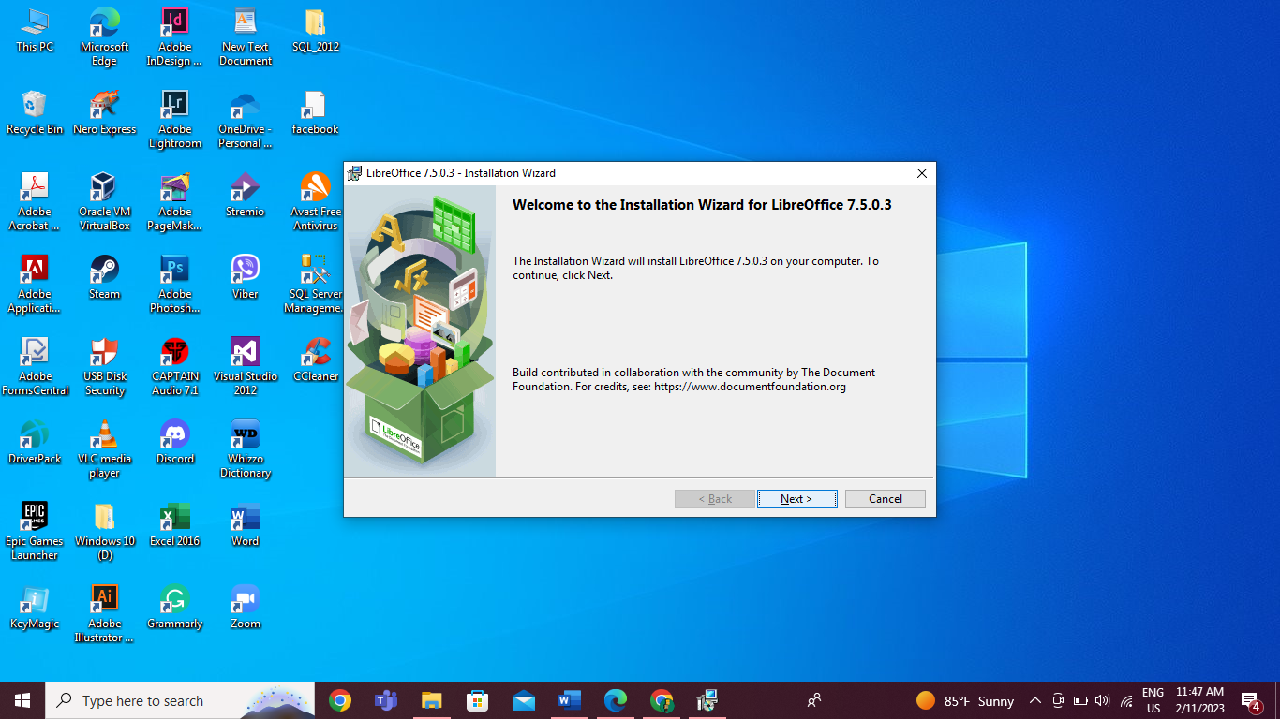

Fig.8 – After that, the box telling you the Installation Wizard will install LibreOffice on your PC and click “Next” to continue.

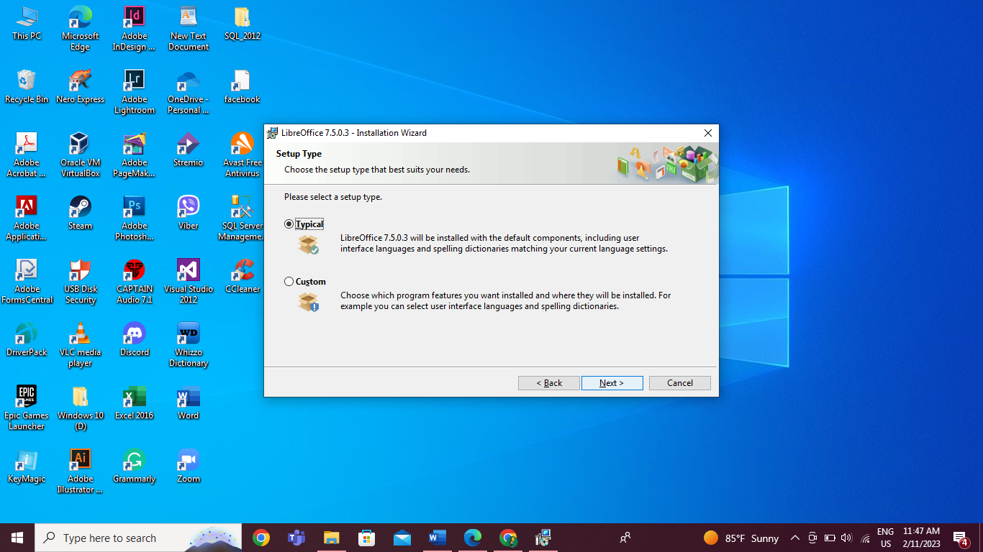

Fig.9 – To install, LibreOffice will ask you to choose the setup that suits your needs. You can choose “Typical” and “Custom” so I chose “Typical” for the setup and clicked “Next”.

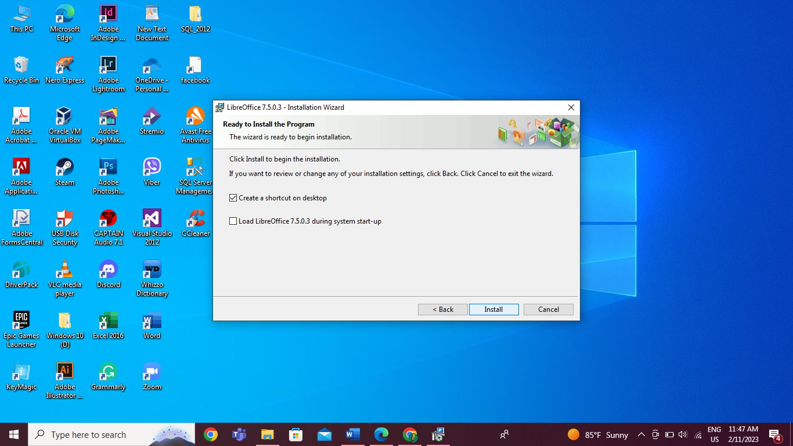

Fig.10 – Then, I chose “Create a shortcut on desktop” and start the installation.

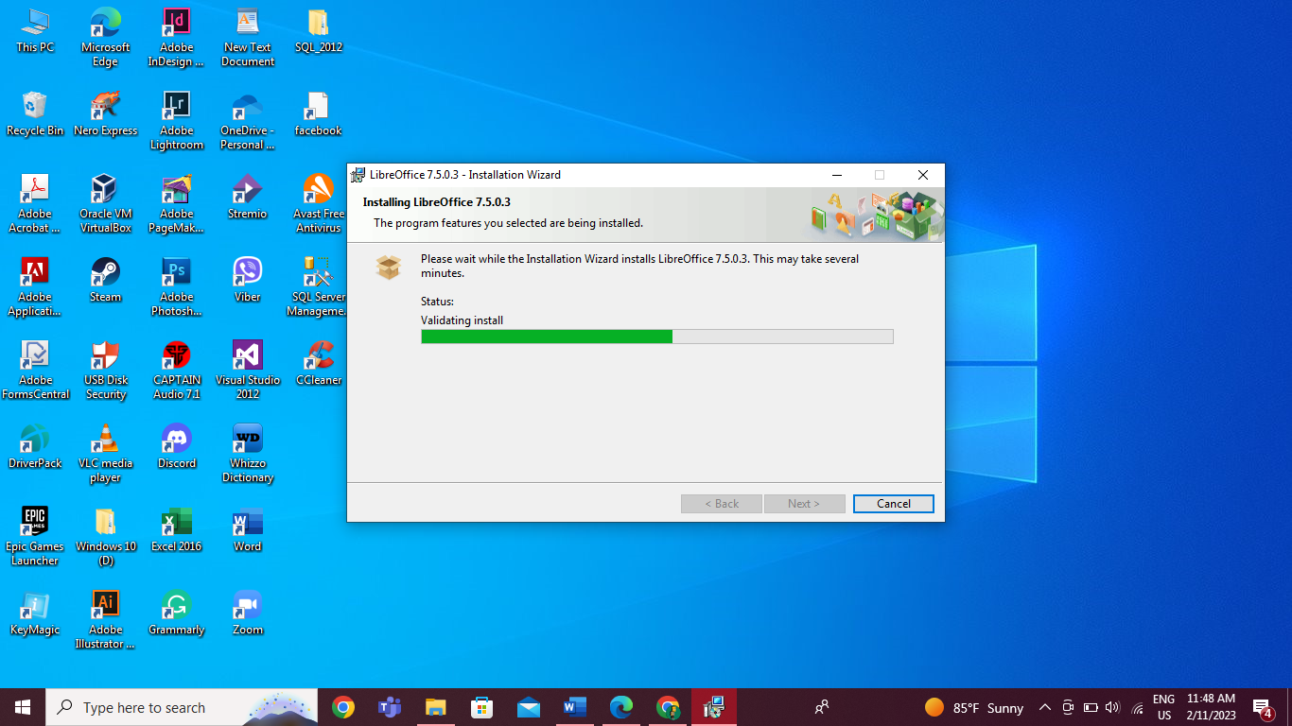

Fig.11 – The installation is going to process and it may take several minutes.

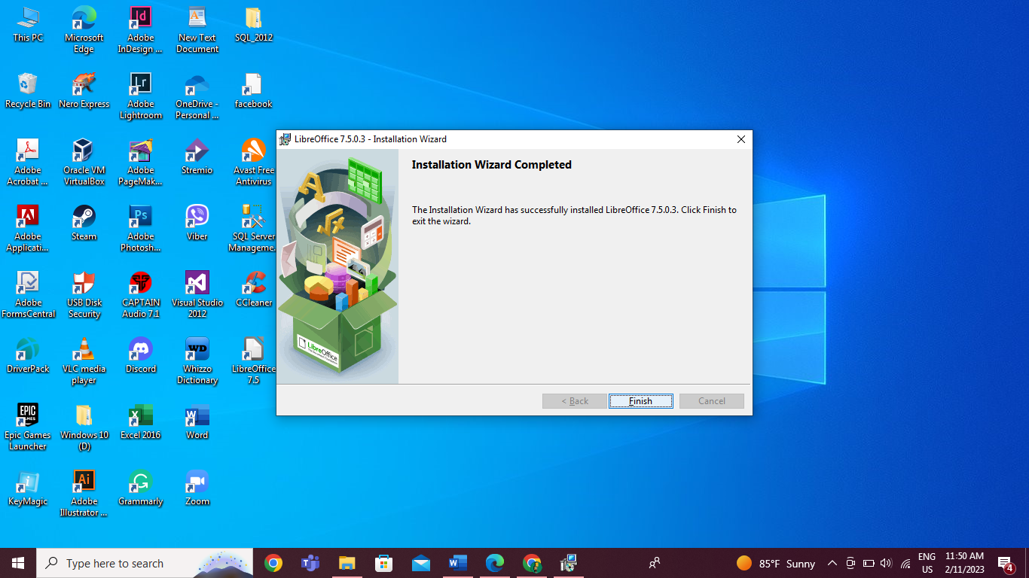

Fig.12 – After the LibreOffice installation is all complete click the “Finish” button and you will see the “LibreOffice” icon already appears on your PC screen.

## 3. Identification and description of problems and unresolved issues.

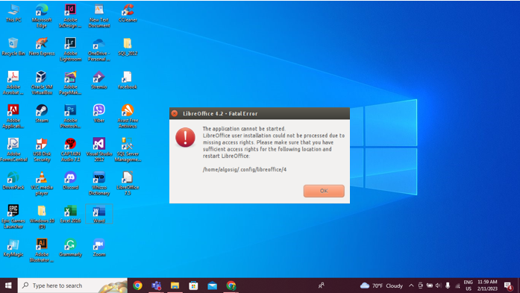

Fig.1 – This is a “Fatal Error” that occurs while installing “LibreOffice”. The reason for that is that there were missing access rights when I did the installation.

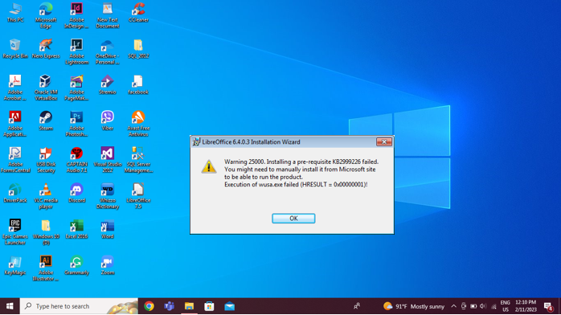

Fig.2 – This is an installation failure error when installing” LibreOffice”.

# d) Installation of free utility

## 1. Identification of utility, outline of what it does and reason why you chose this.

## 

Fig.1 – Utility software is a system software that helps maintain the proper and smooth functioning of a computer system. It manages the operations of the computer system to gather and helps the operating system to maintain and optimize. To install a utility I chose “CCleaner” because it is widely used and easy to install.

## 2. Identification and description of key stages in installation.

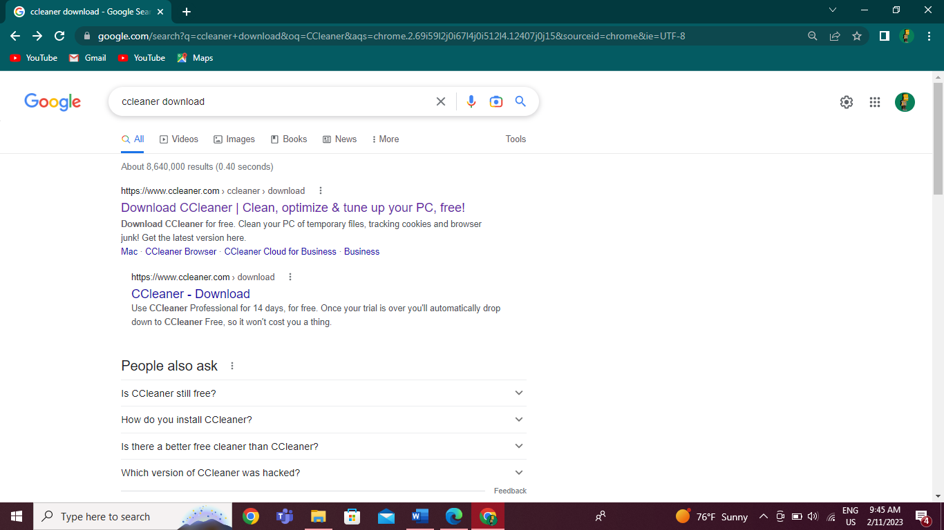

Fig.1 – First, I went to Google and typed “CCleaner download” to start the installation and clicked on the first website called “Download CCleaner”.

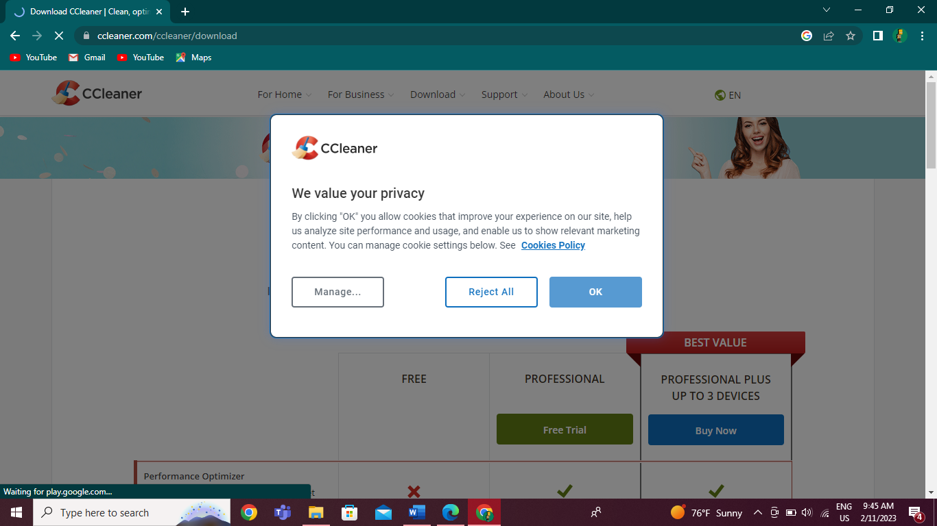

Fig.2 – Then, they will ask you to accept the “Cookies Policy” so I clicked “OK” to accept it.

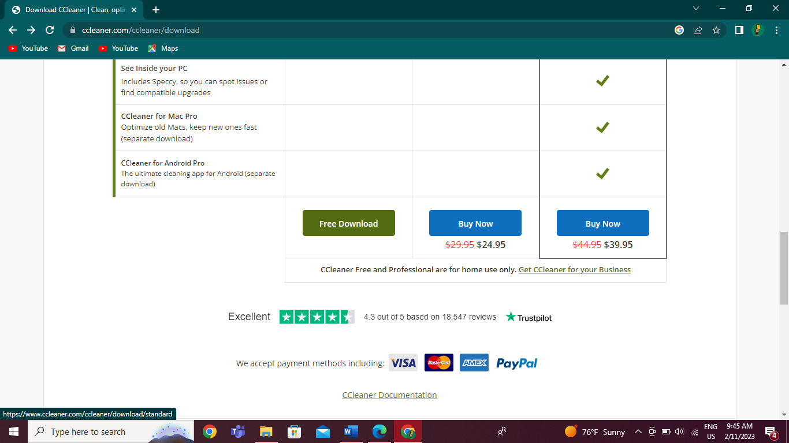

Fig.3 – When I got to the website, I clicked on the “Free Download” button and started to download it.

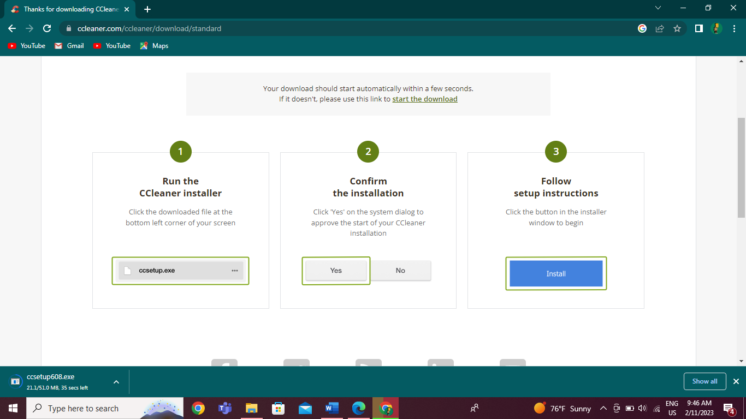

Fig.4 – After that, the download process is starting.

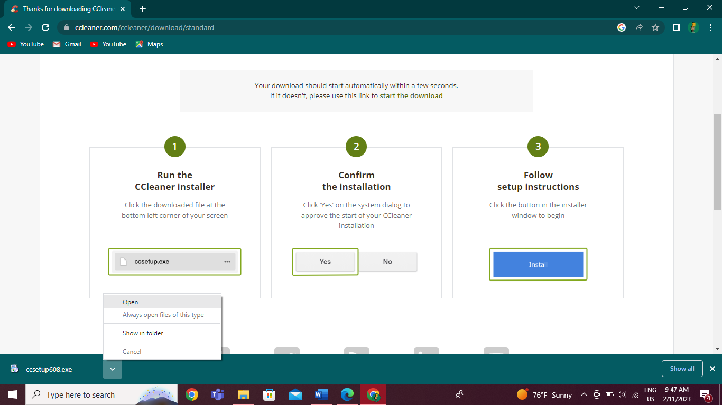

Fig.5 – When the download is complete, I Right clicked on the complete download file and open it.

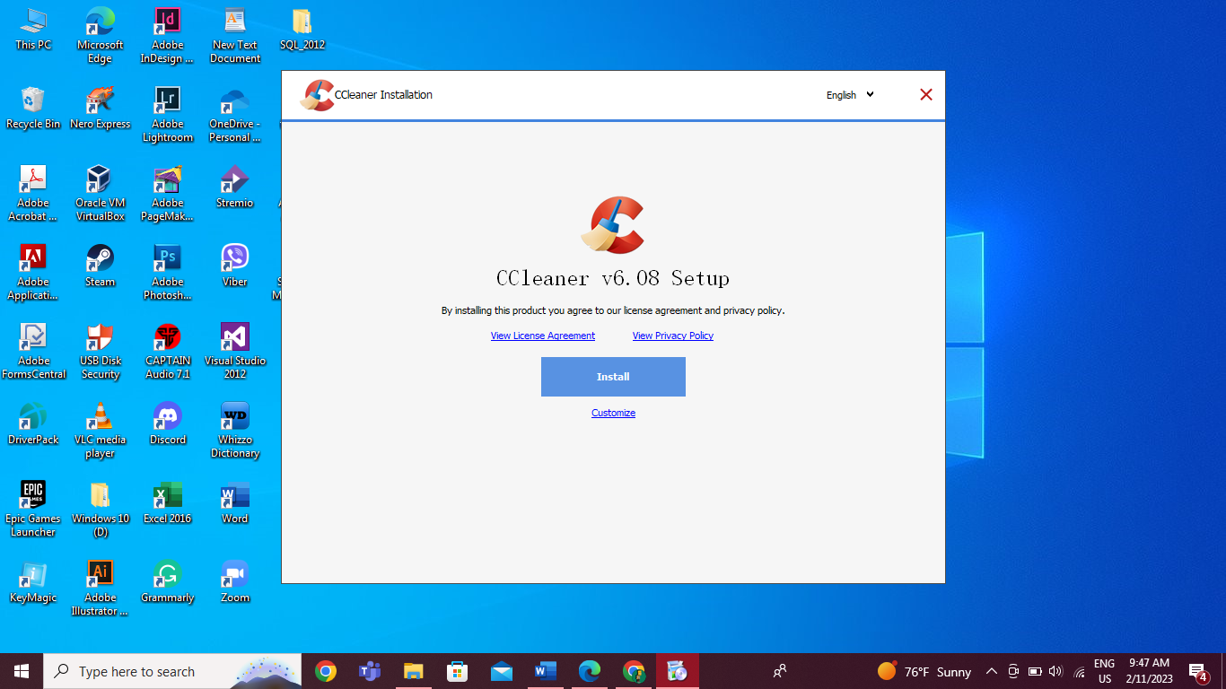

Fig.6 – After running the setup, “CCleaner Installation” will appear on your PC screen, and click the “Install’ button to continue the installation.

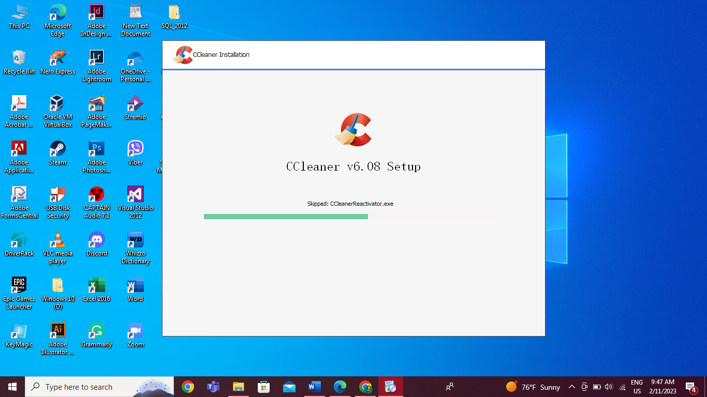

Fig.7 – You need to wait a few minutes to complete the installation process.

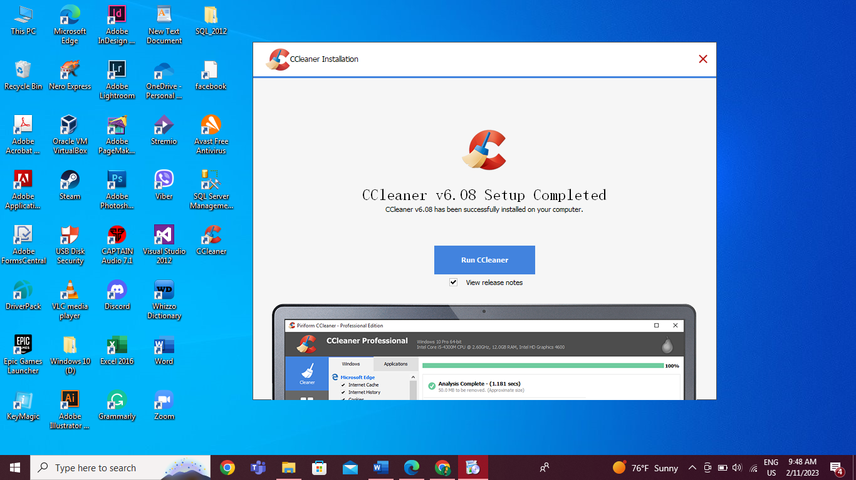

Fig.8 – If the installation setup is complete “CCleaner” icon will appear on your desktop and it ready to use.

## 3. Identification and description of problems and unresolved issues.

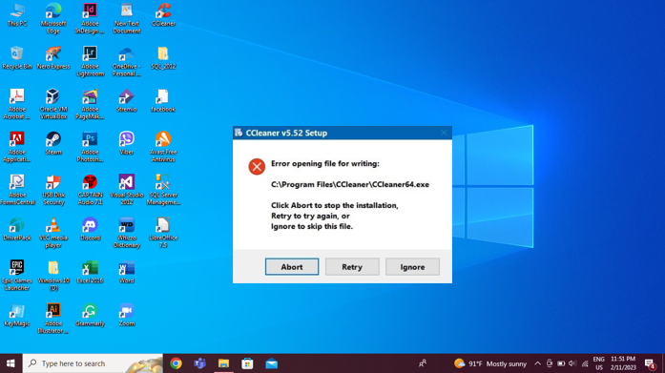

Fig.1 – This error is the error of not being able to install CCleaner in Windows 10 due to the different versions

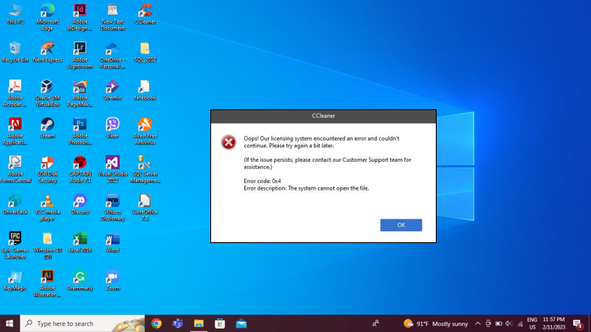

Fig.2 – This error is a license error in CCleaner software.

# Task (3)

# Faulty PCs and Software Maintenance

# Fault finding and computer maintenance

## Faulty PC’s (1)

## The steps that you followed to identify the fault.

If you notice symptoms like sudden system crashes, freezes, reboots, blue screen errors, missing files, or unusually slow performance on your computer, it might indicate RAM failure. Running a memory test can help diagnose the issue, and replacing the faulty RAM module can resolve the problem.

## The cause of the fault.

To anticipate harm to the gadget’s interior of the motherboard, it's essential to evacuate power from the body sometime recently rectifying the deformity. This may be done by wearing an antistatic wrist strap. Within the case of a Smash blame, it's critical to check in case it's legitimately introduced and clean the memory space of any clean. In case these steps fall flat, introducing an additional Slam can resolve the issue.

## 3) The steps taken to resolve the fault.

Before correcting this defect, when the system is turned on, you need to first remove the electricity coming from your body. In order to remove the electricity from such a body, you have to wrap a tool called an antistatic wrist strap around your hand. If you wrap it like that, you should be able to handle it without damaging the devices inside the motherboard. To solve this RAM fault, you have to check if the RAM is installed in the memory slot. Sometimes there may be errors or crashes due to a lack of connection. Otherwise, the dust in the memory slot must be cleaned. If you can’t with the points mentioned above, if you install a good extra RAM, the error will disappear.

## 4) The success or failure of the repair.

As mentioned above, make sure that the RAM is installed in the memory slot or clean the dust in the memory slot and if you open the computer, you can use it as smoothly as the new one. So, repairing RAM is successful.

## Faulty PC’s (2)

## The steps that you followed to identify the fault.

I turned on the power supply and plugged it in, but the monitor screen stayed blank. It seems that there's an issue with the connection between the power supply and the PC. I need to troubleshoot the problem to figure out what's causing the issue and fix it as soon as possible.

## The cause of the fault.

After testing what is really happening with this PC, I found out that the connector between the power supply and the PC is not working properly due to the quite loose power cable. The power cable is slightly loose and not functioning correctly. This can be extremely dangerous, as a loose connection can lead to electrical shocks or fires. Additionally, it may also affect the computer's performance.

## The steps taken to resolve the fault.

After knowing the reason for the fault of the connection, first I checked the power cable behind the case but when I realized that it wasn’t broken so I moved on to verify the PC power cable is securely plugged in. To do so, I carefully removed the power cable from the wall outlet and then plugged it back in, ensuring a secure connection. Be sure that when you check the power cable connection unplugged the adapter from the wall outlet to prevent electric shock.

## The success or failure of the repair.

After reconnecting the power cable to the PC there is no black screen anymore and it is normally turned on properly. Therefore, the repair process for this PC was completed successfully.

## Faulty PC’s (3)

## The steps that you followed to identify the fault.

If your computer gets too hot, you may notice some unusual things happening on your screen, like strange colors or flickering. These issues are signs that something is wrong with your PC, specifically with the graphic card fan. To fix the problem, you'll need to find a solution that addresses the fan failure and restores normal functioning.

## The cause of the fault.

If the computer's GPU fans are clogged with dust, they may overheat and cause the GPU to fail. This is a common reason for GPU failure, and it can be prevented by regularly cleaning the computer's fans. To avoid this issue, it's important to check the GPU fans and clean them to keep them working properly.

## The steps taken to resolve the fault.

To solve this kind of situation first check the computer’s case is full of dust. If there is dust cool air cannot flow in and hot air cannot flow out. This prevents the GPU and other system components from cooling properly. So, you need to open the computer’s case and clean any dust buildup from the fan blades. To clean up you can use an air compressor or wipe with a better microfiber towel. If you clear it, the fan will work well and it prevents the GPU from overheating.

## The success or failure of the repair.

Once you've cleared out the dust and dirt from your graphics card's fan, you won't have to deal with any peskier screen flickers or odd glitches while using your computer. You'll be able to go about your usual PC activities without any interruptions or issues.

## Maintenance of Computer System

## 1) **Identification** of OS update / software package to update.

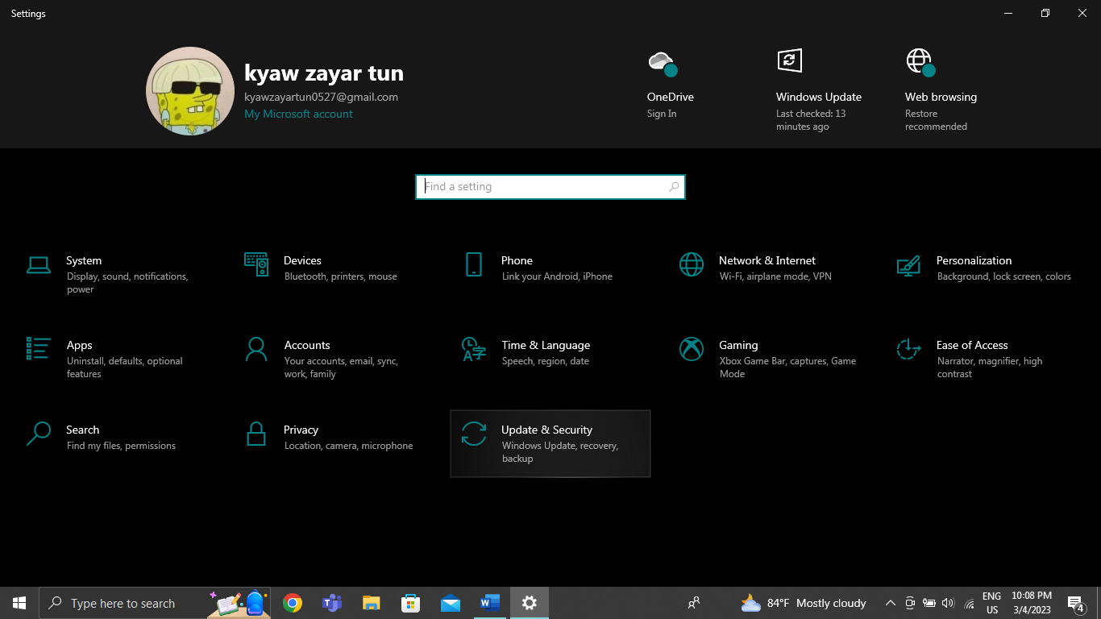

Fig.1 – Updating your computer's window is important for several reasons. Updating your computer's window provides the latest security patches, bug fixes, and features to enhance performance, stability, and user experience. Not updating can leave your computer open to security threats and cause compatibility issues. To update your OS, first, you need to click the setting button, and if you are in click again on “Update & Security”.

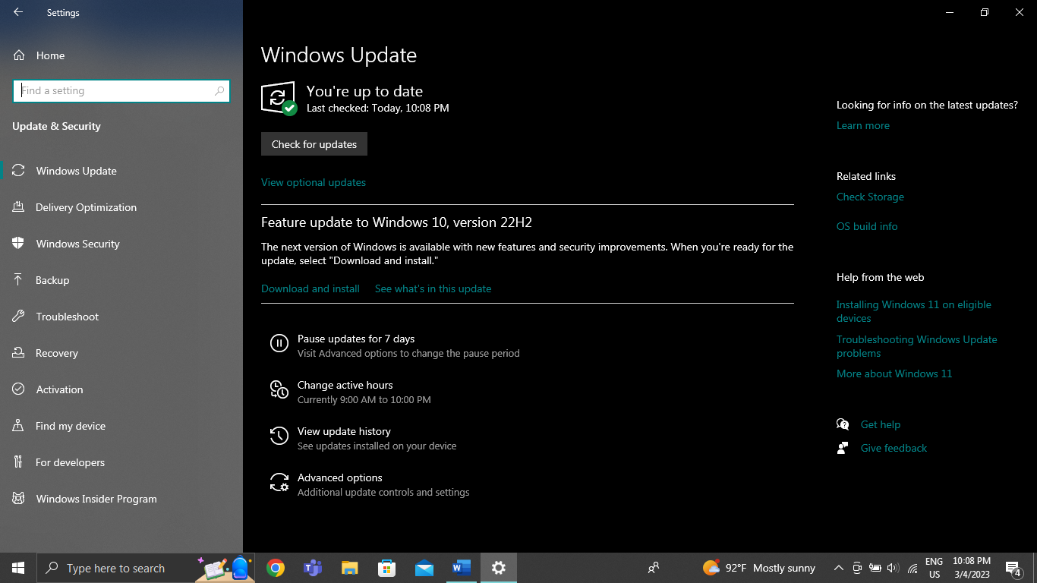

Fig.2 – After that, you will see the “Windows Update” and below that there is a “Check for updates” button. You can click that button to check the updates. There are also two buttons that say “Download and install” and “See what’s in this update”. If you want to know what will be new in the update you can click “See what’s in this update” and click “Download and install” to start processing the update.

## 2) Identification of hardware driver to update.

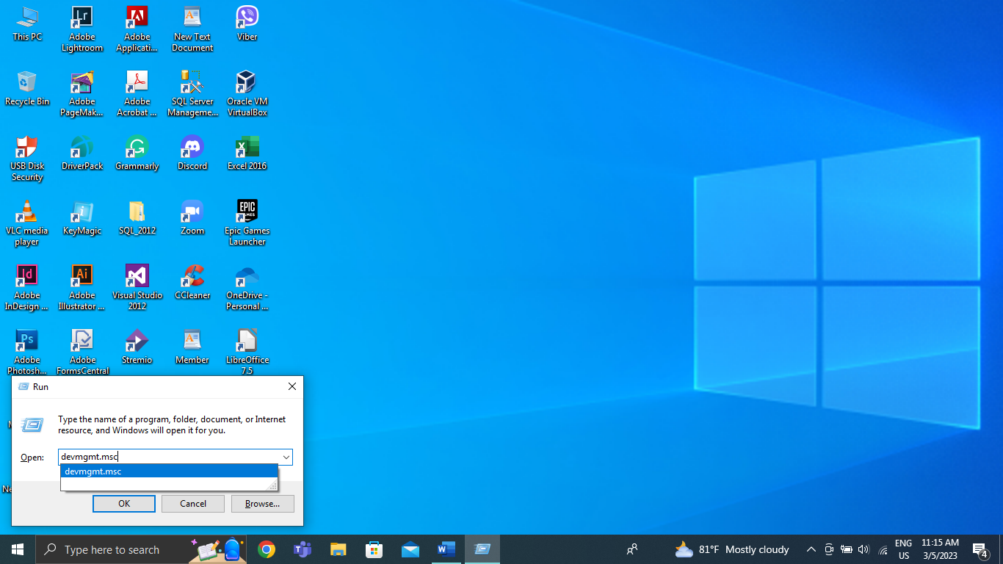

Fig.1 – First of all, to update the hardware driver I clicked the Window key and R on the keyboard to bring up the “Run” box then I typed “devmgmt.msc” and clicked on the “OK” button to display the device manager to update driver.

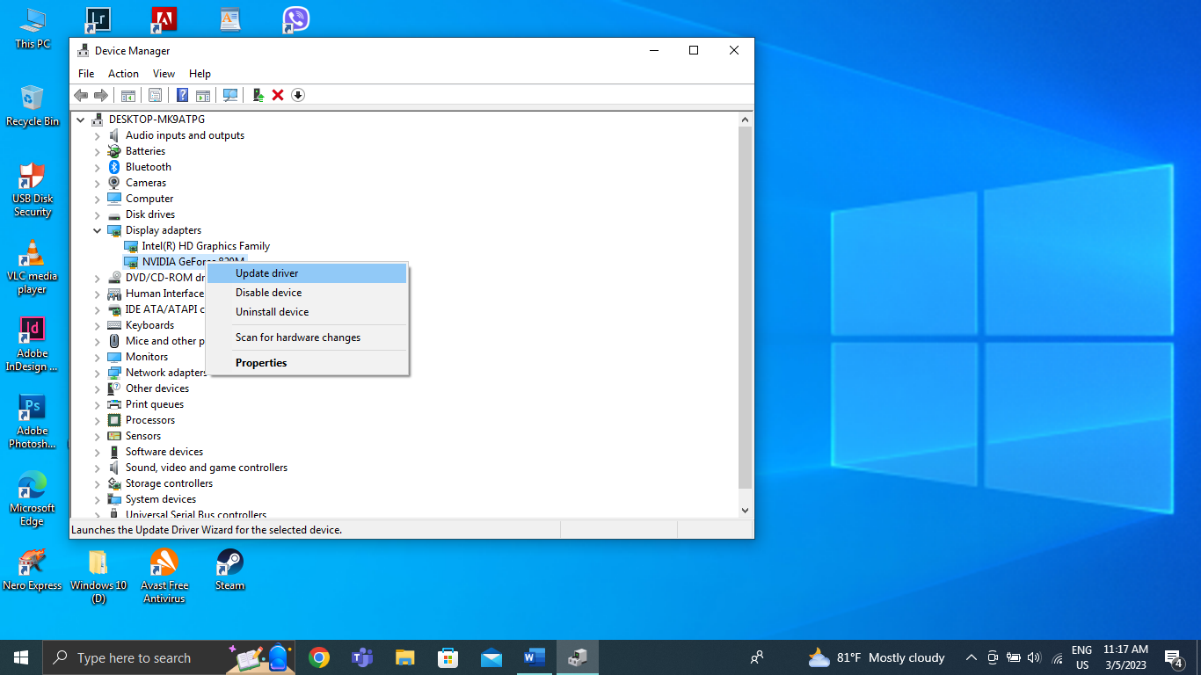

Fig.2 – When I got to the device manager, I clicked on the arrow in front of the display adapters. After that, I right-clicked on the “NVIDIA GeForce 820M” and click on the “Update drive” again to continue the update process of the driver.

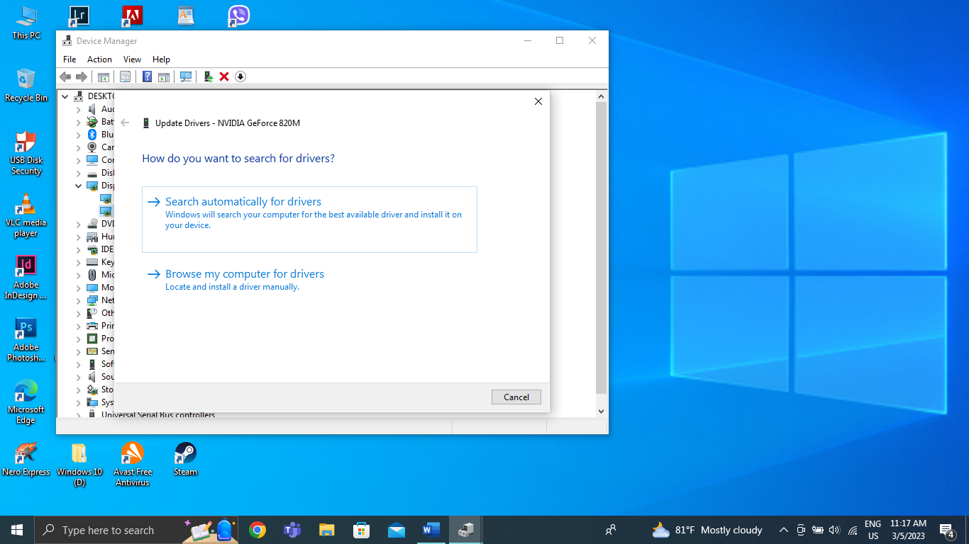

Fig.3 – After that, it will ask you “How do you want to search for drivers?”. There are two options to choose from, the first one is it will automatically search and install the driver you need and the second one is to install a diver manually like you can find the driver on your own if you downloaded or copied it from another device.

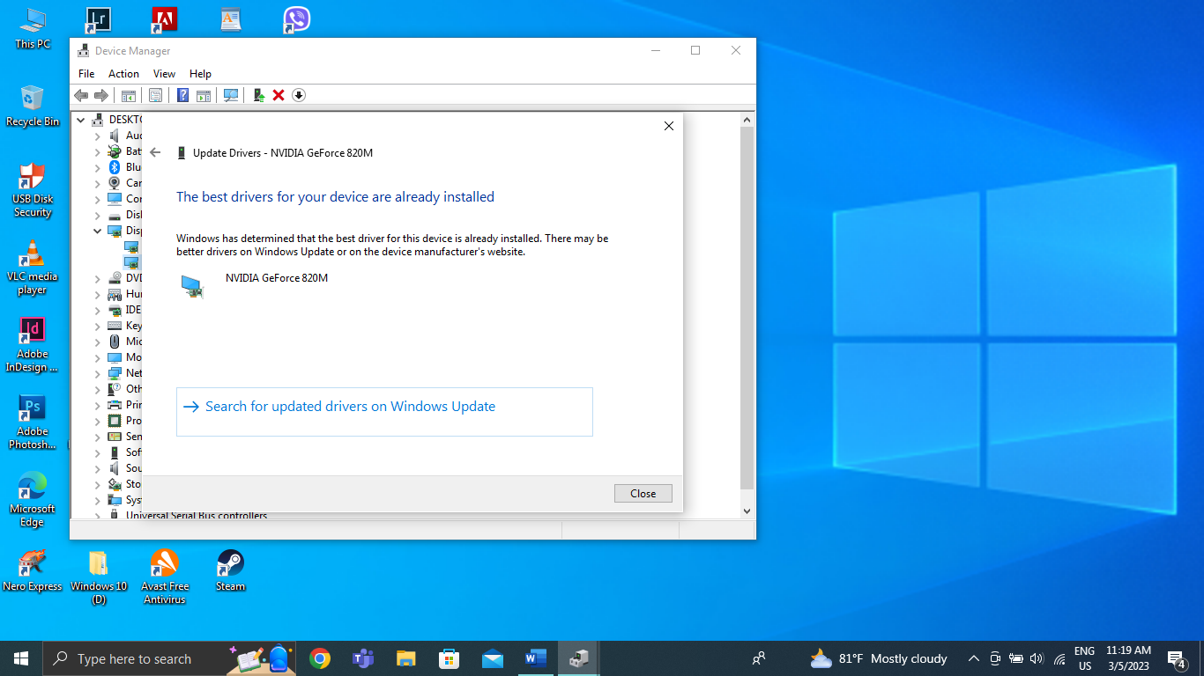

Fig.4 – So, I clicked on “Search automatically for drivers” so it will search and update your needed driver automatically because I don’t have the driver that is downloaded or copied from another device. When the update process is complete successfully, I click on the button called “Close” to quit the process.

## 3) Performance of system maintenance and the outcome explaining why it was done and the improvements brought to the system.

Performing regular system maintenance is important to ensure that the system operates smoothly and efficiently. This maintenance can include tasks such as cleaning up unnecessary files, installing software updates, and fixing any bugs or errors that may be present.

There are several reasons why system maintenance is important. First, it helps to prevent system crashes, which can result in data loss and other issues. Second, it can improve the system's speed and performance by removing unnecessary files, cleaning up the system registry, and installing software updates. Third, it can help to prevent security breaches by installing security patches and updates. The outcome of system maintenance is a system that operates smoothly and efficiently. By removing unnecessary files and optimizing the system's performance, the system can run faster and with less strain on its resources. Additionally, by fixing any bugs or errors, the system can be prevented from crashing or experiencing other issues that could lead to data loss or other problems.

In conclusion, system maintenance is an essential process that should be done regularly to ensure that a computer or other system performs optimally. It helps to prevent system crashes, improve the system's speed and performance, and prevent security breaches. By performing regular system maintenance, users can enjoy a more reliable and efficient system.

# b) Routine / Preventative maintenance

## 1. Identify FIVE (5) potential reasons why a user might experience this problem and for each of the issues identified explain how you would recommend investigating and addressing the issue.

**Lack of disk space**

Performance issues may arise if a computer's disk space is full. The amount of data and programs on the hard disk may be the cause of this. By selecting the hard drive with the right click when on "This PC" or "My Computer," you may inspect the disk space used to further analyze this problem. Remove useless software from your computer and erase unnecessary files or transfer them to an external hard drive to resolve this issue.

**Outdated hardware or software**

Outdated hardware or software can cause slow performance on a computer. To investigate this issue, check the applications' system requirements to make sure the machine satisfies them in order to explore this problem. For the computer hardware, check for almost any upgrades to the software or drivers. Update the software and device drivers to the most recent versions to make this issue go away.

**Malware or viruses**

A computer's performance can suffer significantly from malware and viruses, making it sluggish and unresponsive. It is strongly recommended to run a malware scan with antivirus software to find any dangerous apps on the system in order to resolve this problem. When malware or viruses are found, quarantine them or eradicate them using antivirus software to stop future harm to the system and improve the overall performance of the system.

**Overloaded memory**

Running too many programs or having too many browser tabs open can cause a memory overload and result in slow computer performance. Check the task manager to discover which apps are using the most RAM so you can look into it. Close any superfluous apps or tabs to free up memory and fix the problem. This will improve the computer's speed and efficiency, allowing for smoother operation and faster processing.

**Fragmented hard drive**

When a hard drive gets fragmented, files are broken up into tiny bits and dispersed over the disk's many regions. This can lead to slow performance as the computer needs to work harder to access and piece together the fragmented files. Using a disk defragmentation program on a regular basis might assist maintain the hard drive organized and effectively to fix this issue. The system can benefit from an improved performance by using this utility to reorganize the files on the disk so that they are stored in contiguous blocks.

## 2. Identify FIVE (5) regular maintenance tasks that users should undertake and for each of the issues identified explain why each of them is important

**Install updates and patches**

Regularly updating and patching the operating system and installed applications on a computer is one of the important factors in maintaining the best performance of a computer. Normally, by updating a computer, bugs security vulnerabilities and performance problems can be made allowing the system to run more smoothly and efficiently. Neglecting to update can lead to system crashes, security breaches, and reduced functionality. Checking for automatic update is recommended because it can improve the security of a computer so that it can use the latest functions

**Disable unnecessary startup programs**

Programs have a tendency to be scheduled to begin operating automatically when a computer boots up, but this can have a particularly strong impact on speed. Unnecessary startup programs can slow down the system's startup time and overall performance due to the low RAM. By disabling unnecessary startup programs, you can help improve system performance and speed up the computer's startup time. As a result of the impact, your computer will be able to manage its resources more effectively, resulting in a smoother and more efficient user experience.

**Clean the computer's hardware**

A computer can overheat and damage some of the internal parts. If we have to look for the cause of the damage, it is usually caused by the dirt accumulation of particles and dirt inside the computer. You can use compressed air or a soft brush to clean the dust so that computers can be used for a long time without overheating. So, cleaning and cleaning your computer's hardware on a regular basis is essential for the best performance and longevity.

**Regularly clean up the hard drive**

Having too many files on the hard drive can also slow down the performance of a computer. The hard drive should be regularly cleaned at least once a month to remove unwanted files and programs. Compared to an organized hard drive, a cluttered hard drive can take longer to find data, slowing it down and significantly affecting a computer’s performance. This can lead to slower processing rates and longer load times. Users may maximize their computer's performance and guarantee that it performs smoothly and effectively by cleaning out their hard drives on a regular basis.

**Run antivirus and malware scans**

Running antivirus and malware protection on a computer is important because it helps maintain the health and performance of the user’s computer. Using these scans, it helps in finding and removing malicious software that can slow down the computer and eventually destroy the data and information inside. This is particularly pertinent for individuals who routinely download files from the internet or utilize external storage devices, both of which are major sources of malware infection. Following these appropriate preventive procedures can help keep your computer functioning smoothly and your personal data safe.

## Conclusion

In conclusion, this assignment required a thorough understanding of IT infrastructure, system design, installation of Windows, antivirus software, office software, and free utilities. Students were required to complete a variety of tasks, including routine and preventative maintenance, identifying and justifying the requirements of a modern small to medium-sized organization, producing generic specifications, identifying specific products, evaluating and selecting solutions, and completing the tasks. This task provoked understudies to think fundamentally and apply their insight into IT frameworks and parts, while creating significant abilities that will be gainful in their future vocations.

# References for Task (1)

acctivate, 2023. *acctivate.* [Online]   
Available at: https://acctivate.com/features/customer-management-software/  
[Accessed 18 March 2023].

Acronis, 2023. *Acronis.* [Online]   
Available at: https://www.acronis.com/en-us/products/cloud/cyber-protect/features/  
[Accessed 13 April 2023].

Adam Hughes, C. S., 2005-2022. *Microsoft SQL Server.* [Online]   
Available at: https://www.techtarget.com/searchdatamanagement/definition/SQL-Server  
[Accessed 7 April 2022].

Allen8535, 2018. *Best brand of switch for small-to-medium sized businesses?.* [Online]   
Available at: https://community.spiceworks.com/topic/2174054-best-brand-of-switch-for-small-to-medium-sized-businesses  
[Accessed 6 April 2022].

Anon., 1996-2022. *Amazon.* [Online]   
Available at: https://www.amazon.com/Newest-Dell-PowerEdge-Server-E3-1225/dp/B0722J7NNX/ref=sr_1_8?crid=21UE7XACOR7EJ&keywords=dell+small+business+server&qid=1649075286&sprefix=dell+server+for+business%2Caps%2C324&sr=8-8  
[Accessed 7 April 2022].

Anon., 1996-2022. *Amazon.* [Online]   
Available at: https://www.amazon.com/HP-Z640-Tower-Server-E5-2680/dp/B0896SX7HK/ref=sr_1_4?crid=1XOGIY1S3IZ0L&keywords=hp+small+business+server&qid=1649076662&sprefix=%2Caps%2C340&sr=8-4  
[Accessed 7 April 2022].

Anon., 1996-2022. *Amazon.* [Online]   
Available at: https://www.amazon.com/Dell-Inspiron-Processor-Touchscreen-Computer/dp/B0818BX4XG/ref=sr_1_15?crid=JE5XZZ0UMN04&keywords=dell+desktop&qid=1649004488&refinements=p_n_feature_two_browse-bin%3A5446812011&rnid=562234011&s=pc&sprefix=dell+desktop+%2Caps%2C327&  
[Accessed 7 April 2022].

Anon., 1996-2022. *Amazon.* [Online]   
Available at: https://www.amazon.com/HP-Pavilion-Processor-Touchscreen-Computer/dp/B0893SRQJM/ref=sr_1_9?crid=22ZYCH10K6EK6&keywords=hp+desktop+27+inch+windows+10+pro&qid=1649005376&sprefix=hp+desktop+27+inch+windows+10+pro%2Caps%2C328&sr=8-9  
[Accessed 7 April 2022].

Anon., 1996-2022. *Amazon.* [Online]   
Available at: https://www.amazon.com/Polycom-Corded-Business-Media-System/dp/B01EECUBJ4/ref=sr_1_5?crid=1EBZ5POS9XKW0&keywords=polycom+voip+phones+for+business&qid=1649035533&sprefix=polycom+voip+phone%2Caps%2C353&sr=8-5  
[Accessed 7 April 2022].

Anon., 1996-2022. *Amazon.* [Online]   
Available at: https://www.amazon.com/ASUS-RT-AX3000-802-11ax-Lifetime-Whole-Home/dp/B084BNH26P/ref=sr_1_1?crid=1RUUMZ37TDSKV&keywords=asus+wifi+router+for+business&qid=1649042318&sprefix=asus+wifi+router+for+b%2Caps%2C377&sr=8-1  
[Accessed 7 April 2022].

Anon., 1996-2022. *Amazon.* [Online]   
Available at: https://www.amazon.com/WiFi-6-Router-Gigabit-Wireless/dp/B08H8ZLKKK/ref=sr_1_2?crid=3REH6NQ1Z0OS&keywords=TP-link+wifi+router+for+business&qid=1649043080&sprefix=tp-link+wifi+router+for+business%2Caps%2C436&sr=8-2  
[Accessed 7 April 2022].

Anon., 1996-2022. *Amazon.* [Online]   
Available at: https://www.amazon.com/TP-LINK-Gigabit-Ethernet-Network-TL-SG116E/dp/B07GRG63P6/ref=sr_1_2?crid=2II08PVVXQC8F&keywords=tp+link+switch+16+port&qid=1649047410&sprefix=tp+link+switch+16+%2Caps%2C579&sr=8-2  
[Accessed 7 April 2022].

Anon., 1996-2022. *Amazon.* [Online]   
Available at: https://www.amazon.com/NETGEAR-16-Port-Gigabit-Ethernet-Network/dp/B07DFBX347/ref=sr_1_3?crid=3KU24X8YYHK8P&keywords=netgear+switch+16+port&qid=1649050465&sprefix=%2Caps%2C643&sr=8-3  
[Accessed 7 April 2022].

Anon., 1996-2022. *Amazon.* [Online]   
Available at: https://www.amazon.com/Brother-Monochrome-HL-L2350DW-Two-Sided-Replenishment/dp/B0763WDSYZ/ref=sr_1_1?crid=5Q2E141YYD97&keywords=brother%2Blaser%2Bprinter&qid=1649076738&sprefix=brother%2Blaser%2B%2Caps%2C607&sr=8-1&th=1  
[Accessed 7 April 2022].

Anon., 1996-2022. *Amazon.* [Online]   
Available at: https://www.amazon.com/HP-LaserJet-M404dw-Monochrome-Double-Sided/dp/B009UYYH8I/ref=sr_1_1?crid=1AHP919CZPX2I&keywords=HP+LaserJet+Pro+M404+dw+wireless+Monochrome+Printer+with+built-in+Ethernet+%26+2-sided+Printing+%28W1A56A%29&qid=1649301251&sprefix=%2Ca  
[Accessed 7 April 2022].

Anon., 1996-2022. *Amazon.* [Online]   
Available at: https://www.amazon.com/LibreOffice-v4-3-Open-Source-Download/dp/B00PT6GQY4/ref=sr_1_2?crid=2NQBX22NLJ63Q&keywords=libre+office+software&qid=1649050673&sprefix=libre+office+so%2Caps%2C432&sr=8-2  
[Accessed 7 April 2022].

Anon., 1996-2022. *Asus Wireless Router Reviews.* [Online]   
Available at: https://www.pcmag.com/categories/wireless-routers/brands/asus  
[Accessed 7 April 2022].

Anon., 1998-2021. *What is an operating system?.* [Online]   
Available at: https://edu.gcfglobal.org/en/computerbasics/understanding-operating-systems/1/  
[Accessed 28 March 2022].

Anon., 1999-2022. *Alibaba.com.* [Online]   
Available at: https://www.alibaba.com/product-detail/Grandstream-VoIP-Phone-GXP1628-Up-to_60773983057.html?spm=a2700.details.0.0.2d055159nfl03X  
[Accessed 7 April 2022].

Anon., 1999-2022. *Alibaba.com.* [Online]   
Available at: https://www.alibaba.com/product-detail/Microsoft-Office-2016-Standard-DVD-and_1600362575147.html?spm=a2700.galleryofferlist.normal_offer.d_image.3e226896hRmlUA  
[Accessed 7 April 2022].

Anon., 2000-2022. *All The Features That Make FreshBooks Ridiculously Easy To Use.* [Online]   
Available at: https://www.freshbooks.com/features  
[Accessed 7 April 2022].

Anon., 2001-2019. *What size monitor do I need?.* [Online]   
Available at: https://www.ebuyer.com/blog/what-size-monitor-do-i-need/  
[Accessed 6 April 2022].

Anon., 2006-2022. *Is AccountEdge right for your business?.* [Online]   
Available at: https://www.softwareadvice.com/accounting/accountedge-pro-profile/  
[Accessed 7 April 2022].

Anon., 2006-2022. *Is FreshBooks right for your business?.* [Online]   
Available at: https://www.softwareadvice.com/accounting/freshbooks-profile/  
[Accessed 7 April 2022].

Anon., 2006-2022. *Microsoft Teams Software.* [Online]   
Available at: oftwareadvice.com/collaboration/microsoft-teams-profile/  
[Accessed 7 April 2022].

Anon., 2006-2022. *MySQL software.* [Online]   
Available at: https://www.softwareadvice.com/database-management-systems/mysql-profile/  
[Accessed 7 April 2022].

Anon., 2006-2022. *QuickBooks Payroll Software.* [Online]   
Available at: https://www.softwareadvice.com/hr/quickbooks-full-service-payroll-profile/  
[Accessed 7 April 2022].

Anon., 2006-2022. *Webflow Software.* [Online]   
Available at: https://www.softwareadvice.com/cms/webflow-profile/  
[Accessed 7 April 2022].

Anon., 2006-2022. *WordPress Software.* [Online]   
Available at: https://www.softwareadvice.com/cms/wordpress-profile/  
[Accessed 7 April 2022].

Anon., 2012-2022. *How much SSD storage do servers need?.* [Online]   
Available at: https://www.spigotmc.org/threads/how-much-ssd-storage-do-servers-need.47546/  
[Accessed 6 April 2022].

Anon., 2013-2022. *NETGEAR Ethernet Switches.* [Online]   
Available at: https://www.trustradius.com/products/netgear-ethernet-switches/reviews  
[Accessed 7 April 2022].

Anon., 2013-2022. *NETGEAR Ethernet Switches.* [Online]   
Available at: https://www.trustradius.com/products/netgear-ethernet-switches/reviews  
[Accessed 7 April 2022].

Anon., 2014-2022. *Compare FreshBooks vs AccountEdge Pro.* [Online]   
Available at: https://www.softwaresuggest.com/compare/freshbooks-vs-accountedge-pro  
[Accessed 7 April 2022].

Anon., 2017-2022. *Dell vs HP – Which Brand is Better and Why?.* [Online]   
Available at: https://www.archisoup.com/studio-tools/dell-vs-hp#:~:text=and%20Asian%20factories.-,What%20makes%20Dell%20stand%20out,the%20top%20of%20the%20game.  
[Accessed 6 April 2022].

Anon., 2017. *How To Tell How Much Digital Storage You Will Need.* [Online]   
Available at: https://www.ilmcorp.com/tell-much-digital-storage-will-need/#:~:text=Servers%20operate%20in%20terms%20of,often%20employing%20several%20over%20time.  
[Accessed 6 April 2022].

Anon., 2018. *What is Microsoft Teams and who should be using it?.* [Online]   
Available at: https://www.compete366.com/blog-posts/microsoft-teams-what-is-it-and-should-we-be-using-it/  
[Accessed 7 April 2022].

Anon., 2019. *Difference between MySQL and MS SQL Server.* [Online]   
Available at: https://www.geeksforgeeks.org/difference-between-mysql-and-ms-sql-server/  
[Accessed 7 April 2022].

Anon., 2020. *How many cores? Is more always better?.* [Online]   
Available at: https://www.newcmi.com/blog/how-many-cores  
[Accessed 28 March 2022].

Anon., 2020. *IT infrastructure matters much more than you think.* [Online]   
Available at: https://www.lazorpoint.com/insights/bid/396690/it-infrastructure-matters-much-more-than-you-think  
[Accessed 28 March 2022].

Anon., 2020. *macOS Catalina Q&A.* [Online]   
Available at: https://everymac.com/mac-answers/macos-catalina-faq/macos-catalina-1015-compatible-macs-system-requirements.html  
[Accessed 6 April 2022].

Anon., 2021. *11 Best Operating System • Top Operating System Products of 2021.* [Online]   
Available at: https://www.dumblittleman.com/best-operating-system/  
[Accessed 6 April 2022].

Anon., 2021. *4 Reasons Why Microsoft Teams Is the Best Collaboration Software for Businesses.* [Online]   
Available at: https://www.worksighted.com/microsoft/4-reasons-why-microsoft-teams-is-the-best-collaboration-software-for-businesses/  
[Accessed 7 April 2022].

Anon., 2021. *Canon vs HP Printer: The Showdown.* [Online]   
Available at: https://www.yoyoink.com/articles/canon-vs-hp-printer/  
[Accessed 7 April 2022].

Anon., 2021. *File Server.* [Online]   
Available at: https://www.gladinet.com/what-is-file-server/  
[Accessed 28 March 2022].

Anon., 2021. *Norton Security.* [Online]   
Available at: https://us.norton.com/norton-security-antivirus  
[Accessed 7 April 2022].

Anon., 2021. *OS Process Q & A #3.* [Online]   
Available at: https://www.tutorialspoint.com/operating_system/os_process_qa3.htm  
[Accessed 28 March 2022].

Anon., 2021. *Servers 101: How Much RAM Do You Need.* [Online]   
Available at: https://www.servermonkey.com/blog/servers-101-how-much-ram-do-you-need.html  
[Accessed 6 April 2022].

Anon., 2021. *Some of Our Favourite Features of macOS 10.15 Catalina.* [Online]   
Available at: https://www.simply.ca/blogs/news/some-of-our-favorite-features-of-macos-10-15-catalina  
[Accessed 6 April 2022].

Anon., 2021. *The 8 benefits of virtual meetings.* [Online]   
Available at: https://eztalks.com/video-meeting/the-8-benefits-of-virtual-meetings.html#:~:text=Most%20web%20meeting%20software%20enable,the%20actual%20real%20time%20session.  
[Accessed 28 March 2022].

Anon., 2021. *The IT infrastructure and its components.* [Online]   
Available at: https://www.amnet.com.sg/the-it-infrastructure-and-its-components/  
[Accessed 28 March 2022].

Anon., 2021. *Top 6 advantages Of Microsoft Office 365.* [Online]   
Available at: https://www.systemart.com/blogs/top-6-advantages-of-microsoft-office-365  
[Accessed 7 April 2022].

Anon., 2021. *Top Server Brands.* [Online]   
Available at: https://source-tech.net/top-server-brands-2/  
[Accessed 6 April 2022].

Anon., 2021. *What is the Best Monitor Size for Office Work at Home?.* [Online]   
Available at: https://thewiredshopper.com/monitor-size-for-office-work-at-home/  
[Accessed 6 April 2022].

Anon., 2021. *Zoom.* [Online]   
Available at: https://explore.zoom.us/docs/en-us/whatsnew.html  
[Accessed 7 April 2022].

Anon., 2022. *10 Best Operating Systems For Laptops And Computers [2022 LIST].* [Online]   
Available at: https://www.softwaretestinghelp.com/best-operating-systems/  
[Accessed 6 April 2022].

Anon., 2022. *6 benefits of using database management systems (DBMS).* [Online]   
Available at: https://pipeline.zoominfo.com/sales/6-benefits-of-using-database-management-systems-dbms  
[Accessed 28 March 2022].

Anon., 2022. *Acronis Cyber Backup.* [Online]   
Available at: https://www.softwareadvice.com.au/software/267409/acronis-cyber-backup-cloud  
[Accessed 7 April 2022].

Anon., 2022. *Backup Server.* [Online]   
Available at: https://www.techopedia.com/definition/4190/backup-server  
[Accessed 28 March 2022].

Anon., 2022. *ExpressVPN.* [Online]   
Available at: https://en.wikipedia.org/wiki/ExpressVPN  
[Accessed 7 April 2022].

Anon., 2022. *Grandstream.* [Online]   
Available at: randstream.com/products/ip-voice-telephony/gxp-series-ip-phones/gxp-series-basic-ip-phones  
[Accessed 7 April 2022].

Anon., 2022. *How many cores can Windows 10 Pro support?.* [Online]   
Available at: https://frameboxxindore.com/linux/how-many-cores-can-windows-10-pro-support.html  
[Accessed 6 April 2022].

Anon., 2022. *How to Find Windows 10 Computer Specifications & Systems Requirements.* [Online]   
Available at: https://www.microsoft.com/en-au/windows/windows-10-specifications  
[Accessed 6 April 2022].

Anon., 2022. *Introduction to Microsoft Office Software.* [Online]   
Available at: https://softwarekeep.com/help-center/introduction-to-microsoft-office-software  
[Accessed 28 March 2022].

Anon., 2022. *Mac vs PC: 10 Reasons PCs are Better than Macs.* [Online]   
Available at: https://computercures.com.au/mac-vs-pc-10-reasons-pcs-are-better-than-macs/#:~:text=Windows's%20virtual%20memory%20is%20much,computer%20to%20ensure%20it's%20reliable.  
[Accessed 6 April 2022].

Anon., 2022. *macOS Catalina - Technical Specifications.* [Online]   
Available at: https://support.apple.com/kb/SP803?locale=en_US  
[Accessed 6 April 2022].

Anon., 2022. *Mail Server.* [Online]   
Available at: https://techterms.com/definition/mail_server#:~:text=A%20mail%20server%20(or%20email,that%20sends%20and%20receives%20email.&text=Mail%20servers%20send%20and%20receive,used%20to%20process%20incoming%20mail.  
[Accessed 28 March 2022].

Anon., 2022. *MySQL.* [Online]   
Available at: https://www.g2.com/products/mysql/pricing  
[Accessed 7 April 2022].

Anon., 2022. *Printer.* [Online]   
Available at: https://techterms.com/definition/printer  
[Accessed 28 March 2022].

Anon., 2022. *Recommended & Minimum Computer Configurations for Students (Windows).* [Online]   
Available at: https://www.umass.edu/it/support/hardware/recommended-minimum-computer-configurations-windows  
[Accessed 6 April 2022].

Anon., 2022. *Server (computing).* [Online]   
Available at: https://en.wikipedia.org/wiki/Server_(computing)  
[Accessed 28 March 2022].

Anon., 2022. *Server design recommendations.* [Online]   
Available at: https://docs.pexip.com/server_design/server_design_intro.htm  
[Accessed 6 April 2022].

Anon., 2022. *Single-core.* [Online]   
Available at: https://en.wikipedia.org/wiki/Single-core  
[Accessed 28 March 2022].

Anon., 2022. *Top 10 Laptop Brands in the world.* [Online]   
Available at: https://www.globalbrandsmagazine.com/top-10-laptop-brands-in-the-world/  
[Accessed 6 April 2022].

Anon., 2022. *tp-link.* [Online]   
Available at: https://www.tp-link.com/baltic/service-provider/switch/  
[Accessed 7 April 2022].

Anon., 2022. *TP-Link Archer AX11000 vs Asus RT-AC86U: which wireless router is better?.* [Online]   
Available at: https://www.t3.com/au/news/tp-link-archer-ax11000-vs-asus-rt-ac86u-which-wireless-router-is-better#:~:text=The%20differences%20between%20these%20two,the%20best%20budget%20router%20going.  
[Accessed 7 April 2022].

Anon., 2022. *Usage share of operating systems.* [Online]   
Available at: https://en.wikipedia.org/wiki/Usage_share_of_operating_systems#:~:text=For%20desktop%20and%20laptop%20computers,desktop%20Linux%22%20at%202.35%25).  
[Accessed 6 April 2022].

Anon., 2022. *What are the main features of MySQL?.* [Online]   
Available at: https://www.tutorialspoint.com/what-are-the-main-features-of-mysql  
[Accessed 7 April 2022].

Anon., 2022. *What is a Firewall?.* [Online]   
Available at: https://www.forcepoint.com/cyber-edu/firewall  
[Accessed 28 March 2022].

Anon., 2022. *What is a wireless Router? Wi-Fi Router.* [Online]   
Available at: https://www.cisco.com/c/en/us/products/wireless/wireless-router.html  
[Accessed 28 March 2022].

Anon., 2022. *What is the main features of Windows operating system?.* [Online]   
Available at: https://www.compuhoy.com/what-is-the-main-features-of-windows-operating-system/  
[Accessed 6 April 2022].

Anon., 2022. *Windows 10.* [Online]   
Available at: https://en.wikipedia.org/wiki/Windows_10#:~:text=Windows%2010%20is%20a%20major,retail%20on%20July%2029%2C%202015.  
[Accessed 6 April 2022].

Anon., 2022. *WordPress Benefits & Features.* [Online]   
Available at: https://www.iqcomputing.com/st-louis-web-design/wordpress-features-benefits/  
[Accessed 7 April 2022].

Anon., 2022. *Zoom.* [Online]   
Available at: https://www.g2.com/products/zoom/reviews  
[Accessed 7 April 2022].

Anon., n.d. *How many computers do you have in your classroom?.* [Online]   
Available at: https://www.teach-nology.com/poll/30.php  
[Accessed 28 March 2022].

Anon., n.d. *Importance, Benefits, & Advantages of using accounting software for small business.* [Online]   
Available at: https://www.zoho.com/books/articles/advantages-of-using-accounting-software-small-business.html#:~:text=From%20basic%20invoicing%20and%20billing,business%20grow%20smoothly%20and%20continuously.  
[Accessed 28 March 2022].

Anon., n.d. *Market share held by the leading computer (desktop/tablet/console) operating systems worldwide from January 2012 to December 2021.* [Online]   
Available at: https://www.statista.com/statistics/268237/global-market-share-held-by-operating-systems-since-2009/  
[Accessed 6 April 2022].

Anon., n.d. *Payroll software.* [Online]   
Available at: ibusinessinfo.co.uk/content/advantages-and-disadvantages-payroll-software#:~:text=Many%20businesses%20choose%20to%20use,pay%2C%20etc%20with%20minimum%20effort  
[Accessed 28 March 2022].

Anon., n.d. *Sizing Backup Servers.* [Online]   
Available at: https://www.globaldatavault.com/blog/sizing-backup-servers/  
[Accessed 6 April 2022].

Anon., n.d. *What is an antivirus product? Do I need one?.* [Online]   
Available at: https://www.ncsc.gov.uk/guidance/what-is-an-antivirus-product#:~:text=Antivirus%20products%20work%20by%20detecting,and%20other%20types%20of%20malware.  
[Accessed 28 March 2022].

Anon., n.d. *What is IT infrastructure?.* [Online]   
Available at: https://www.ibm.com/topics/infrastructure#:~:text=Why%20IT%20infrastructure%20is%20important,-Technology%20powers%20nearly&text=When%20properly%20networked%2C%20technology%20can,competitive%20edge%20in%20the%20market.  
[Accessed 28 March 2022].

Anon., n.d. *What is LibreOffice?.* [Online]   
Available at: https://www.libreoffice.org/discover/libreoffice/#:~:text=LibreOffice%20includes%20several%20applications%20that,and%20Math%20(formula%20editing).  
[Accessed 7 April 2022].

Apple.com, 2023. *Apple.com.* [Online]   
Available at: https://www.apple.com/newsroom/2021/06/macos-monterey-introduces-powerful-features-to-get-more-done/  
[Accessed 14 April 2023].

Ashtari, H., 2023. *spiceworks.* [Online]   
Available at: https://www.spiceworks.com/tech/tech-101/articles/unix-linux-windows-comparison/  
[Accessed 13 April 2023].

avidxchange, 2017. *avidxchange.* [Online]   
Available at: https://www.avidxchange.com/blog/electronic-payments-complete-guide/  
[Accessed 24 March 2023].

Baker, K., 2021. *How to Use WordPress: Ultimate Guide to Building a WordPress Website.* [Online]   
Available at: https://blog.hubspot.com/marketing/wordpress-website  
[Accessed 7 April 2022].

Beal, V., 2021. *PC (Personal Computer).* [Online]   
Available at: https://www.webopedia.com/definitions/personal-computer/  
[Accessed 28 March 2022].

beehexa, 2022. *beehexa.* [Online]   
Available at: https://www.beehexa.com/blog/how-to-set-up-shopify-pos-in-2022  
[Accessed 12 April 2023].

BinaryNow, 2023. *BinaryNow.* [Online]   
Available at: https://alternative2office.org/  
[Accessed 13 April 2023].

Blake, M., 2022. *Polycom Vs Grandstream – Find the best Brand For Your Business Communication Needs.* [Online]   
Available at: https://techprojournal.com/polycom-vs-grandstream/  
[Accessed 7 April 2022].

Blue, T., 2023. *Best Chinese Products.* [Online]   
Available at: https://bestchineseproducts.com/best-lenovo-desktop/  
[Accessed 12 April 2023].

BooksTime, 2023. *BooksTime.* [Online]   
Available at: https://www.bookstime.com/articles/quickbooks  
[Accessed 13 April 2023].

Bose, M., 2021. *NAKIVO.* [Online]   
Available at: https://www.nakivo.com/blog/installing-windows-10-as-a-guest-operating-system-in-vmware-fusion/  
[Accessed 12 April 2023].

Brahma, S., 2023. *The Fashion Frill.* [Online]   
Available at: https://thefashionfrill.com/fashion/impact-of-social-media/  
[Accessed 24 March 2023].

Butterfield, E., n.d. *Epson vs Canon vs HP printers: Who makes the best all-in-one?.* [Online]   
Available at: https://www.tomsguide.com/us/epson-vs-canon-vs-hp-printers,review-4326.html  
[Accessed 7 April 2022].

C., R., 2021. *What makes a CPU fast?.* [Online]   
Available at: https://medium.com/geekculture/what-makes-a-cpu-fast-344517cf91f9  
[Accessed 28 March 2022].

Camellia, 2023. *litextension.* [Online]   
Available at: https://litextension.com/blog/weebly-vs-wordpress/  
[Accessed 13 April 2023].

CARRASQUEIRA, J., 2023. *XDA.* [Online]   
Available at: https://www.xda-developers.com/windows-11-home-vs-windows-11-pro/  
[Accessed 13 April 2023].

CarrierBid, 2023. *CarrierBid.* [Online]   
Available at: https://www.carrierbid.com/telecom-cost-reduction-strategies/  
[Accessed 18 March 2023].

Cedric, 2023. *EaseUS.* [Online]   
Available at: https://www.easeus.com/knowledge-center/ram-vs-hard-drive.html  
[Accessed 2 April 2023].

Ceymox Technologies, 2021. *community.* [Online]   
Available at: https://community.nasscom.in/communities/mobile-web-development/e-commerce-website-functional-and-non-functional-requirements  
[Accessed 25 March 2023].

C, G., n.d. *5 reasons why your business needs to install a server.* [Online]   
Available at: https://www.tvgconsulting.com/top-5-reasons-business-needs-server/  
[Accessed 28 March 2022].

CIN7, 2023. *CIN7.* [Online]   
Available at: https://www.cin7.com/pricing/  
[Accessed 13 April 2023].

CISA, 2023. *CISA.* [Online]   
Available at: https://www.cisa.gov/news-events/news/securing-network-infrastructure-devices  
[Accessed 18 March 2023].

Claerr, J., 2020. *About Different Types of Processors.* [Online]   
Available at: https://www.techwalla.com/articles/about-different-types-of-processors  
[Accessed 28 March 2022].

Clayton, T., 2023. *Rigorous Themes.* [Online]   
Available at: https://rigorousthemes.com/blog/best-microsoft-word-alternatives-for-mac/#1_LibreOffice  
[Accessed 12 April 2023].

CLICKPOST, 2023. *CLICKPOST.* [Online]   
Available at: https://www.clickpost.ai/blog/best-pos-point-of-sale-apps-for-shopify#Point-of-Sale  
[Accessed 13 April 2023].

Communication Square, 2023. *Communication Square.* [Online]   
Available at: https://www.communicationsquare.com/news/how-cloud-based-marketing-software-streamlines-customer-engagement/  
[Accessed 12 April 2023].

comparitech, 2023. *comparitech.* [Online]   
Available at: https://www.comparitech.com/net-admin/computer-inventory-management-software/  
[Accessed 18 March 2023].

ComputerTechnicians, 2023. *ComputerTechnicians.* [Online]   
Available at: https://computertechnicians.com.au/libreoffice-vs-microsoft-office-which-is-the-best-for-you/  
[Accessed 13 April 2023].

Conger, L., 2020. *How Much Web Hosting Storage Do You Need for Your Site?.* [Online]   
Available at: https://hostadvice.com/blog/how-much-web-hosting-storage-do-you-need-for-your-site/#:~:text=Most%20websites%20don't%20need,around%2021.0%20terabytes%20per%20day.  
[Accessed 6 April 2022].

Contreras, S., 2022. *Best TP-Link router 2022.* [Online]   
Available at: https://www.androidcentral.com/best-tp-link-router-system  
[Accessed 7 April 2022].

Counte, S. L., 1996-2022. *Amazon.* [Online]   
Available at: https://www.amazon.com/MacBook-Pro-MacOS-Catalina-Getting/dp/1629178829/ref=sr_1_6?crid=DLM1I7DGTK4Y&keywords=macos+catalina+10.15&qid=1649036443&sprefix=macos+catalina+10.15%2Caps%2C367&sr=8-6  
[Accessed 7 April 2022].

Crawford, H., 2022. *QuickBooks Payroll Review: Pros, Cons, Alternatives.* [Online]   
Available at: https://www.nerdwallet.com/article/small-business/quickbooks-payroll-review  
[Accessed 7 April 2022].

Cruz, A., 2022. *Inkjet vs Laser: Which Printer Should You Get?.* [Online]   
Available at: https://www.ldproducts.com/blog/pros-cons-of-inkjet-and-laser-printers/  
[Accessed 6 April 2022].

DABROWSKI, S., 2020. *What Is Server RAM?.* [Online]   
Available at: https://www.techbuyer.com/us/blog/what-is-server-memory-us  
[Accessed 6 April 2022].

D'Antoni, J., 2019. *SQL Server 2019 Licensing: How Much Does It Cost and What's Included?.* [Online]   
Available at: https://redmondmag.com/articles/2019/11/08/sql-server-2019-licensing.aspx  
[Accessed 7 April 2022].

Davies, R., 2023. *the ascent.* [Online]   
Available at: https://www.fool.com/the-ascent/small-business/pos/square-review/  
[Accessed 12 April 2023].

Degtiarenko, I., 2021. *What are the macOS Catalina system requirements.* [Online]   
Available at: https://macpaw.com/how-to/macos-catalina-compatibility  
[Accessed 6 April 2022].

Digitalthinkerhelp, 2023. *Digitalthinkerhelp.* [Online]   
Available at: https://digitalthinkerhelp.com/what-is-server-in-networking-types-examples-functions-and-uses/  
[Accessed 18 March 2023].

ebay, 2023. *ebay.* [Online]   
Available at: https://www.ebay.com/itm/115309548248  
[Accessed 13 April 2023].

e-catalog, 2023. *e-catalog.* [Online]   
Available at: https://e-catalog.co.uk/LENOVO-T23D.htm  
[Accessed 13 April 2023].

Ecomclips, 2019. *Ecomclips.* [Online]   
Available at: https://ecomclips.com/blog/shopify-pos-getting-started-with-shopify-pos/  
[Accessed 13 April 2023].

Ecommerce, O., 2011. *Web Hosting: Is 1GB enough space? How much disk space do you need?.* [Online]   
Available at: https://ozcart.com/ecommerce/web-hosting-is-1gb-enough-space-how-much-disk-space-do-you-need  
[Accessed 6 April 2022].

Eddy, N. J. R. a. M., 2021. *Bitdefender Antivirus Plus.* [Online]   
Available at: https://au.pcmag.com/antivirus/13246/bitdefender-antivirus-plus  
[Accessed 7 April 2022].

elogic commerce, 2022. *elogic commerce.* [Online]   
Available at: https://elogic.co/blog/functional-and-non-functional-requirements-for-ecommerce-websites/#:~:text=Key%20functional%20requirements%20of%20ecommerce,usability%2C%20security%2C%20and%20performance.  
[Accessed 25 March 2023].

Emley, B., 2023. *zapier.* [Online]   
Available at: https://zapier.com/blog/hubspot-vs-zoho/  
[Accessed 13 April 2023].

FinancesOnline, 2023. *FinancesOnline.* [Online]   
Available at: https://financesonline.com/top-15-customer-relationship-management-software/  
[Accessed 12 April 2023].

FinancesOnline, 2023. *FinancesOnline.* [Online]   
Available at: https://financesonline.com/top-15-payroll-management-software-systems/  
[Accessed 12 April 2023].

Fisher, T., 2021. *What is a router and how does it work?.* [Online]   
Available at: https://www.lifewire.com/what-is-a-router-2618162  
[Accessed 28 March 2022].

Fitzgerald, A., 2023. *HubSpot.* [Online]   
Available at: https://blog.hubspot.com/website/weebly-vs-wordpress  
[Accessed 13 April 2023].

Fox, P., 2022. *Central Processing Unit (CPU).* [Online]   
Available at: https://www.khanacademy.org/computing/computers-and-internet/xcae6f4a7ff015e7d:computers/xcae6f4a7ff015e7d:computer-components/a/central-processing-unit-cpu  
[Accessed 28 March 2022].

FreshBooks, 2022. *FreshBooks.* [Online]   
Available at: https://www.freshbooks.com/hub/accounting/how-payroll-systems-work  
[Accessed 24 March 2023].

Galang, A., 2022. *The 8 Best Computer Brands.* [Online]   
Available at: https://www.lifewire.com/best-computer-brands-4691899   
[Accessed 6 April 2022].

G, D., 2022. *Paragon Backup Review.* [Online]   
Available at: https://techjury.net/reviews/paragon-backup-review/#gref  
[Accessed 7 April 2022].

Geeksforgeeks, 2022. *Geeksforgeeks.* [Online]   
Available at: https://www.geeksforgeeks.org/prototype-design-pattern/  
[Accessed 24 March 2023].

Girsch-Bock, M., 2020. *AccountEdge Pro Review.* [Online]   
Available at: https://www.fool.com/the-blueprint/accountedge-pro-review/  
[Accessed 7 April 2022].

Grasdal, M., 2022. *Database Server.* [Online]   
Available at: https://www.sciencedirect.com/topics/computer-science/database-server  
[Accessed 28 March 2022].

Graw, M., 2023. *Top10.com.* [Online]   
Available at: https://www.top10.com/website-builders/reviews/weebly  
[Accessed 12 April 2023].

Gupta, J., 2023. *Znetlive Blog.* [Online]   
Available at: https://www.znetlive.com/blog/cyber-protection-solution-by-acronis/  
[Accessed 13 April 2023].

gusto, 2023. *gusto.* [Online]   
Available at: https://gusto.com/product/pricing  
[Accessed 14 April 2023].

Hans, K., 2022. *CLIMB.* [Online]   
Available at: https://climbtheladder.com/10-esxi-scratch-partition-best-practices/  
[Accessed 2 April 2023].

Haranas, M., 2018. *Top 5 Best-Selling Server Brands In Q2 2018.* [Online]   
Available at: https://www.crn.com/slide-shows/data-center/top-5-best-selling-server-brands-in-q2-2018   
[Accessed 6 April 2022].

Hart, M., 2021. *Gusto Payroll Software Review and Prices.* [Online]   
Available at: https://www.usnews.com/360-reviews/business/payroll-software/gusto  
[Accessed 7 April 2022].

Hart, M., 2023. *U.S.News.* [Online]   
Available at: https://www.usnews.com/360-reviews/business/payroll-software/gusto#:~:text=Gusto%20is%20a%20good%20option,doesn't%20offer%20household%20payroll.  
[Accessed 13 April 2023].

Hiley, C., 2022. *Norton 360 Antivirus review: is it secure enough?.* [Online]   
Available at: https://cybernews.com/best-antivirus-software/norton-antivirus-review/  
[Accessed 7 April 2022].

Hoffman, T., 2022. *The Best Computer Monitors for Business in 2022.* [Online]   
Available at: https://www.pcmag.com/picks/the-best-computer-monitors-for-business#:~:text=For%20basic%20office%20use%2C%201080p,27%20inches%20in%20panel%20size.   
[Accessed 6 April 2022].

homebase, 2023. *homebase.* [Online]   
Available at: https://joinhomebase.com/blog/retail-payroll-software/  
[Accessed 13 April 2023].

HouseOfIt, 2021. *HouseOfIt.* [Online]   
Available at: https://houseofit.ph/blog/7-components-of-it-infrastructure-and-how-they-work-together  
[Accessed 18 March 2023].

Hunt, C., 2018. *How to tell if Windows 10 Home or Pro is right for you.* [Online]   
Available at: https://www.windowscentral.com/windows-10-pc-product-edition-comparison  
[Accessed 6 April 2022].

IBM, 2022. *IBM.* [Online]   
Available at: https://www.ibm.com/topics/mobile-technology  
[Accessed 18 March 2023].

Intelligentservers, 2023. *Intelligentservers.* [Online]   
Available at: https://intelligentservers.co.uk/hpe-proliant-ml30-gen10-4lff-tower-server-p06761-b21  
[Accessed 14 April 2023].

IONOS, 2023. *IONOS.* [Online]   
Available at: https://www.ionos.com/digitalguide/e-mail/technical-matters/office-365-business-packages/  
[Accessed 13 April 2023].

Jancis, M., 2022. *ExpressVPN vs NordVPN: which VPN is better?.* [Online]   
Available at: ybernews.com/best-vpn/nordvpn-vs-expressvpn/#:~:text=NordVPN%20is%20ultimately%20a%20faster,gives%20the%20service%20an%20edge.  
[Accessed 7 April 2022].

Jean, 2023. *EaseUs.* [Online]   
Available at: https://www.easeus.com/backup-recovery/best-windows-backup-software.html  
[Accessed 12 April 2023].

Jeff White, Cassie Bottorff, 2023. *Forbes.* [Online]   
Available at: https://www.forbes.com/advisor/business/salesforce-pricing-guide/#salesforce_crm_pricing_section  
[Accessed 13 April 2023].

Jenkins, A., 2023. *ORACLE Netsuite.* [Online]   
Available at: https://www.netsuite.com/portal/resource/articles/inventory-management/stock-replenishment.shtml  
[Accessed 24 March 2023].

Jibble, 2023. *Jibble.* [Online]   
Available at: https://www.jibble.io/hr-software-reviews/US-payroll/gusto  
[Accessed 12 April 2023].

Johnson, B., 2022. *7 reasons front-end developers should use Webflow.* [Online]   
Available at: https://webflow.com/blog/webflow-front-end-development  
[Accessed 7 April 2022].

Johnson, C., 2022. *What is a VOIP Phone & how does it work?.* [Online]   
Available at: https://www.nextiva.com/blog/what-is-a-voip-phone.html  
[Accessed 28 March 2022].

Johnson, J., 2023. *BND.* [Online]   
Available at: https://www.businessnewsdaily.com/16059-paychex-review.html  
[Accessed 12 April 2023].

Jones, C., 2021. *HOW MUCH DOES MICROSOFT TEAMS COST?.* [Online]   
Available at: https://redriver.com/microsoft-teams/how-much-does-microsoft-teams-cost  
[Accessed 7 April 2022].

Kardashevsky, C., 2020. *Choose the Right Hard Disk Drive for your servers.* [Online]   
Available at: https://theitbros.com/choose-right-hard-disk-drive-for-servers/  
[Accessed 28 March 2022].

Kay, R., 2023. *CIO.* [Online]   
Available at: https://www.cio.com/article/230190/ibm-lenovo-and-cisco-take-top-marks-in-server-reliability.html  
[Accessed 13 April 2023].

Kerai, A., 2023. *business.org.* [Online]   
Available at: https://www.business.org/finance/inventory-management/zoho-inventory-review/  
[Accessed 13 April 2023].

Key, M. E. &. K., 2022. *ExpressVPN Review.* [Online]   
Available at: https://www.pcmag.com/reviews/expressvpn#:~:text=ExpressVPN%20is%20an%20excellent%20VPN,similarly%20priced%2C%20or%20even%20cheaper.  
[Accessed 7 April 2022].

Key, M. E. &. K., 2022. *NordVPN Review.* [Online]   
Available at: https://www.pcmag.com/reviews/nordvpn  
[Accessed 7 April 2022].

Komando, K., 2012. *How much computer storage do you really need.* [Online]   
Available at: https://www.usatoday.com/story/tech/columnist/komando/2012/11/30/komando-computer-storage/1726835/  
[Accessed 28 March 2022].

Kueber, R., 2023. *U.S.News.* [Online]   
Available at: https://www.usnews.com/360-reviews/business/payroll-software/paychex  
[Accessed 14 April 2023].

Kumar, A., 2023. *Zero Dollor tips.* [Online]   
Available at: https://www.zerodollartips.com/microsoft-windows-operating-system-history/  
[Accessed 12 April 2023].

Lahn, M., 2017. *How much RAM do I need for my dedicated server?.* [Online]   
Available at: https://www.servermania.com/kb/articles/how-much-ram-do-i-need-for-my-dedicated-server/  
[Accessed 6 April 2022].

LCSO, 2023. *LCSO.* [Online]   
Available at: https://www.learncomputerscienceonline.com/central-processing-unit/  
[Accessed 2 April 2023].

Le, A., 2023. *litextension.* [Online]   
Available at: https://litextension.com/blog/shopify-pos-system/#how-much-does-shopify-pos-system-cost  
[Accessed 13 April 2023].

LeadG2, 2020. *LeadG2.* [Online]   
Available at: https://leadg2.thecenterforsalesstrategy.com/blog/advantages-of-using-email-for-business-communication  
[Accessed 24 March 2023].

Lenovo Press, 2023. *Lenovo Press.* [Online]   
Available at: https://lenovopress.lenovo.com/lp1043-thinksystem-sn550-server-xeon-sp-gen-2  
[Accessed 13 April 2023].

Lenovo, 2023. *Lenovo.* [Online]   
Available at: https://www.lenovo.com/us/en/servers-storage/servers/?orgRef=https%253A%252F%252Fwww.google.com%252F  
[Accessed 12 April 2023].

Lenovo, 2023. *Lenovo.* [Online]   
Available at: https://www.lenovo.com/us/en/desktops?orgRef=https%253A%252F%252Fpapersowl.com%252F  
[Accessed 13 April 2023].

Lenovo, 2023. *Lenovo.* [Online]   
Available at: https://www.lenovo.com/us/en/p/accessories-and-software/monitors/office/61c3mar6us  
[Accessed 13 April 2023].

Lenovo, 2023. *Lenovo.* [Online]   
Available at: https://www.lenovo.com/us/en/p/servers-storage/servers/towers/thinksystem-st50/77xx7trst51?orgRef=https%253A%252F%252Fwww.google.com%252F&sortBy=savingAmount  
[Accessed 14 April 2023].

Li, L., 2022. *Management Library.* [Online]   
Available at: https://management.org/paycor-payroll-review  
[Accessed 13 April 2023].

LOCKWOOD, E., 2023. *smith.* [Online]   
Available at: https://smith.ai/blog/top-10-crms-for-software-saas-companies-streamlining-software-as-a-service-with-integrated-customer-relationship-management-tools  
[Accessed 13 April 2023].

Löke, T., 2023. *TrustRadius.* [Online]   
Available at: https://www.trustradius.com/reviews/acronis-cyber-protect-cloud-2023-03-16-04-05-21  
[Accessed 12 April 2023].

LOUIE, J., 2023. *Planetlicker.* [Online]   
Available at: https://planetlicker.com/what-is-shopify-and-how-does-it-work/  
[Accessed 13 April 2023].

lumapps, 2023. *lumapps.* [Online]   
Available at: https://www.lumapps.com/internal-communication/workplace-internal-communication-tools/  
[Accessed 18 March 2023].

Managementstudyguide, 2023. *Managementstudyguide.* [Online]   
Available at: https://www.managementstudyguide.com/managing-technology-in-operations-management.htm  
[Accessed 17 March 2023].

Marketing91, 2023. *Marketing91.* [Online]   
Available at: https://www.marketing91.com/functions-of-retailing/  
[Accessed 2 April 2023].

Mendelson, E., 2021. *Microsoft Office Professional 2021 Review.* [Online]   
Available at: https://www.pcmag.com/reviews/microsoft-office-professional-2021  
[Accessed 7 April 2022].

M, I., 2022. *TESTFORT.* [Online]   
Available at: https://testfort.com/blog/functional-vs-non-functional-testing-can-you-have-one-without-the-other  
[Accessed 25 March 2023].

Microsoft, 2022. *Windows 10 Pro (Download).* [Online]   
Available at: https://www.microsoft.com/en-us/d/windows-10-pro/df77x4d43rkt?activetab=pivot:overviewtab  
[Accessed 6 April 2022].

Microsoft, 2023. *Microsoft.* [Online]   
Available at: https://learn.microsoft.com/en-us/windows-hardware/manufacture/desktop/configure-uefigpt-based-hard-drive-partitions?view=windows-11  
[Accessed 2 April 2023].

Microsoft, 2023. *Microsoft.* [Online]   
Available at: https://www.microsoft.com/en-ww/microsoft-365/business/compare-all-microsoft-365-business-products?market=mm#  
[Accessed 13 April 2023].

Microsoft, 2023. *Microsoft.* [Online]   
Available at: https://www.microsoft.com/en-us/d/windows-11-pro/dg7gmgf0d8h4  
[Accessed 13 April 2023].

mondayblog, 2023. *mondayblog.* [Online]   
Available at: https://monday.com/blog/crm-and-sales/crm-with-inventory-management/  
[Accessed 18 March 2023].

Muchmore, M., 2016. *Paragon Backup & Recovery 16 Review.* [Online]   
Available at: https://www.pcmag.com/reviews/paragon-backup-recovery-16  
[Accessed 7 April 2022].

newegg, 2023. *newegg.* [Online]   
Available at: https://www.newegg.com/p/N82E16883101609  
[Accessed 13 April 2023].

Ortega, F., 2023. *LO4D.* [Online]   
Available at: https://softmaker-office.en.lo4d.com/windows  
[Accessed 12 April 2023].

Osman, M., 2023. *KINSTA.* [Online]   
Available at: https://kinsta.com/blog/wordpress-statistics/  
[Accessed 12 April 2023].

Oyewole, 2023. *BusinessYield.* [Online]   
Available at: https://businessyield.com/finance-accounting/manage-payroll/  
[Accessed 12 April 2023].

Paragon Software, 2023. *Paragon Software.* [Online]   
Available at: https://www.paragon-software.com/business/hard-disk-manager/  
[Accessed 14 April 2023].

Partner, 2019. *11 reasons why you should switch to an HP computer.* [Online]   
Available at: https://businesstech.co.za/news/industry-news/325481/11-reasons-why-you-should-switch-to-an-hp-computer/  
[Accessed 6 April 2022].

Patel, H., 2022. *The 7 Greatest Challenges Facing Education Technology Today.* [Online]   
Available at: https://www.wpgconsult.com/the-7-greatest-challenges-facing-education-technology-today/  
[Accessed 28 March 2022].

Paul Crocetti, 2008-2022. *Acronis.* [Online]   
Available at: https://www.techtarget.com/searchdatabackup/definition/Acronis  
[Accessed 7 April 2022].

Petters, J., 2020. *What is a Domian Controller, When is it needed+ Set Up.* [Online]   
Available at: https://www.varonis.com/blog/domain-controller/  
[Accessed 28 March 2022].

Pickavance, M. D. N., 2022. *techradar.* [Online]   
Available at: https://www.techradar.com/reviews/acronis-cloud-storage  
[Accessed 13 April 2023].

Potuck, M., 2021. *9TO5MAC.* [Online]   
Available at: https://9to5mac.com/2021/10/25/apple-releases-macos-monterey/  
[Accessed 14 April 2023].

Practices, N. M. B., 2015. *The Benefits of 802.11ac in Small Business.* [Online]   
Available at: https://solutionsreview.com/wireless-network/the-benefits-of-802-11ac-in-small-business/#:~:text=Because%20802.11ac%20has%20a,losing%20any%20speed%20or%20connectivity.  
[Accessed 6 April 2022].

quickbooks, 2022. *quickbooks.* [Online]   
Available at: https://quickbooks.intuit.com/global/oa/online-accounting-software-for-small-business/?cid=ppc_QBO_MM_Top_B_Exact_G&gclid=CjwKCAjw8-OhBhB5EiwADyoY1W2JMKKUJSUfhvqQd_tbL9N2jOoWZZWWYXoI_1Tcqnd2hyXtjkEDvxoCbaAQAvD_BwE&gclsrc=aw.ds  
[Accessed 13 April 2023].

Raitaluoto, T., 2023. *markettailor.* [Online]   
Available at: https://www.markettailor.io/blog/how-to-use-data-to-drive-growth-in-business  
[Accessed 24 March 2023].

Randa Kriss, H. C., 2022. *Gusto vs. QuickBooks Payroll: Which Is Best for You?.* [Online]   
Available at: https://www.nerdwallet.com/article/small-business/gusto-vs-quickbooks-payroll  
[Accessed 7 April 2022].

RebeLink, 2023. *RebeLink.* [Online]   
Available at: https://www.rebellink.com/tool/bigin-by-zoho-crm-review/  
[Accessed 13 April 2023].

ReQtest, 2012. *Why is the difference between functional and non-functional requirements important?.* [Online]   
Available at: https://reqtest.com/requirements-blog/functional-vs-non-functional-requirements/  
[Accessed 28 March 2022].

Richard, 2021. *How much storage capacity do you need in your SSD?.* [Online]   
Available at: https://www.coolblue.nl/en/advice/how-much-storage-capacity-do-i-need-ssd.html#:~:text=You'll%20need%20an%20SSD,up%20about%2040GB%20to%2050GB.  
[Accessed 7 April 2022].

Rosencrance, L., 2023. *TechTarget.* [Online]   
Available at: https://www.techtarget.com/searcherp/definition/ERP-finance-module  
[Accessed 12 April 2023].

Roughan, G., 2021. *UNLEASHED.* [Online]   
Available at: https://www.unleashedsoftware.com/blog/what-is-order-management-definition-processes-systems  
[Accessed 24 March 2023].

Rowe, A., 2023. *tech.co.* [Online]   
Available at: https://tech.co/pos-system/square-pos-pricing#:~:text=Square%20for%20Retail%20Plus%20costs,reports%2C%20and%20Square%20Team%20Management.  
[Accessed 13 April 2023].

Rubenking, N. J., 2021. *Bitdefender Antivirus Plus Review.* [Online]   
Available at: https://www.pcmag.com/reviews/bitdefender-antivirus-plus  
[Accessed 7 April 2022].

Rubenking, N. J., 2021. *Norton AntiVirus Plus.* [Online]   
Available at: https://au.pcmag.com/antivirus/59128/norton-antivirus-plus  
[Accessed 7 April 2022].

Rusen, C. A., 2020. *How to choose a wireless router: 10 things to consider.* [Online]   
Available at: https://www.digitalcitizen.life/things-consider-when-buying-wireless-router/  
[Accessed 6 April 2022].

R, V., 2022. *Getthatpc.* [Online]   
Available at: https://getthatpc.com/are-acer-dekstops-good/  
[Accessed 12 April 2023].

S.Gillis, A., 1999-2022. *Web Server.* [Online]   
Available at: https://whatis.techtarget.com/definition/Web-server#:~:text=A%20web%20server%20is%20software,and%20delivering%20webpages%20to%20users.  
[Accessed 28 March 2022].

SafetyCulture, 2023. *SafetyCulture.* [Online]   
Available at: https://safetyculture.com/app/top-10-retail-inventory-management-software/  
[Accessed 2 April 2023].

Seppala, E., 2023. *MerchantMaverick.* [Online]   
Available at: https://www.merchantmaverick.com/xero-vs-quickbooks-online/  
[Accessed 13 April 2023].

ServerWatch, 2023. *ServerWatch.* [Online]   
Available at: https://www.serverwatch.com/guides/what-is-a-server/  
[Accessed 17 March 2023].

SEVERMALL, 2023. *SEVERMALL.* [Online]   
Available at: https://servermall.com/sets/tower-hpe-servers/  
[Accessed 13 April 2023].

Sevilla, G., 2023. *PC.* [Online]   
Available at: https://www.pcmag.com/reviews/salesforce-essentials  
[Accessed 13 April 2023].

Shaller, J., 2021. *HPE vs Dell Servers Compared Pros and COns Evaluated.* [Online]   
Available at: https://www.exittechnologies.com/blog/data-center/hpe-vs-dell-servers/   
[Accessed 6 April 2022].

Shamil, P. F. R., 2022. *Functional Requirements of the College Management System Project.* [Online]   
Available at: https://t4tutorials.com/functional-requirements-of-the-college-management-system-project/  
[Accessed 28 March 2022].

Shaw, K., 2020. *What is a network switch, and how does it work?.* [Online]   
Available at: https://www.networkworld.com/article/3584876/what-is-a-network-switch-and-how-does-it-work.html  
[Accessed 28 March 2022].

shiftbase, 2023. *shiftbase.* [Online]   
Available at: https://www.shiftbase.com/blog/best-payroll-software  
[Accessed 12 April 2023].

Shopify, 2023. *Shopify.* [Online]   
Available at: https://www.shopify.com/pricing  
[Accessed 13 April 2023].

Shweta, C. B., 2023. *Forbes Advisor.* [Online]   
Available at: https://www.forbes.com/advisor/business/software/what-is-quickbooks/  
[Accessed 12 April 2023].

SIMON, S. D., 2021. *YokelLocal.* [Online]   
Available at: https://www.yokellocal.com/blog/build-customer-relationships  
[Accessed 24 March 2023].

Singh, M., 2017. *Windows 10 Home vs. Windows 10 Pro: What's the Difference, and Which One Is for You?.* [Online]   
Available at: https://gadgets360.com/laptops/features/windows-10-home-vs-windows-10-pro-differences-new-features-718532  
[Accessed 6 April 2022].

Sliwa, C., 2008-2022. *Data Backup Software.* [Online]   
Available at: https://www.techtarget.com/searchdatabackup/definition/data-backup-software  
[Accessed 28 March 2022].

SoftMaker, 2023. *SoftMaker.* [Online]   
Available at: https://www.softmaker.com/en/comparison-freeoffice-softmaker-office  
[Accessed 13 April 2023].

Software4Business, 2009. *Software4Business.* [Online]   
Available at: https://software4business.com.au/why-is-cin7-such-a-great-solution/  
[Accessed 12 April 2023].

SoftwareAdvice, 2023. *SoftwareAdvice.* [Online]   
Available at: https://www.softwareadvice.com.au/software/247915/acronis-cyber-protect-cloud#pricing  
[Accessed 13 April 2023].

SoftwareWorld, 2023. *SoftwareWorld.* [Online]   
Available at: https://www.softwareworld.co/top-rated-inventory-management-software/#Zoho%20Inventory  
[Accessed 12 April 2023].

Solutions, A. C., 2017. *Dell vs HP Servers: Which Brand is Best?.* [Online]   
Available at: https://blog.accentonit.com/dell-vs-hp-servers-which-brand-is-best  
[Accessed 6 April 2022].

SOURCEFORGE, 2023. *SOURCEFORGE.* [Online]   
Available at: https://sourceforge.net/software/payroll/  
[Accessed 12 April 2023].

Stowell, E., 2022. *The 4 Best Brother Printers of 2022.* [Online]   
Available at: https://www.ldproducts.com/blog/best-brother-printers/  
[Accessed 7 April 2022].

Stroud, F., 2021. *Server Memory And Disk Space.* [Online]   
Available at: https://www.webopedia.com/insights/how-much-memory-and-disk-space-will-my-server-need/  
[Accessed 6 April 2022].

StudyCompass, 2017. *StudyCompass.* [Online]   
Available at: https://studycompass.co.uk/xero-accounting-software/  
[Accessed 12 April 2023].

Swift, T., 2023. *eComputerTips.com.* [Online]   
Available at: https://ecomputertips.com/what-is-mac-os/  
[Accessed 12 April 2023].

Techbuyer, 2023. *Techbuyer.* [Online]   
Available at: https://www.techbuyer.com/uk/blog/what-is-a-server  
[Accessed 17 March 2023].

TechTarget, 2023. *TechTarget.* [Online]   
Available at: https://www.techtarget.com/searchitoperations/definition/IT-operations  
[Accessed 17 March 2023].

techtorium, 2022. *techtorium.* [Online]   
Available at: https://techtorium.ac.nz/the-difference-between-ram-and-hard-drive/  
[Accessed 2 April 2023].

Thiha, K., 2020. *A+ Software Hardware.* Yangon: s.n.

Totka, M., 2003-2022. *5 things you need for your small business infrastructure.* [Online]   
Available at: https://smallbiztrends.com/2016/08/small-business-infrastructure.html  
[Accessed 28 March 2022].

UKDiss.com, 2023. *UKDiss.com.* [Online]   
Available at: https://ukdiss.com/examples/zalando-analysis-success-challenges.php  
[Accessed 24 March 2023].

VAINU, 2023. *VAINU.* [Online]   
Available at: https://www.vainu.com/blog/types-of-sales-tools-you-must-know/  
[Accessed 18 March 2023].

Web Marketing Tools, 2023. *Web Marketing Tools.* [Online]   
Available at: https://webmetools.com/weebly/pricing  
[Accessed 13 April 2023].

webdigital, 2021. *webdigital.* [Online]   
Available at: https://www.webdigitalauckland.co.nz/why-wordpress-is-the-most-widely-used-cms/  
[Accessed 12 April 2022].

weebly, 2023. *weebly.* [Online]   
Available at: https://www.weebly.com/pricing?lang=en  
[Accessed 13 April 2023].

Williams, L., 2022. *20 Best Cyber Security Software Tools.* [Online]   
Available at: https://www.guru99.com/cybersecurity-software-tools.html#:~:text=A%20Cyber%20security%20software%20is,resources%2C%20hacker%20attacks%2C%20etc.  
[Accessed 28 March 2022].

WordPress.com, 2023. *WordPress.com.* [Online]   
Available at: https://wordpress.com/  
[Accessed 13 April 2023].

Xero, 2023. *Xero.* [Online]   
Available at: https://www.xero.com/us/pricing-plans/  
[Accessed 13 April 2023].

ZOHO CRM, 2023. *ZOHO CRM.* [Online]   
Available at: https://www.zoho.com/crm/zohocrm-pricing.html  
[Accessed 13 April 2023].

ZOHO, 2023. *ZOHO.* [Online]   
Available at: https://www.zoho.com/inventory/pricing/  
[Accessed 13 April 2023].

АВТОР, 2021. *meshok-sovetov.* [Online]   
Available at: https://meshok-sovetov.ru/most-widely-used-windows-operating-system/  
[Accessed 12 April 2023].

# Candidate Checklist

Please use the following checklist to ensure that your work is ready for submission.



Have you read the NCC Education documents 'What is Academic Misconduct? Guidance for Candidates' and 'Avoiding Plagiarism and Collusion: Guidance for Candidates' and ensured that you have acknowledge all the sources that you have used in your work?



Have you completed the 'Statement and Confirmation of Own Work' form and attached it to your assignment? **You must do this**.

Have you ensured that your work has not gone over or under the recommended word count by more than 10%?



Have you ensured that your work does not contain viruses and can be run directly?

